

MEng Project

PROJ515

Automatic Boat Mooring System

IP Landscape

Authors:

Thomas Stinton

Daniel Charles

Guy Ringshaw

Josiah Bignell

Contents

Contents 2

Scope 4

Overall 4

Delivery Method 4

Connection 4

Guidance 4

Delivery Method 5

Search Strategy 5

Patent #1 5

Patent #2 7

Search strategy #2 9

Patent #3 9

Patent #4 11

Patent #5 12

Search Strategy #3 14

Patent #6 14

Patent #7 16

Connection 17

Search Strategy 17

Patent #1 18

Patent #2 19

Patent #3 21

Patent #4 23

Search Strategy #2 25

Patent #5 25

Patent #6 27

Patent #7 29

Patent #8 31

Guidance 33

Search Strategy #1 33

Patent #1 34

Patent #2 35

Patent #3 36

Search Strategy #2 38

Patent #4 38

Patent #5 40

Patent #6 42

Patent #7 43

Overall 45

Search Strategy 45

Patent #1 46

Patent #2 47

Patent #3 48

Patent #4 49

Patent #5 51

Patent #6 52

Patent #7 54

Patent #8 56

IP Landscape Conclusion 58

Appendix 59

A.1 59

A.2 65

A.3 73

A.4 78

# Scope

## Overall

A method for automatically performing the mooring of a small marine vessel such as a 1- or two-person crew boat within a trot mooring such that the only manual action required to initiate a mooring by said crew is maintaining a steady approach to the mooring space and activating the system via a button press once within appropriate range.

Once within appropriate range, the system will locate the mooring space and subsequently, the trot mooring bridal line by means of a machine vision and time of flight based guidance system to locate buoys attached to the bridal line. When authorised by a crew member, the system will use the guidance data to aim and deploy a securing line with a means of connection toward the bridal line. The system will then retrieve said line once it is attached to the bridal line, allowing the vessel to moor.

## Delivery Method

A vessel mounted method for deploying a securing line terminated with a means of connecting to a bridal line. Secured via motors and guided by a machine vision based system, the delivery system uses means of a spring-loaded launcher to deliver a line attachment payload. The mechanism will be capable of automatically deploying the line payload, consisting of a line terminated by a connection device, to a bridal line, and retrieving both lines, by means of a simple winch mechanism, back to the host vessel once the bridal line is secured by the connection device to the deployed line.

## Connection

A method of connecting a flexible member (e.g. rope or elastic material) to a mooring line using an end-device. The flexible member must have the strength to maintain a connection between the vessel and the mooring line without breaking. The end device must be able to attach and detach quickly and efficiently, while remaining light-weight (for launching) and sturdy (for the whole duration of the mooring process).

## Guidance

A vessel mounted method for locating and ranging buoys attached to a trot mooring bridal line suspended in a body of water via machine vision with an appropriate sensor array. With said buoys equipped with IR beacons such that IR cameras, computed on a Raspberry Pi machine vision program, can visually acquire the target buoys and aim, via motors, time-of-flight sensors to determine range between the host vessel and target buoys. The system’s software will use the machine vision and ranging data to provide guidance for the aiming of a line deployment system.

Within this document there are hyperlinks that lead to relevant sections/webpages. All bold patent names will lead to the corresponding webpage of the patent, and the Independent Claims sub-heading can be used to go to the relevant section in the Appendix (along with returning using the relevant A.X.X sub-heading)

# Delivery Method

## Search Strategy

To find patents relevant to this component of the system, the delivery method must be broken down into several defining characteristics, mechanisms and components that can be used to produce a relevant keyword search within Espacenet.

The delivery system must be capable of deploying a rope with some kind of securing device on the end, such as a hook, to attach to bridal lines for mooring. The system will be mounted on the side of the boat and will be guided and automatic with respect to the deployment of the rope and hook and the securing of the hook (or other securing mechanism) to the bridal line.

The primary proposal for the rope deployment mechanism was a spring-loaded launcher to send the hook beyond the bridal line such that it could attach when reeled in.

With this in mind, an initial search of “rope AND hook AND deployment” can be used to represent the most fundamental aspects of the delivery system. This search returned 7020 results, so further refinement is required.

Adding “AND automatic” to the list of keywords yields 597 results, narrowing the search.

Adding “AND boat mooring” to the list of keywords further narrows the search to 36 results.

Briefly browsing through the results, the level of relevance varies.

Adding “AND retrieval” to cover the bridal line retrieval aspect of the system brings the search to 18 results, with a final search entry of “rope AND hook AND guided deployment AND automatic AND boat mooring AND retrieval”

Browsing these results, most are irrelevant, related to nuclear power and waste management. Examining the more relevant options, there are some interesting patents to consider.

The first search results (results sorted by relevance by default) depicts a Chinese patent:

## Patent #1

[**CN110816754A**](https://worldwide.espacenet.com/patent/search?q=pn%3DCN110816754A) Mechanical arm type launching and retrieval system of underwater robot and launching and retrieval method of mechanical arm type launching and retrieval system

Applicant(s) - SHENYANG INST AUTOMATION CAS

Inventor(s) - XU HUIXI; ZHANG HONGBIN; YIN YUAN; LIU JIAN

Abstract:

*“The invention relates to a* ***mechanical arm*** *type* ***launching and retrieval*** *system of an underwater robot and a* ***launching and retrieval*** *method of the* ***mechanical arm*** *type laying and collecting system. One end of a* ***mechanical arm*** *is detachably mounted on a mother ship, and the upper end of a winding swinging stop mechanism is hinged to the other end of the* ***mechanical arm*** *through a connecting plate A. Oneend of a damping hydraulic cylinder is mounted at the other end of the mechanical arm, the other end of the damping hydraulic cylinder is connected with the connecting plate A, and the winding swinging stop mechanism achieves yaw and trim swinging stop through the damping hydraulic cylinder and is limited and locked through the damping hydraulic cylinder after swinging stop. A* ***rope throwing*** *mechanism for enabling the underwater robot to throw ropes on the sea level is mounted on a bow of the underwater robot, the* ***rope throwing*** *mechanism is provided with a bow throwing-out buoyancy block capable of being released and thrown out, after being released and thrown out, the bow throwing-out buoyancy block drives a rope throwing mooring rope connected to the underwater robot to be unfolded, andthe lower end of the winding swinging stop mechanism is connected with the thrown-out rope throwing mooring rope through a* ***mooring rope****.* ***Automatic*** *and less-humanized operation can be achieved, and manpower is liberated to a large degree.”*

Relevant Figure(s)

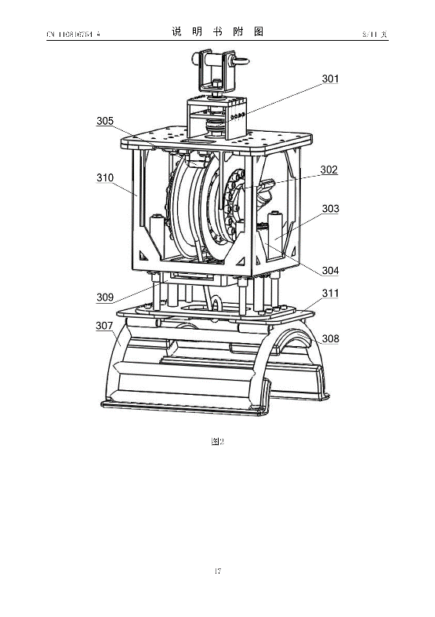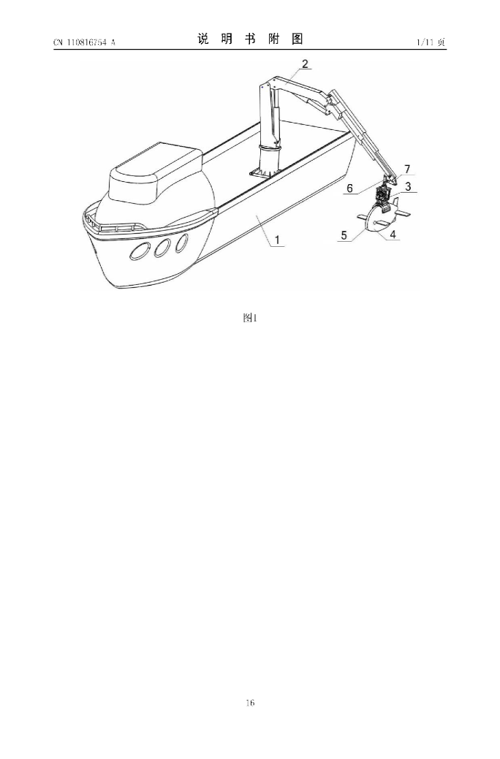

Dates and Legal

Priorities - CN201810921105A·2018-08-14

Application - CN201810921105A·2018-08-14

Publication: CN110816754A·2020-02-21

The latest legal event available on espacenet, CN SE01 states “ENTRY INTO FORCE OF REQUEST FOR SUBSTANTIVE EXAMINATION”, dated 2020-03-17. With no further event data available, we must proceed with the assumption that the patent has not been granted in China, the only country in which it has been published. This brings the patent into considerations as a potential design influence.

[Independent](#Del1_Claims) Claim(s)

Claim 1:

While this claim mentions a manipulator arm and rope throwing mechanism, our proposed system does not infringe, since the primary scope of our system being boat mooring and bridal line retrieval differs greatly from the domain of submersible robot deployment and retrieval described within the claim. Furthermore, our spring-loaded rope launcher proposal bears even less similarities to the system described in the claim as the mechanical scope does not involve a manipulator arm.

Claim 19:

Since this claim describes a system for retrieving a submersible robot with a mechanical arm, again our proposed system does not infringe as it is entirely based on bridal line retrieval for boat mooring, placing it within a fundamentally separate scope to that described within this claim.

Summary:

As outlined in the Dates and Legal section, this patent is not active, and was only published in China, bringing it into discussion for how it may influence the future design of our proposed system. In particular, the integration of a rope throwing mechanism into a mechanical manipulator arm may have potential use for boat mooring.

## Patent #2

[**AU2023202325A1**](https://worldwide.espacenet.com/patent/search?q=pn%3DAU2023202325A1) SYSTEM AND METHOD FOR TUG-BOAT LINE TRANSFER

Applicant(s) - ROBERT ALLAN LTD [CA]

Inventors(s) - SHIVES MICHAEL; DEN HERTOG VINCENT; LISAGOR OSCAR; HASS DARREN

Abstract:

*An apparatus, system, and method for* ***transferring a line*** *from a tug-boat to a vessel. One or more photosensors are trained on the vessel to detect a target position thereon. An upper* ***manipulator*** *is coupled to the line via an end-effector thereof and is configurable to position the end-effector relative to the target position to allow* ***transfer of the line*** *from the tug-boat to the vessel. One or more processors tracks the target position relative to the end-effector based on output from the photosensors. A lower* ***manipulator*** *is coupled to the tug-boat and the upper* ***manipulator****, and is configurable to orient the upper* ***manipulator*** *in accordance with an inertial frame. Computer-readable memory is coupled to the one or more processors and stores processor-executable instructions that, when executed, configure the one or more processors to execute one or more methods.*

Relevant figure(s):

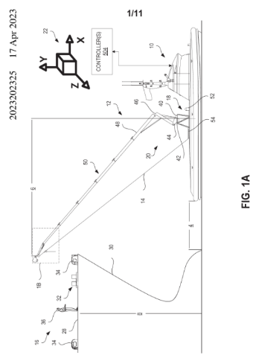

Dates and Legal

Priorities - US202263349938P·2022-06-07

Application - AU2023202325A·2023-04-17

Publication - AU2023202325A1·2023-05-11

With the legal event data section on espacenet empty, it seems that this patent is not active. Being a recent patent, with a publication date of 2023-05-11, it may be possible that this patent is under an examination process that has not yet been documented on espacenet. Regardless, the lack of any documentation leaves the assumption that the patent is not active. Furthermore, the patent lists US priorities, with an Australian application and publication shown on espacenet. Things brings the patent into discussions for potential use and influence within our design, especially given our UK and European focus.

Independent Claim(s)

There 4 claims associated with the patent, with 3 being independent

Claim 1:

This claim describes the usage of a computer to implement a line transfer system. Since the claim describes transferring a line between vessels with a pair of manipulators, it can be concluded that our proposed system does not infringe this claim. While the description of manipulators and photosensors may be considered fundamentally adjacent to our proposed system of IR sensor guided line deployment and bridal line retrieval, their respective mechanisms are entirely separate, the claim makes no mention of boat mooring or bridal line/buoy retrieval, instead describing a vessel-to-vessel interaction.

Claim 2 is dependent on claim 1.

Claim 3:

This claim describes a system of line transfer between vessels. The lines are managed by a lower and upper manipulator tracked by “one or more” photosensors trained on the target vessel.

The focus on guided line manipulation between marine vessels makes the description of this system potentially adjacent to our proposed system. Our system does not describe a dual manipulator mechanism to transfer lines between vessels and therefore does not infringe this aspect of the claim. However, moorings occasionally consist of a line transfer between neighbouring vessels in a mooring. Therefore, further legal considerations would be required if the system’s functionality was expanded to include a neighbour vessel interaction.

Furthermore, the description of using “photosensors trained on the vessel” is potentially adjacent to our proposed system of tracking buoys with IR sensors and beacons, since an IR sensor can be classified as a type of photosensor. However, since our system is centred around guiding line deployment towards bridal lines and buoys, with IR sensors tracking beacons on buoys rather than photosensors tracking vessels, our proposed system does not infringe this aspect of the claim either.

Claim 4:

Similar to Claims 1 and 3, this claim further describes the tub-boat to vessel line transfer. It reiterates the photosensor detection aspect and the low and upper manipulators used to transfer the line. This claim goes into further detail describing the use of an “end-effector” on each manipulator to connect to a line. Our proposed system does not infringe this claim for the same reasons provided in the prior claim discussions. The system describes using manipulators with “end-effectors” rather than a launch system, nor does the system have any relevance in the context of boat mooring and more specifically, bridal line retrieval.

Summary:

As stated in the Dates and Legal section for this patent, there is nothing to suggest that this patent is active in the countries it was applied for. With this in consideration, potential uses of the systems described in the patent can be discussed. Similarly, the first patent discussed within the delivery section also described a method of line manipulation by means of a mechanical manipulator. In a future design evolution, our system may be able to incorporate some kind of mechanical manipulator with an appropriate end-effector for deploying lines or perhaps directly retrieving bridal lines.

## Search strategy #2

As the prior search returned a very narrow search that contained some relevant but many irrelevant patents, a more open search was performed for the second lot of search results. While a more open search requires more manual work to find relevant results within, there were a lot more relevant patents available that did not appear in prior searches.

Keeping the initial search within the main area of interest, the first two search terms used were “Boat mooring AND hook deployment”. This resulted in 286 search results.

To narrow the search down to the specific domain of deployment and retrieval, an additional term “AND line retrieval” was added, bringing the search down to 70 results.

## Patent #3

[**US3931782A**](https://worldwide.espacenet.com/patent/search?q=pn%3DUS3931782A) Mooring method for deployment and retrieving of mooring

Applicant(s) - OCEAN DRILLING EXPLORATION

Inventor(s) - CHILDERS MARK A; DAWKINS ENOCH L

Abstract:

*“This invention relates to a mooring method and system and includes a process of deploying and retrieving anchors, each anchor being attached by a long mooring line to a floating moored structure.”*

Relevant figure(s)

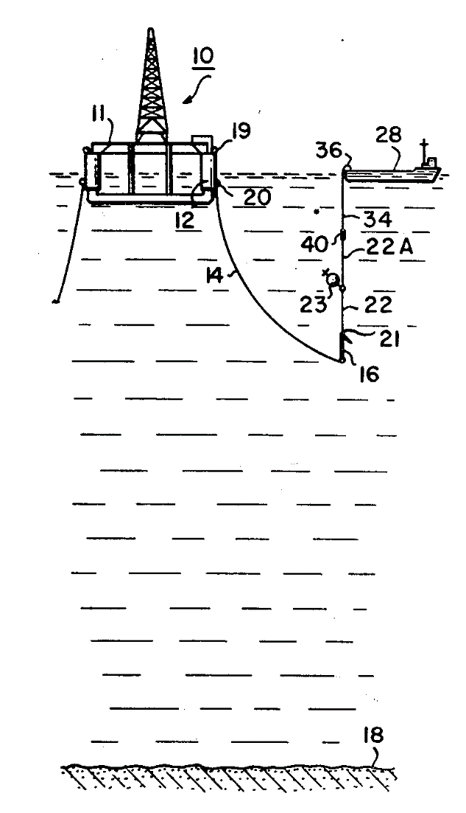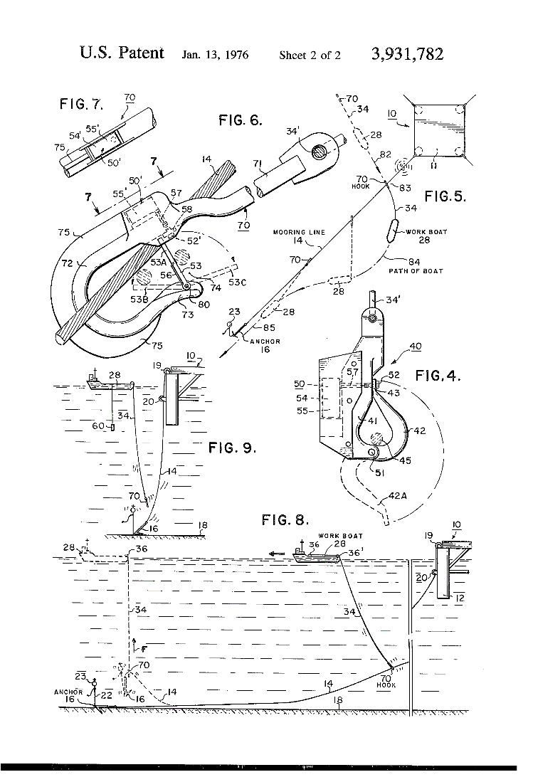

Dates and legal

Priorities - US50958174A·1974-09-26

Application - US50958174A·1974-09-26

Publication - US3931782A·1976-01-13

While this patent has no legal event entries on espacenet, the main bibliographic page shows that the patent was published in several countries, including the UK and some European countries, which covers our main regions of focus. Despite this, the patent is lapsed, since the date on the original document shows 1976, meaning that it lapsed around 1996.

Independent Claim(s)

There are two independent claims associated with this patent

Claim 1:

This claim describes a system of mooring a floating structure to an anchored line, with means of deploying, attaching and retrieving the mooring line with a workboat. The claim goes into further detail describing how the workboat will use a hook to attach to the structure’s mooring line, move away from the structure to a *“desired location”*, lower said line throughout *“the body of water”*, bury the anchor and finally detaching the hook from this mooring line and retrieving it, completing the mooring.

The use of hooked lines bears fundamental similarities to our system; however, this system describes a means of a smaller vessel to assist with the anchor mooring of a larger structure, where our system is a self-mooring system, where it moors the vessel the system is attached to.

Claim 5:

This claim reiterates many of the same functionalities described in claim 1, albeit with more detail regarding the environment in which the mooring system is used with respect to the structure being moored. This claim does go on to describe how the hook mentioned prior will be *“remote-operated”.*

The remote-operation aspect of this patent presents a potential opportunity to be investigated for our system since this patent has long since expired.

Summary:

This patent describes a workboat-assisted large structure anchor mooring and our proposed system describes a vessel’s self-mooring to a preexisting trot mooring configuration. As discussed in the Dates and Legal section, this patent is long expired, considering this, the remote operation of the hook described is worth investigating for potential use within our system. Such a mechanism may prove useful for manipulating a bridal line in both attachment and detachment once retrieved.

## Patent #4

[**US4479454A**](https://worldwide.espacenet.com/patent/search?q=pn%3DUS4479454A) Multi-position mooring line apparatus

Applicant(s) - SCHEPEL DONALD D

Inventor(s) - SCHEPEL DONALD D

Abstract

*“A mooring device having a plurality of functional positions of adjustment. The device facilitates the docking of a boat by obviating the need to disembark from the boat as the boat approaches a pier or wharf. Specifically, the apparatus includes an elongate, flexible arm member having a line-retaining member formed at the distal free end thereof that presents the mooring lines to the boat operator while such operator remains on the boat. The arm projects from a novel hemispherical in configuration base member having a plurality of circumferentially and angularly spaced bores provided therein and such base member is further rotatable about an axis of symmetry so that the positions that the apparatus may assume are virtually unlimited.”*

Relevant figure(s):

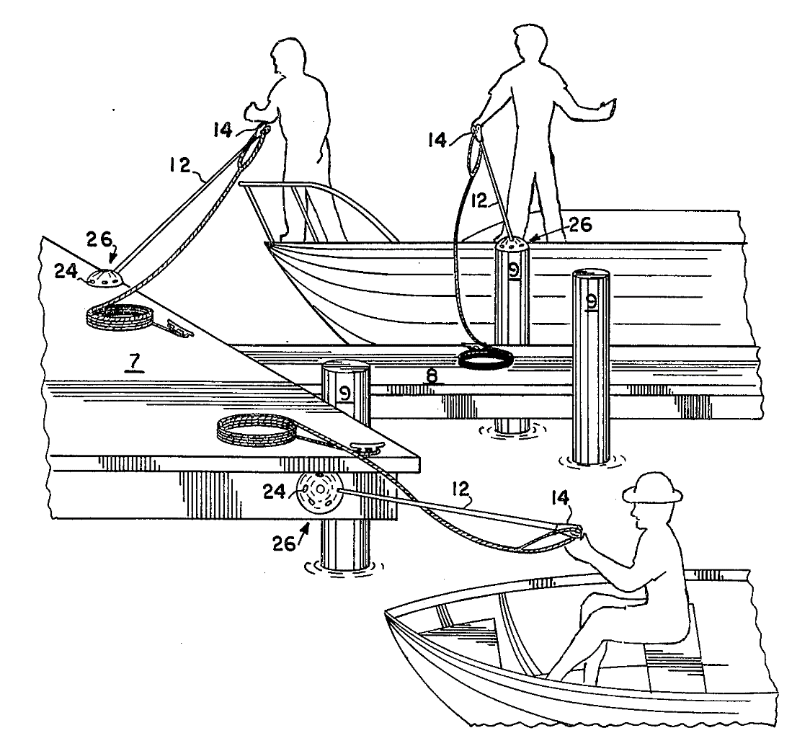

Dates and Legal

Priorities - US50382083A·1983-06-13

Application - US50382083A·1983-06-13

Publication - US4479454A·1984-10-30

Only published within the US, and thus outside our primary region of interest, this patent does not pose as an infringement concern unless a region expansion is considered. Regardless, the legal event data available on espacenet shows that the patent lapsed due to a failure to pay maintenance fees many years ago, dated 1992-11-01. Furthermore, since the patent was published in 1984, the patent would have lapsed around 2004 anyway. This brings the patent into a potential use discussion.

Independent Claim(s):

Claim 1:  
The claim describes a device used to extend mooring lines out from a docking platform such that a boat can be moored without the need for a member of the crew to disembark and fetch a line. The claim describes the mechanical of the extender device, where the focus of the claim seems to be.

Summary

As discussed in the Dates and Legal section, this patent has long since lapsed. Considering this, the concept of a flexible line extender may have potential for the deployment and retrieval mechanism of our system. Possibly as a fixture to the vessel or the buoys themselves, a line extender may have use in increasing the effective range of the mooring system, putting less reliance on the pilot for bringing the vessel within range.

Patent #5

[**US8967066B1**](https://worldwide.espacenet.com/patent/search?q=pn%3DUS8967066B1) Automatic docking line management system

Applicant(s) - BEKEY IVAN

Inventor(s) - BEKEY IVAN

Abstract

*“An apparatus and method for use on aquatic vessels for automatically retracting a docking line released from the vessel when undocking so that it is stored out of the water next to a fixed structure such as a piling, initiated with one simple manual operation; and extending the line when docking the vessel by engaging said line and attaching it to the vessel, also all with one simple manual operation. The means for generating the retraction forces acting on the docking line can be a spring-actuated reel mounted on the fixed structure, causing tension in a thin retrieving line attached to the docking line. Alternatively the forces can be generated by sets of weighted blocks and pulleys, or elastic cords. Use of the embodiments will avoid undocking stresses of using long boathooks to hang docking lines on pilings, and reaching them when docking; or throwing them.”*

Relevant figure(s)

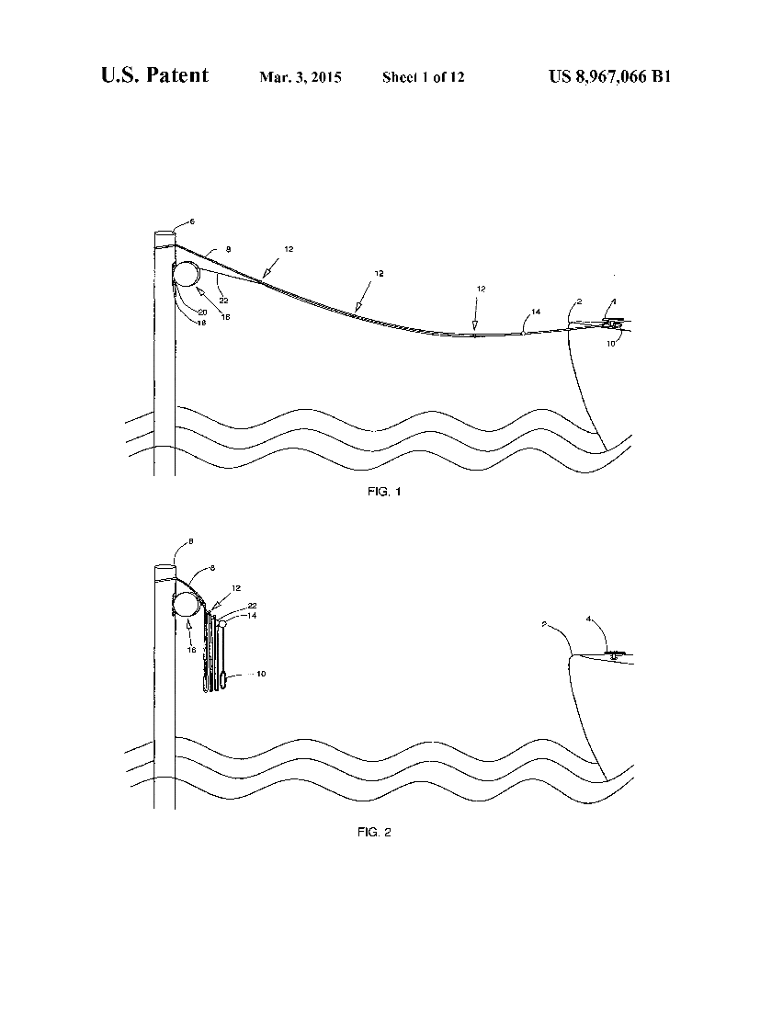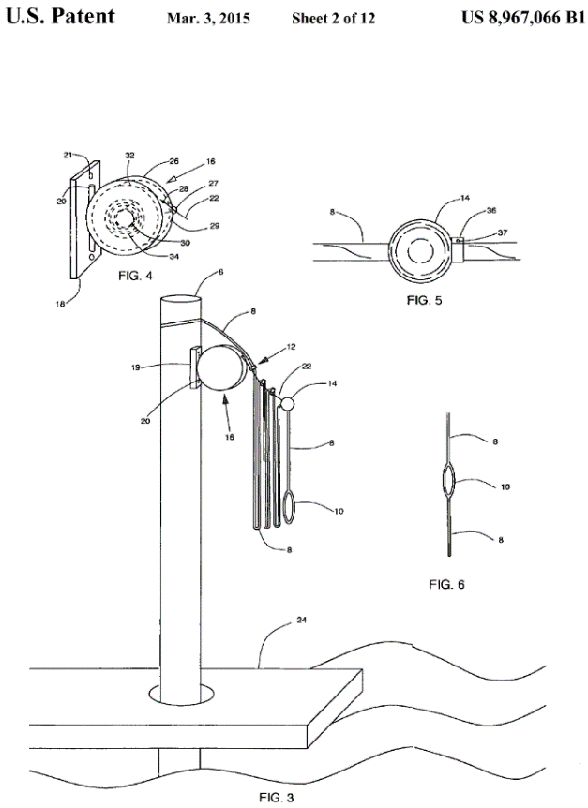

Dates and Legal

Priorities - US201161476860P·2011-04-19; US201213506439A·2012-04-19

Application - US201213506439A·2012-04-19

Publication - US8967066B1·2015-03-03

With solely US publication entries, this patent is outside our primary region of interest. Furthermore, the legal event section on espacenet shows that the patent lapsed due to maintenance fee payment failure, dated 2023-05-02. This brings the patent into use discussion, even in the event of a distribution expansion of our system to the US.

Independent Claim(s)

Claim 1:

This claim describes a system of managing vessel docking lines from a “fixed structure over water”. The main apparatus consists of the main docking line attached to the structure, with a retrieval line “communicating” with the main docking line. The claim further details the means of retrieval line to docking line attachment, and how the docking line can be extended and retrieved for subsequent dockings. Furthermore, the claim describes how a docking or undocking only requires a single manual operation.

While the system bears conceptual similarities to our proposed system, in that it pertains to the self-mooring of a vessel, the nature of the mooring performed is completely different. Our proposed system moors a vessel to a trot mooring with buoys and bridal line, not a fixed structure or dock. Furthermore, our proposed system performs line management from the vessel attempting to moor, rather than from the structure being moored to, as described within this claim.

Claim 12:

Claim 12 reiterates several of the mechanical details of the first claim, albeit with a unique description of an elastic cord used where claim 1 described a retrieval line.

The elastic cord seems to be the only difference between the first two independent claims, where the claims essentially describe two similar variants of the same system. Considering this, the same points outlined in the discussion of claim 1 also apply to this claim.

Claim 20:

Similarly, to claim 12, claim 20 describes a variant of the system described in claim 1. The main differences can be found in section c of claim 20, where unique mechanisms ensure “orderly retraction and extension” of the docking line.

Considering this is another variation of the same fundamental system described in claim 1, there is nothing that makes the system more analogous to our proposed system.

Summary

Due to the patent having lapsed earlier in 2023, as outlined in the Dates and Legal section, we can discuss its potential for use. The twin line system of having a retrieval line manage a docking line has potential for our line/hook deployment and retraction system, where a dedicated retraction line may be a more mechanically effective means of retrieving a secured bridal line.

## Search Strategy #3

Altering the prior search’s mention of hook to line, giving: “Boat mooring AND line deployment AND line retrieval”. Returned 200 results, with more docking related patents. Adding “Automatic” to the last group of keywords, resulting in “Boat mooring AND line deployment AND automatic line retrieval” provided 81 results.

## Patent #6

[**US2022234871A1**](https://worldwide.espacenet.com/patent/search?q=pn%3DUS2022234871A1)Retractable Docking Line

Applicant(s) - DELL WILLIAM GARRETT [US]

Inventor(s) - DELL WILLIAM GARRETT [US]

Abstract

*“A device for storing and dispensing line for mooring a boat to a dock includes a user interface, an auto-retracting reel assembly, and optionally, a conduit connecting the user interface to the reel assembly. The user interface comprises a canister mounted on a gunwale, or the like, for storing the distal, looped end of a mooring line, a top lid that slides horizontally between an open and closed position, a rail support engaged by the top lid, and a bottom lid having a hole defined therein. The extended mooring line may be locked into place by frictional engagement between the spring loaded top lid and the rail support. To retract the mooring line, a user may open the top lid of the user interface for automated retraction, winding around the reel, until the stopping collar prevents the distal, looped end of the mooring line from passing therethrough.”*

Relevant figure(s)

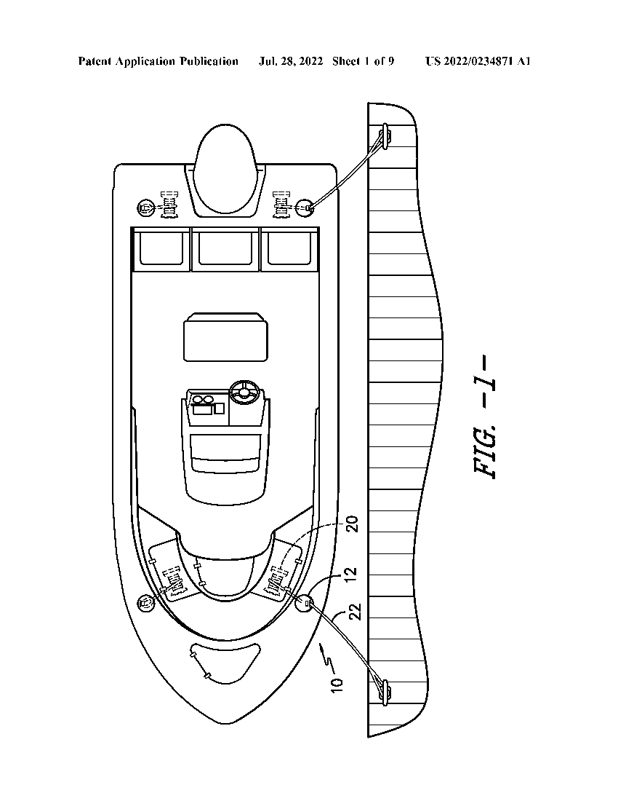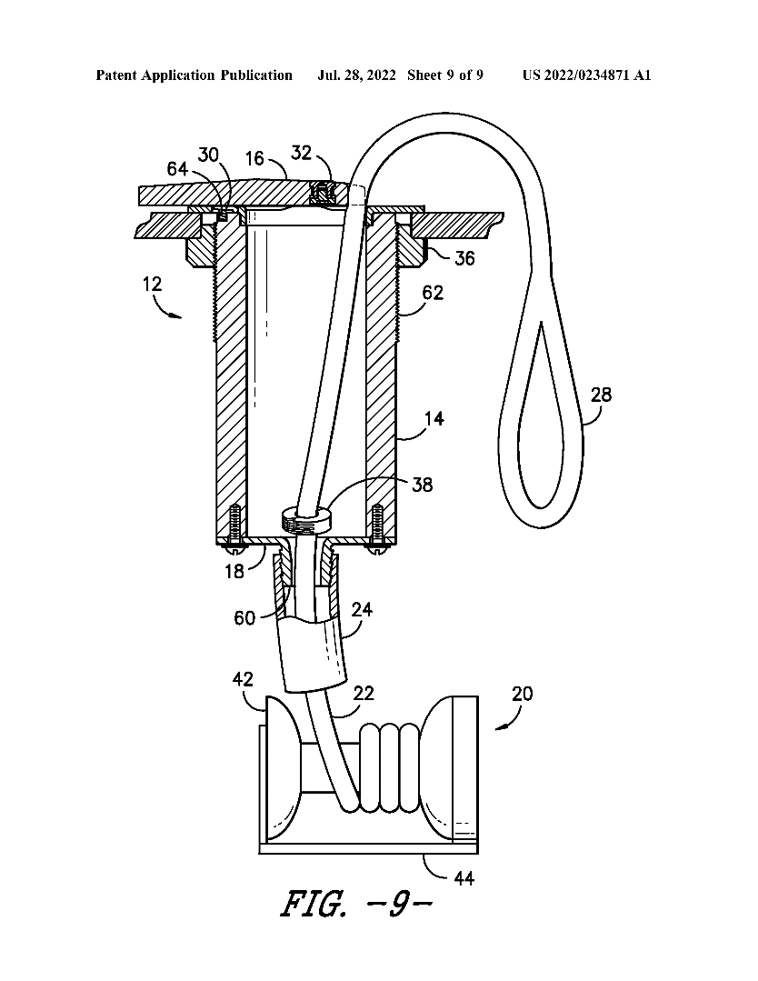

Dates and Legal

Priorities - US202117155646A·2021-01-22

Application - US202117155646A·2021-01-22

Publication - US2022234871A1·2022-07-28

With only US publications, this patent is outside our primary region of interest, though still worth examination given its contents and the possibility of a future region expansion for our system. With the original application dated recently (2021-01-22), this patent would be relevant in the case of a region expansion. The legal events section on espacenet shows that the patent is still under examination as of 2023-10-26. Given its US exclusivity and unconfirmed grant status, we can consider its potential for use.

Independent Claim(s)

Claim 1:

The claim describes a system of storing a retractable mooring line on a vessel. The line uses a loop end to attach to a docking structure and is stored within a canister, where the line passes through the top and is retrieved by an “auto-retracting reel assembly”.

This claim describes a system that bears several similarities to our proposed deployment system. Most notably, both systems describe a mechanism to deploy and retract a mooring line from the vessel being moored

However, our proposed system intends to provide both automatic deployment and retraction, while the patent only describes a means of automatic retraction. There is also a fundamental difference between the use of the lines being deployed by both systems, with this patent proposing a system where the mooring lines themselves are contained and managed by the vessel mounted device. The line deployed by our system is not a mooring line itself but a means of retrieving a bridal line such that mooring lines can then be secured to the vessel. Furthermore, our proposed system does not include the description of a lidded canister and proposes a connection system for securing trot mooring bridal lines instead of the looped end for docking attachments shown in the patent. Considering these differences between the two mechanisms, our proposed system would not infringe this claim.

Summary

While we believe the important distinctions between this system and our own would prevent it from infringing, the fundamental similarities between them may necessitate a re-examination if this patent is granted. Especially if our system is modified and US distribution is planned in the future. Considering our primary region focus of the UK and Europe currently, the contents present interesting potential for our system. The self-contained line management system may have a direct use for our system, potentially being a superior method of managing a retrieval line.

## Patent #7

[**US2008245285A1**](https://worldwide.espacenet.com/patent/search?q=pn%3DUS2008245285A1) SELF CONTAINED INTEGRATED MOORING SYSTEM

Applicant(s): UNIV FLORIDA ATLANTIC [US]

Inventor(s): DRISCOLL FREDERICK R [US]; BEAUJEAN PIERRE-PHILIPPE [US]; FRANKENFIELD JOHN CHARLES [US]

Abstract

*“A self contained integrated mooring system configured to contain items within a payload container in a water body is disclosed. The self contained integrated mooring system may include components for conveniently collecting and storing the components of the self contained integrated mooring system. The self contained integrated mooring system may be formed from the payload container, a mooring line handling and storage module, an anchor and a system container in a single system that eliminates having to work and rework anchor lines on a deck of a boat.”*

Relevant Figure(s)

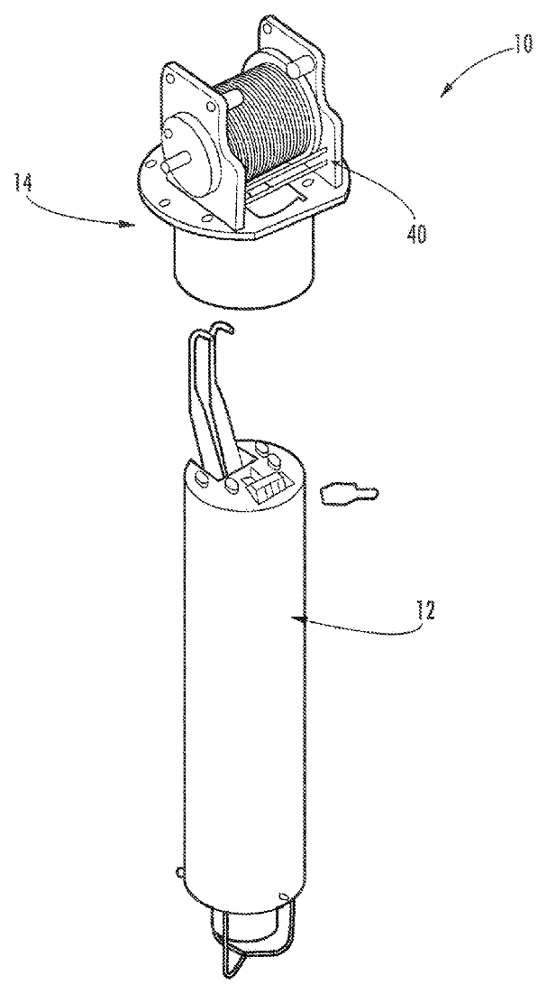

Dates and Legal

Priorities - US1853308A·2008-01-23; US88641807P·2007-01-24

Application - US1853308A·2008-01-23

Publication - US2008245285A1·2008-10-09

With only US publications, this patent is outside our region of interest, however a future region expansion for our proposed system is possible. Examining the legal events available on espacenet, we can see that the patent was granted in 2011 (2011-02-02). However, the final legal event recorded shows that the patent lapsed in 2019 (2019-04-23) due to failure to pay maintenance fees. This brings it into discussions for potential use, both now and in the context of a future US expansion.

Independent Claim(s)

Claim 1:

This claim describes a device for the containment of a mooring system. The patent describes the system’s “internal cavity” used to store the main mooring payload. The mooring line is wound around “at least one spool” with “at least one anchor” communicating with the mooring line handling mechanism.

Our proposed system does not infringe this claim as it makes no claim to a self-contained mooring payload container device with an anchor in communication with the storage mechanism. Furthermore, with trot moorings as the intended use of our proposed system, it makes no claim regarding the use of or interaction with anchors for mooring.

Claim 9:

This claim reiterates the details of the first independent claim, regarding the main cavity and payload retention system. The claim goes on to describe the mechanical details of the mooring line spools, including description of “crossover slots” and a “locking mechanism”. The claim also details the mechanism of the storage container itself, describing a “receiving chamber” and an “anchor receiving chamber”.

Again, our proposed system does not infringe this claim since it is a further description of a self-contained mooring line storage system with anchor interaction that our proposal does not describe. The mooring intended by our system makes no use of anchors or a self-contained mooring line storage cavity.

Summary

As discussed in the Dates and Legal section, the patent lapsed over 4 years ago, bringing it into discussion for potential use. The self-contained line management and spool mechanisms described may be useful within our proposed system, if the mechanism can be adapted for a line-hook style payload, rather than the line-anchor payload described in the claims.

# Connection

## Search Strategy

To effectively find relevant patents, while filtering irrelevant ones, certain keywords are needed to form the search strategy for the “Hook” component. To generate these key words, a summary of the component is written below.

“A hook and clip device to connect a boat to a mooring line, and securely hold itself in place with the ability to disconnect when necessary.”

The keywords taken from this summary are Hook, Clip, Connect, Boat, Mooring, Line, and Disconnect. These will form the patent search and filtering. The aim of this filtering is to find between 5 and 30 results and write about the most relevant of these.

Hook – 3,262,611 Results

Hook AND Clip – 281 718 results.

Hook AND Clip AND Connect – 92 220

Hook AND Clip AND Connect AND Boat – 1747

Hook AND Clip AND Connect AND Boat AND Mooring – 113

Hook AND Clip AND Connect AND Boat AND Mooring AND Disconnect –17

From these 17 Results, the most relevant will be examined for the scope of this project, as some patents had no relevance and contained none of the Keywords listed (e.g. Nuclear reactor facilities for new type conversation for the treatment of nuclear waste, KR20170015393A).

## Patent #1

[**US4932700A**](https://worldwide.espacenet.com/patent/search?q=pn%3DUS4932700A) Mooring line shackle

Applicant(s) – HART RONALD (US)

Inventor(s) - HART RONALD (US)

Abstract

*“A remotely operable shackle particularly adapted for* ***connecting*** *a* ***mooring*** *line to a* ***mooring*** *loop. The shackle may be detachably carried by a* ***boat hook*** *and is remotely operable to* ***connect*** *and* ***disconnect*** *the shackle from a* ***mooring*** *loop.”*

Relevant Figure(s)

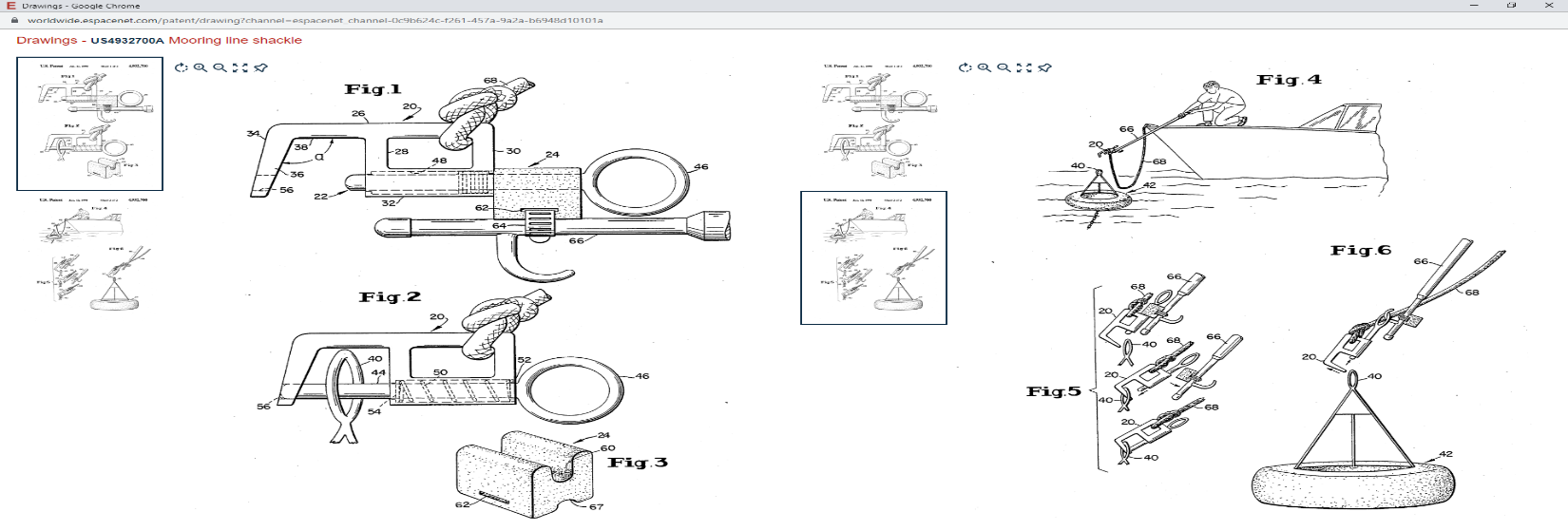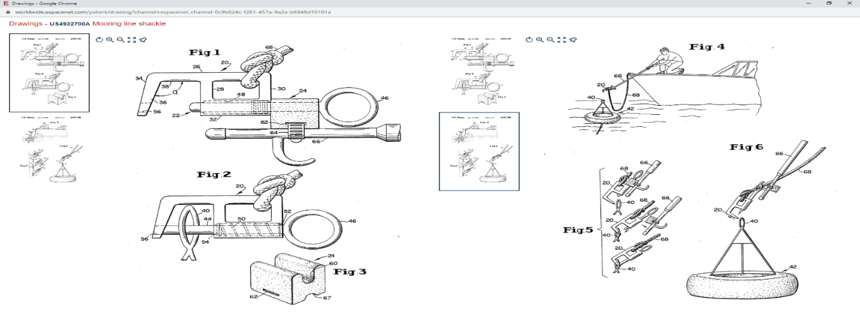

Dates and Legal

Priorities - US29862389A. 1989-01-18

Application - US29862389A. 1989-01-18

Publication - US4932700A. 1990-06-12

Independent Claim(s)

Claim 1:

This claim describes a shackle that connects a mooring line to a mooring loop. The device is comprised of a main body, a looping section on one end with a spring-based shackle pin and a blocking section designed to be detachably mounted.

This claim is very relevant to our project and may be used in the final design. If this patent is still valid then it is very possible that infringement will occur. If this was an industry-level project, great care would be needed to avoid possible infringement based off this claim.

Summary

Fortunately, infringement is not an issue as the Application date is 1989-01-18, meaning, at the latest, it expired on 2009-01-17. However, multiple instances of non-payment resulted in the patent being invalid (effective 1994-06-15) and discontinued (effective 2018-01-29).

This device is relevant to our project, as it is a ranged method of connecting/disconnecting to a buoy. Adapting this to a mooring line would be relatively simple, and the control of the hook can be done via electronics to allow for automation. An adapted version of this device could fit the previously defined summary of the Hook component. If this patent were still valid, there would be a real concern of infringement due to both what the device does and the context of its operation.

Patent #2  
[**US10913514B2**](https://worldwide.espacenet.com/patent/search?q=pn%3DUS10913514B2) Deployable boat hook

Applicant(s) – MARTIN ROY W (US)

Inventor(s) - MARTIN ROY W (US)

Abstract

*“The deployable* ***boat******hook*** *assembly includes a clamping assembly which is attachable to a pole. The clamping assembly includes a clamp adapted to temporarily secure a* ***boat******hook*** *which is configured to connect to a receiving member on a dock. The* ***boat******hook*** *is configured to receive a* ***boat*** *line extending from the* ***boat****. The temporary securement of the* ***boat******hook*** *by the clamping assembly is overcome by an operator moving the pole in a manner to release the clamping assembly from the pole, such that the* ***boat*** *remains* ***connected*** *to the dock by the* ***boat******hook*** *and the* ***boat*** *line.”*

Relative Figure(s)

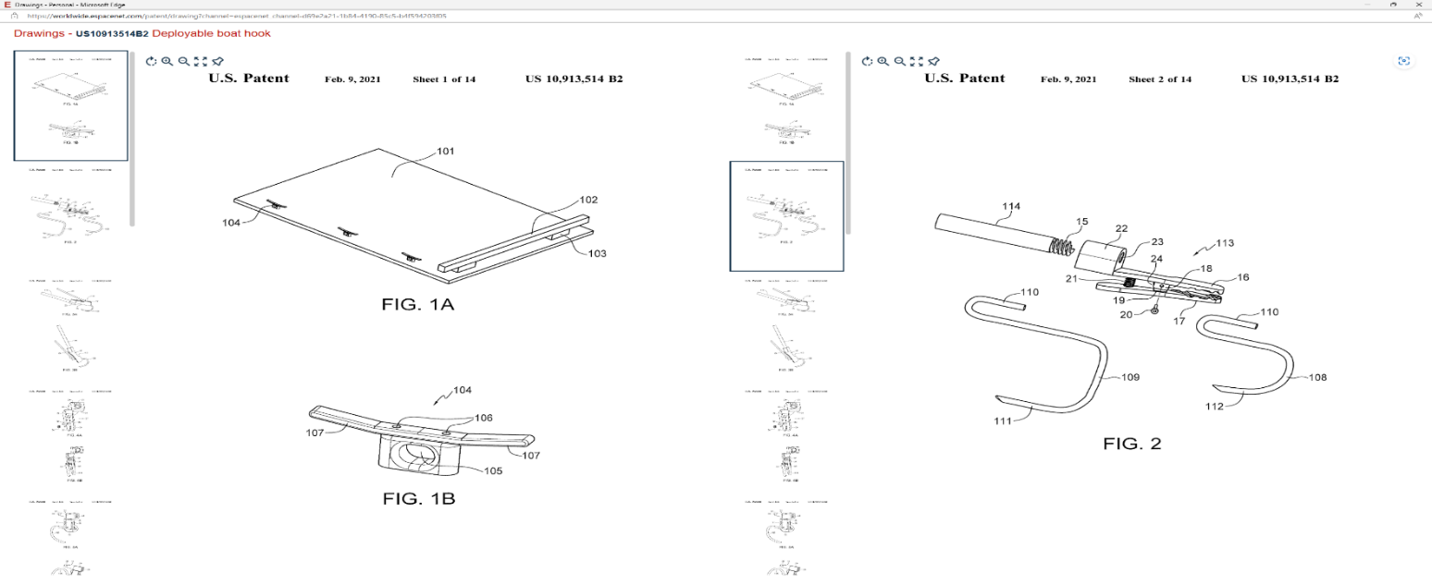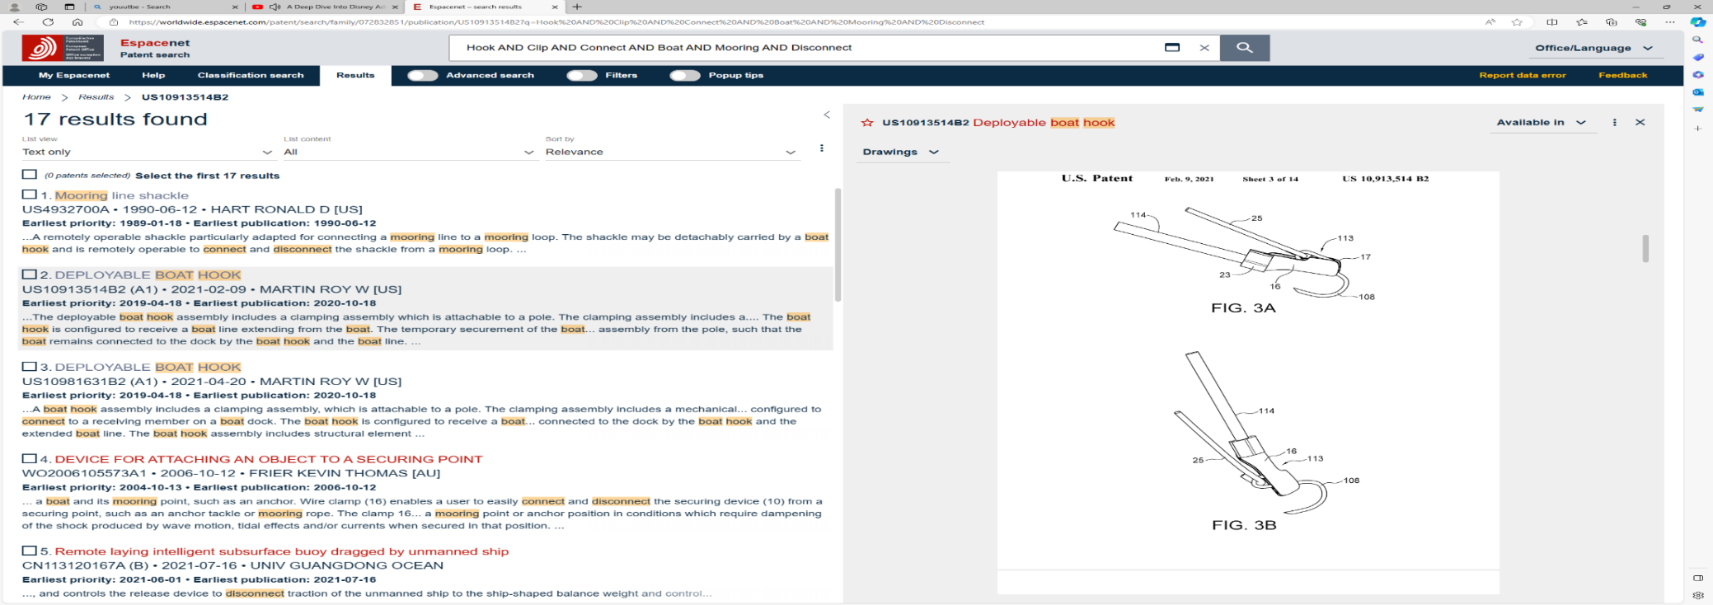

Dates and Legal

Priorities - US201916388383A. 2019-04-18

Application - US201916388383A. 2019-04-18

Publication - US10913514B2. 2021-02-09

Independent Claim(s)

Claim 1:

This claim describes a deployable boat hook comprised of a mechanical clamp, a pole and a boat line. The aim is to attach the clamp to the docking device using the pole, then detach the pole, leaving the clamp and rope attached to the docking device.

This is relevant to our project as we are looking for temporary attachment to a boat line. Our system will be launching the connecting device as opposed to using a fixed pole. This means that claim 1 can be avoided by using a projectile method and making it unable to attach to a pole.

Claim 9:

This claim describes a boat hook comprised of a magnetic clamping attachable to a pole. The pole is directed towards a docking device, and the magnet allows the clamp to attach/detach to the docking device.

Our connection method will not be magnetic, nor connected to a pole. While still relevant to the project, these details ensure that we will not infringe this claim.

Claim 16:

This claim describes a boat hook comprised of a clamp, including a securing portion, attached to a pole. The pole is directed towards a docking device, and the securing portion allows the clamp to attach/detach to the docking device and the other section of the clamp.

Our connection device will be attachable and detachable to the docking device, but no pole will be involved, therefore this claim will not be infringed by our project.

Summary

Infringement could become an issue if this project were to be sold internationally, as the patent was recently granted. However, it only applies to US and Canada regions, and as 18 months have passed since the application date, the deadline for foreign applications has passed. This means that in regions outside of US and CA, this design is not patented. This means the patent will not be infringed within the scope of this project.

This patent has similar uses to Patent #1 as it is a method of attachment. While also extremely relevant and not likely to be infringed, the complexity of the device means it may not be plausible to recreate the device within the time and budget scale of this project. However certain sections and designs may be useful to take and adapt from this patent, for example, FIG 3A and FIG 3B highlight an important section for this project.

## Patent #3

[**WO2006105573A1**](https://worldwide.espacenet.com/patent/search?q=pn%3DWO2006105573A1) Device for attaching an object to a securing point

Applicant(s) – FRIER KEVIN THOMAS (AU); FRIER THOMAS RICHARD (AU)

Inventor(s) - FRIER THOMAS RICHARD (AU);

Abstract

*“A securing device (10) comprises an elastic cable (11) and wire clamp (16). The cable (11) is made from a resilient polymer material which can function as a dampener by elastically deforming to compensate for changes in the distance between a* ***boat*** *and its* ***mooring*** *point, such as an anchor. Wire clamp (16) enables a user to easily connect and* ***disconnect*** *the securing device (10) from a securing point, such as an anchor tackle or* ***mooring*** *rope. The clamp 16 is permanently secured to one end of the elastic cable (11). The combination of the elastic cable (11) and clamp (16) act in concert to provide a device that can be used to quickly and safely secure a vessel to a* ***mooring*** *point or anchor position in conditions which require dampening of the shock produced by wave motion, tidal effects and/or currents when secured in that position.”*

Relevant Figure(s)

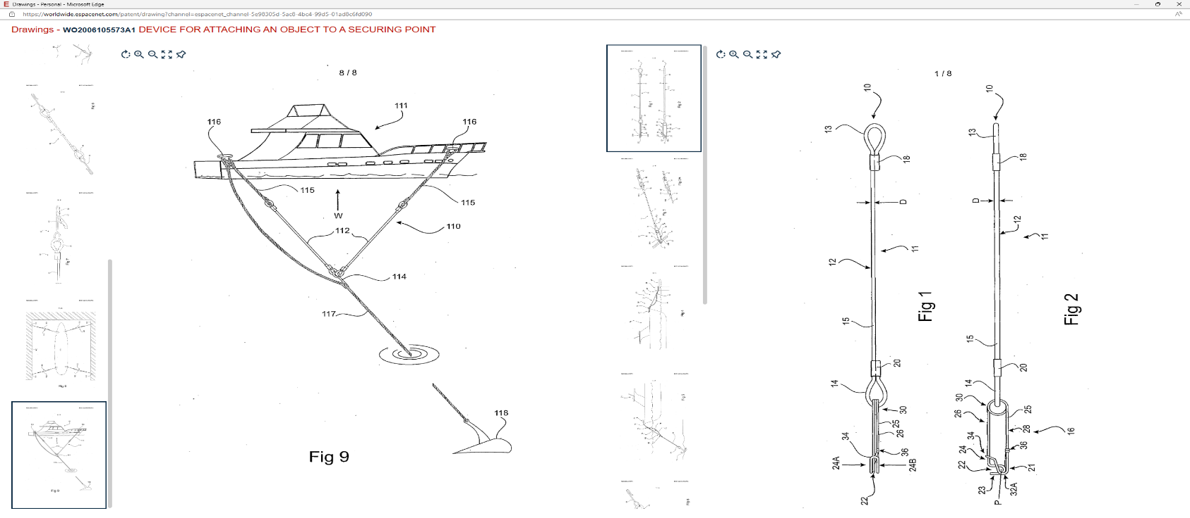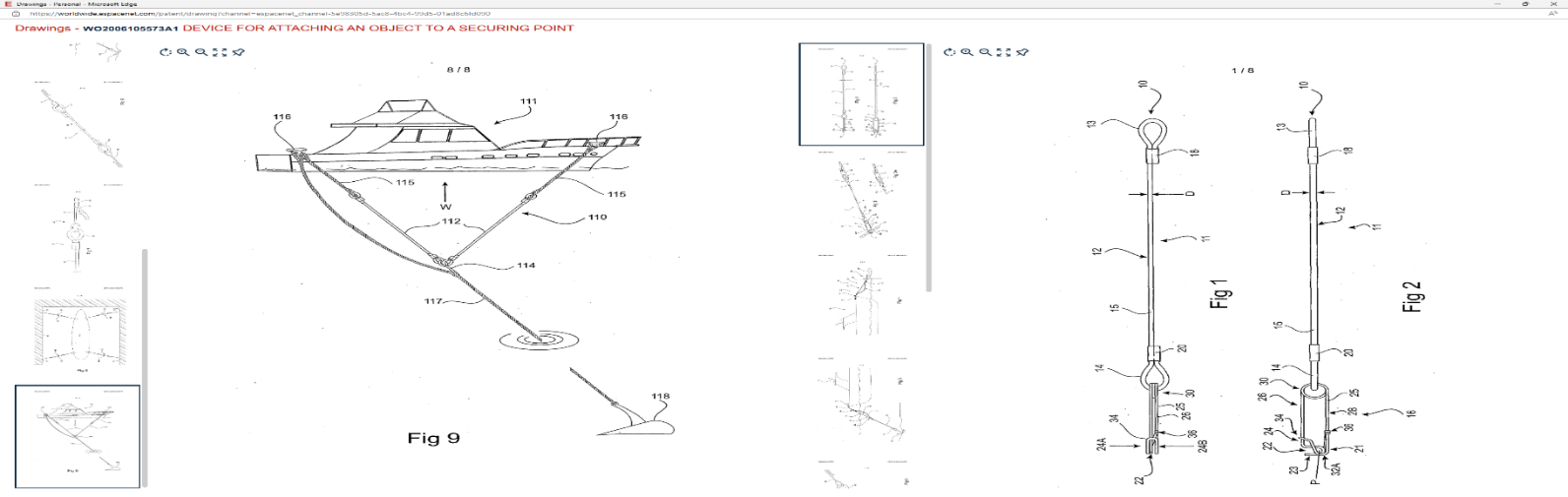

Dates and Legal

Priorities - US61766504P. 2004-10-13

Application - AU2005001573W. 2019-04-18

Publication - W020061055731A1. 2006-10-12

This patent has an unusual event history as shown by the Priorities, Application and Publication codes. Initially the design was filed for the US, then Applied in Australia, and finally Published Worldwide. However, the Legal Events section gives some further details that may help our project.

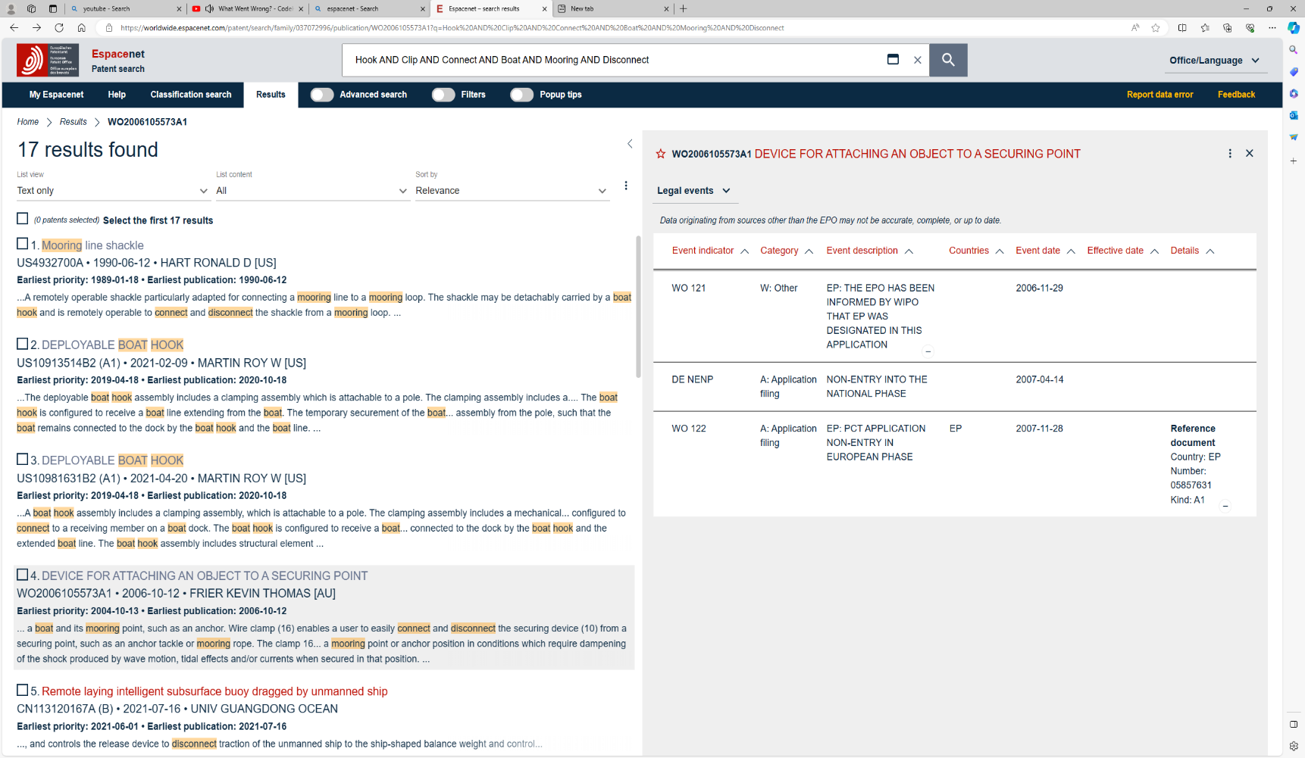

WO 121 – Describes communications between European Patent Office (EPO) and World Intellectual Property Organization (WIPO), which WIPO has informed EPO that Europe is included in the application.

DE NENP – Describes the applicant not filing with EPO for the national phase of application.

WO 122 – Describes failure to comply with EPO standards for European PCT (Patent Cooperation Treaty) within the 31 months allocated.

Independent Claim(s)

Claim 1:

This claim describes a securing device comprising of an elongated flexible member with a clamp for releasable attachment to a point.

This is relevant as the attachment device will also have a flexible link to the boat. While this link may be a solid rope, it could also be some form of elastic material to allow for movement laterally due to wind/water while temporarily moored. In terms of this claim, extreme caution would be needed to ensure this claim is not infringed upon.

Claim 9:

This claim describes a securing device (as described in preceding claims), where the clamp is made from at least two spaced clamps designed to hold rope.

Our project only uses one connecting device for each securing point. This means that infringement of this claim does not occur as only one connection/clamping device is used.

Claim 13:

This claim describes a securing device (as described in preceding claims), where the elongated member has a clamp on each end.

Our project only uses one connecting device for each securing point. This means that infringement of this claim does not occur as only one connection/clamping device is used.

Claim 14:

This claim describes a securing device (as described in preceding claims), where the elongated member is one of a pair, provided with a common clamp.

Our project only uses one flexible member (rope or otherwise) for each securing point. This means that infringement of this claim does not occur as only one flexible member is used.

Claim 15:

This claim describes a securing device (as described in preceding claims), where the securing object is a marine vessel, and the device is used to secure said vessel.

Due to the nature of this project, it would be impossible to infringe this claim only partially. It describes the aim of this component within our project to such a specific degree that it must either be completely obeyed, or completely infringed. If the securing device is used in this project, the dates and legal will be used to determine if infringement has occurred.

Summary

This event history shows that despite being published Worldwide, it failed to meet European standards and therefore is not protected by European patent law. This means that this patent can be used in our project providing no units are sold/distributed outside of Europe. Due to the scope of this project, international sales are not a consideration.

This patent has a useful feature where the movement of the boat is passively dampened by the elastic connection. The relevance of this project along with the general simplicity (especially the use of elasticity) make this an especially useful patent for the project. Consideration of alternative roping material should be considered before a final design is made.

## Patent #4

[**WO2015039483A1**](https://worldwide.espacenet.com/patent/search?q=pn%3DWO2015039483A1) Submerged Buoy Pulley Mooring System

Applicant(s)- Qu Yanming (CN)

Inventor(s) - Qu Yanming (CN)

Abstract

*“A* ***mooring*** *system, mainly comprising a submerged buoy (1)/counterweight (43), a pulley (2), a rope (3), an anchoring base (4) and a rope junction (25); the anchoring base (4) is fastened with a chain (16); the rope (3) is wound around the pulley (2); one end of the rope (3) is tied to the submerged buoy (1), and the other end of the rope (3) is tied to a floating object to be* ***moored****; the rope junction (25) is tied on the rope (3) adjacent to the pulley (2) between the pulley (2) and the floating object to-be-****moored****/anchoring base; a plurality of peripherally-distributed submerged buoy/counterweight pulley anchoring units jointly tension the central floating object to-be-****moored****; the system avoids the problems of anchor chain breaking or anchor base slippage caused by the surge of* ***mooring*** *constraining force, thus providing storm resisting capability, and reducing* ***mooring*** *costs.”*

Relevant Figure(s)

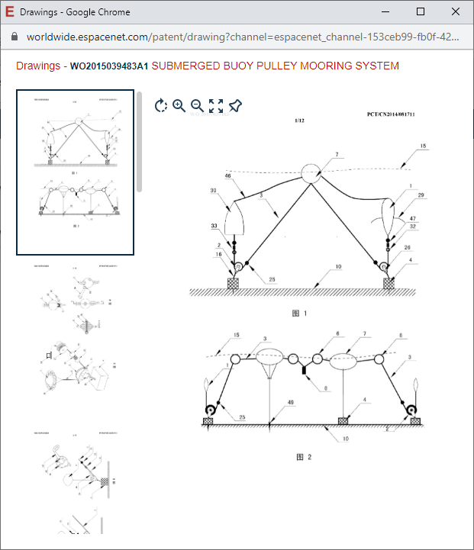

Dates & Legal

Priorities - CN201310469939A·2013-09-22; CN201310554520A·2013-11-09;

CN201410042648A·2014-01-28; CN201410053376A·2014-02-17;

CN201410131615A·2014-04-02; CN201410133806A·2014-04-03;

CN201410250386A·2014-06-04

Application - CN2014081711W. 2014-07-06

Publication - WO2015039483A1. 2015-03-26

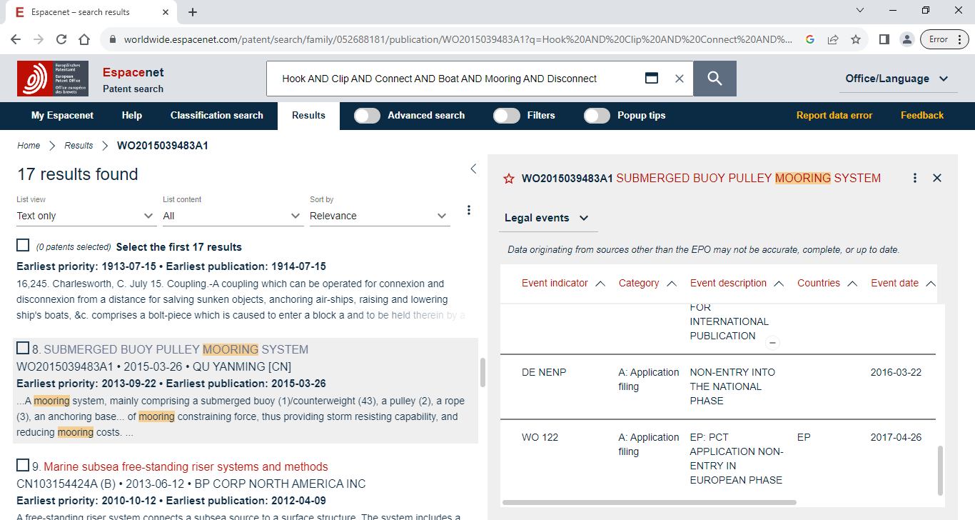

DE NENP – Describes the applicant not filing with EPO for the national phase of application.

WO 122 – Describes failure to comply with EPO standards for European PCT (Patent Cooperation Treaty) within the 31 months allocated.

Independent Claim(s)

It should be noted that this claim has been translated by a machine. For this patent it appears all claims have been placed into claim 1. claim 1 is the only independent claim listed by the patent tree and references itself later in the text. This is most likely a translation/formatting error, as partway through the claim, claim 2 is reference. To analyse this patent, the paragraphs up and including to where it starts with “The above constitutes...” will be treated as a single claim.

Claim 1 describes a submerged pulley mooring system comprising of a pulley, anchor base and a rope. The mooring body is pulled by the ropes of this submerged pulley system.

Claim 2 describes a counterweight pulley anchoring unit. The mooring body is pulled by the rope of the anchoring unit around the plurality of groups.

Summary

From the figures, it can be seen how this may be used for multi-buoy boat mooring. Some advantages of submerged mooring systems include the system being below the boat and mooring area, so no collision needs to be considered. Also, the verticality of the water allows for more space as opposed to just the area from the surface.

If we were to use a similar system, we can legally use this patent within Europe as the patent failed to enter the European phase when attempting to become multi-national. However, outside of Europe may cause issues, but multi-national markets are outside the scope of this project.

## Search Strategy #2

From this point onwards, all patents in the search were irrelevant, not containing a single key word used. Due to this, the search will now be expanded by removing the last word of the search. From this point onwards the search is as follows:

Hook AND Clip AND Connect AND Boat AND Mooring: 114 Results

## Patent #5

[**US8327788B1**](https://worldwide.espacenet.com/patent/search?q=pn%3DUS8327788B1)Mooring pendant apparatus

Applicants - CARDARELLI VENANZIO (US); WOLF RONALD A (US)

Inventors - CARDARELLI VENANZIO (US); WOLF RONALD A (US)

Abstract  
*“A* ***mooring*** *pendant apparatus for releasably coupling and decoupling a* ***boat****. The apparatus having a* ***clip*** *comprising* ***hook*** *and ring sections, with an opening therebetween defining a mouth. A spring loaded movable arm tension biased such that the mouth is kept closed, and it only opens upon activation by a boater pulling on a cable. A functional retractor arm for exerting a greater force on the movable arm than exerted by the internal spring such that the* ***clip*** *opens upon the boater pulling on a cable line. The* ***mooring*** *pendant apparatus operates as an extension of the boater's arm, and it can be utilized either by keeping the apparatus on the* ***boat*** *or leaving it* ***connected*** *to the* ***mooring*** *line and also to the* ***mooring*** *ball.”*

Relevant Figure(s)

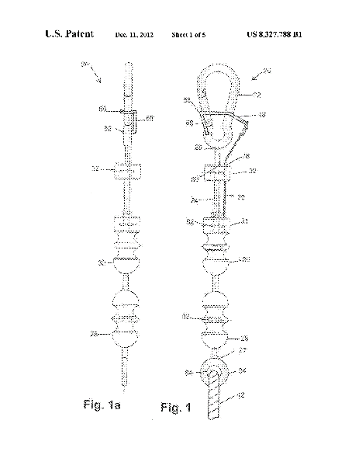

Dates and Legal

Priorities - US201113199248A·2011-08-24; US201113200633A·2011-09-27

Application -US201113200633A·2011-09-27

Publication - US8327788B1·2012-12-11

This patent was granted in the US on 2012-11-21, so it could have been possible it was in use and protected. However, the patent lapsed due to non-payment on 2021-02-09 (effective 2020-12-11) meaning that no infringement is possible.

Independent Claim(s)

Claim 1:

This Claim describes a device for docking a boat, where the device can attach/detach to eyelets either on the boat or to a buoy. The device is comprised of a clip (that includes a hook section), a movable arm containing an internal spring, a retractable lever, an activation system, a connection rod and a controlling cable.

Due to the specific intended use of this design, it would be very difficult to incorporate this into our project without infringing on this claim. The key area we may be able to avoid infringement would be the mention of a movable arm, as the project intends to use some method of launching rather than an arm delivery method.

Summary

Due to the lapse in payment for the patent rights, no infringement possibilities need to be considered. This design may be incorporated into our project, however there would have to be modifications to allow for this design to function attached to a rope or flexible appendage rather than a solid rod/arm. If these modifications are realistic and fit within the scope of this project, then it will function better than a standard hooking/clipping device.

## Patent #6

[**US2550770A**](https://worldwide.espacenet.com/patent/search?q=pn%3DUS2550770A) Boat hook

Inventor(s) - CALEMMO LAWRENCE J

Abstract

This patent has no abstract available on Espacenet (perhaps due to the age of the application). However, the title and figures can be used to extrapolate the use and relevance to this project (which will be discussed in the following sub-sections).

Relevant Figure(s)

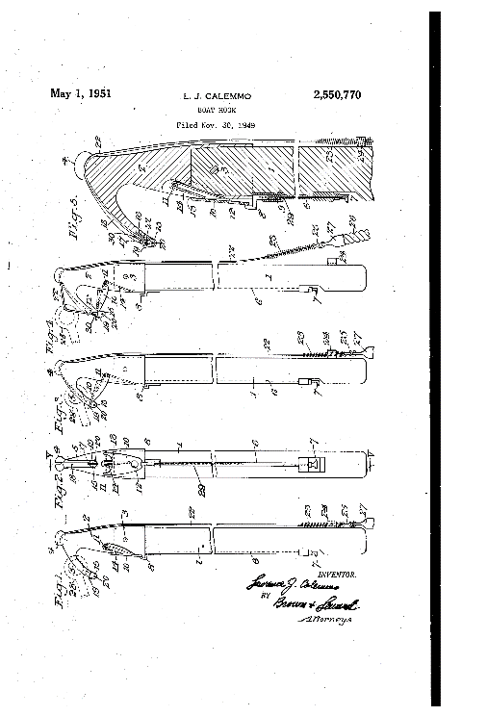

Dates and Legal

Priorities - US13008849A·1949-11-30

Application - US13008849A·1949-11-30

Publication - US2550770A·1951-05-01

The dates show the age of this patent is over 70 years old, this is far beyond the 20 year patent timescale. The age of the patent application may explain the lack of relevant, expected information (such as an abstract). This boat hook design is now in common use as the patent expired and the design became open to use.

No Legal events can be found on Espacenet for this patent.

Independent Claim(s)

Claim 1:

This claim describes a boat hook comprising of a handle, a mounted head, an extending channel through most of the handle, a wire found within the channel, a method of wire actuation at the lower end, a spring latch attached to the upper end of the wire and a lever within the head.

This claim keeps the intended use of the design vague in order to cover as large a scope as possible. Due to this, and the relatively few components, using this design would infringe this claim.

Claim 2:

This claim describes a boat hook comprising of a handle, a mounted head, a hook on the head, a detachable element on the hook, a swinging mechanism, a latch on the handle, a remote release mechanism for the latch.

This claim, while similar to claim 1, describes the mechanisms used in further detail. Once again, the few components and required operation leaves no space to use the design partially or in different context, so infringement of this claim would occur if the design is used within the project.

Claim 3:

This claim is nearly identical to claim 2, however the inclusion of a spring on the detachable element has been included.

If the project could use the design without infringing claim 2, the use of magnets as opposed to a spring could be a method of avoiding infringement for this claim, as the mechanism for detachment would be different, so not all elements of the claim would be met.

Claim 4:

This claim is nearly identical to claim 2, however, the inclusion of a tail portion of the detachable element, with a centring pin, and a flexible method of attachment to

Claim 5:

This claim is near identical to claim 4, however the final sentence incudes a clip on the handle and a spring that's engageable by the clip.

Claim 6:

This claim has some formatting errors and non-sensical characters, however it appears the difference between this and claim 5 is further details into the swinging mechanism. The claim appears to be describing the inclusion and limitation of the swingable section.

Claim 7:

After some analysis, this claim appears to be wholly contained within claim 2.

Claim 8:

This claim describes a boat hook comprising of a handle, a head comprising of a knob and a hook, a detachable element, a method of swinging the head and a method for holding the detachable element. A grove extends along the head, knob and hook sections, and is arranged so the knob can fend off without damaging the flexible leader.

Summary

This design is used by many sailors today, as it has a simple yet effective method to achieve its goal. Due to the age of this patent no infringement can occur, and due to the popularity of the design acquring a hook of this type would be relatively cheap and easy.

## Patent #7

[**US2021179231A1**](https://worldwide.espacenet.com/patent/search?q=pn%3DUS2021179231A1) Adjustable tether system and method

Applicants - PIMENTAL TERRY (US)

Inventors - PIMENTAL TERRY (US)

Abstract

*“An adjustable tether system and method for operating same, the system comprises first and second straps movable connected together by a length adjustment device that adjusts the overall length of the system, first strap has one first strap end that supports a first attachment device and second first strap end fixedly attached to the length adjustment device, the second strap has one second strap end movably inserted into the length adjustment device and other second strap end supporting a second attachment device, wherein for one embodiment, the attachment device removably connects to a vehicle such as a boat while other second attachment device removably connects to an object that is not the vehicle.”*

Relevant Figure(s)

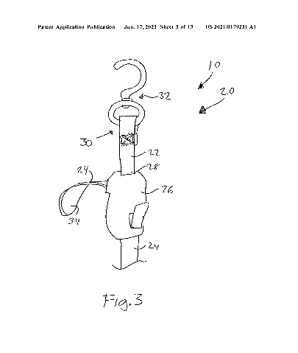

Dates and Legal

Priorities - US201962949415P·2019-12-17; US202017125877A·2020-12-17

Application - US202017125877A·2020-12-17

Publication - US2021179231A1·2021-06-17

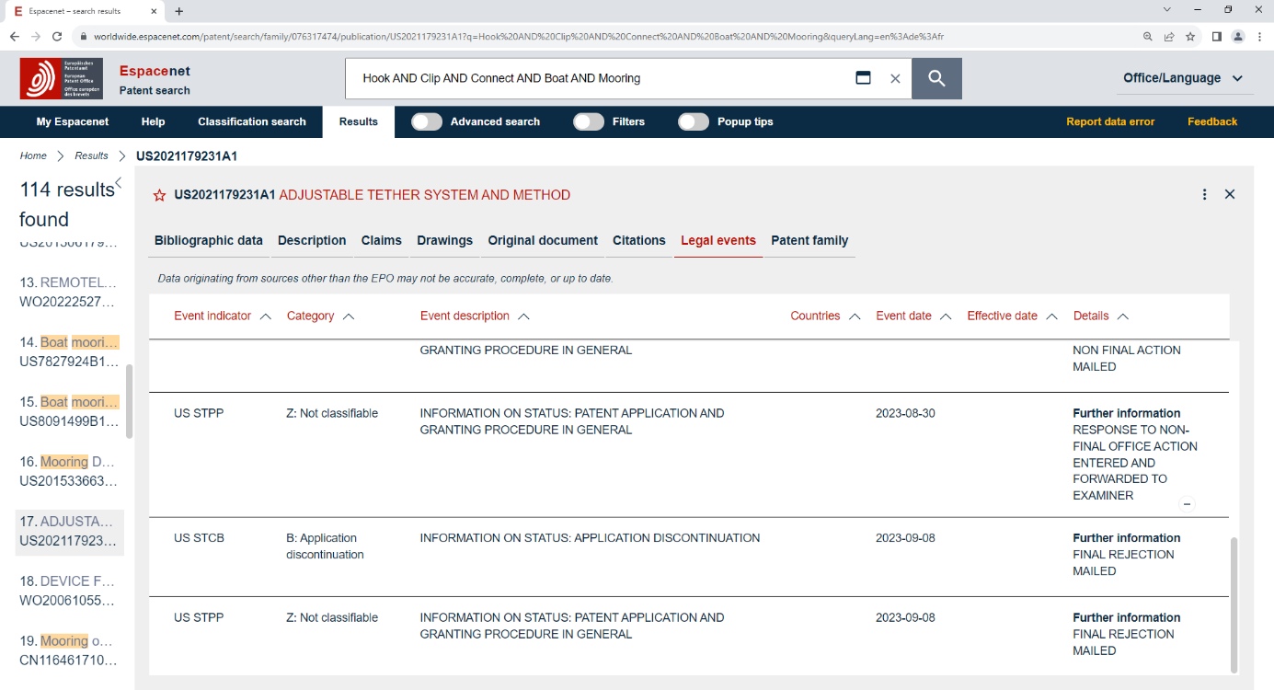

The legal events for this patent show that it was discontinued earlier this year (2023-09-08). This is very fortunate for this project as the timing of discontinuation corresponds with the timescale of this project, allowing us to use this design should we decide to.

Independent Claim(s)

Claim 1:

This claim describes an adjustable tether system comprised of two straps connected by a length adjustment device. The first strap is removably attached to a boat and the second strap is removably attached to a separate object.

From the abstract and figures, it appears this design uses flexible material and knots/loops to function. This is difficult to automate due to the dynamic nature of these types of systems. However, if the tether length adjustment could be automated, this would be a very useful design as the length of the projectile’s connection could be set before launch to ensure there ‘s no over-shooting.

Claim 5:

This claim describes a process of operating an adjustable tether system connected to a boat. The process requires the device from claim 1, a boat, a boat fender, removably connecting between first attachment device and boat fender, removably connecting between second connection device and boat, and setting adjustable tether to desired length.

This claim is unusual as it appears to describe the context and usage of the device named in claim 1, as opposed to a physical or conceptual device. In order to not infringe this claim, the project can attempt to not infringe claim 1, as the device is listed as a requirement for this claim’s process.

Claim 11:

This claim is near identical to claim 5, except it specifies the other object is a mooring device.

This claim can also remain uninfringed if claim 1 is not infringed, as the process requires the device listed in claim 1.

Summary

There is no worry of infringement as mentioned within the Dates and Legal section. While the concept of this design could be useful, the technical drawings and figures are simplistic to the point of not being usable. The principles can be extrapolated but no technical data can be taken. Some examples of the figures are shown below:

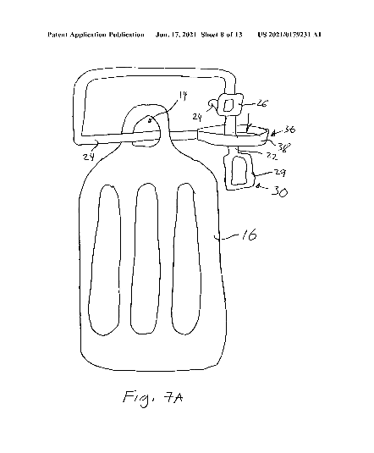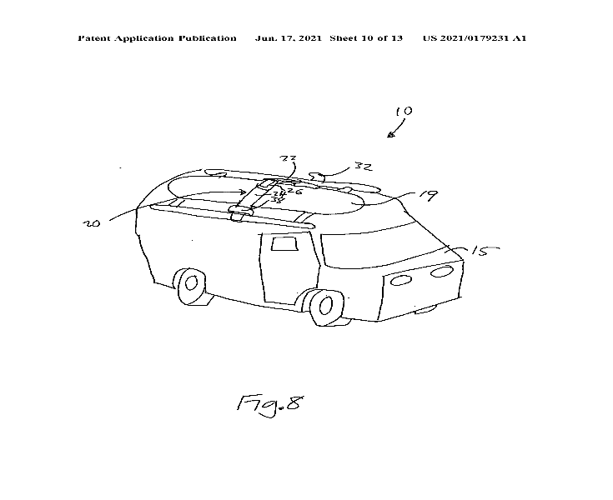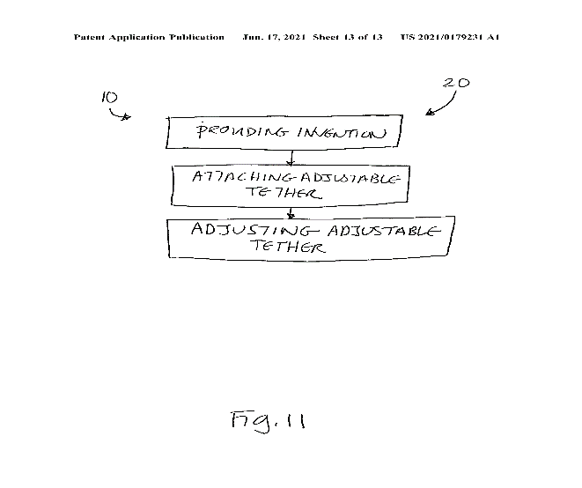

## Patent #8

It should be noted that this final patent was discovered during a different keyword search (“ “). However, the relevancy to this section means it should be analysed as part of the connection patent landscape.

[**CN102666268A**](https://worldwide.espacenet.com/patent/search?q=pn%3DCN102666268A) Mooring retrieval device

Applicants - LAWRENCE GOLDING PHILIP

Inventors - LAWRENCE GOLDING PHILIP; JOSEPH KHOURY EDWARD

Abstract

*“A* ***mooring*** *retrieval device (10) for retrieving a* ***mooring*** *rope (14) in water, the device comprising a buoyant member (12) adapted to be tethered to the end of the* ***mooring*** *rope (14). An elongate retrieval member (16) having an end (18) adapted to engage with the buoyant member (12) whereby, in use, the end of a* ***mooring*** *rope (14) tethered to the buoyant member (12) can be more easily retrieved. Advantageously the end (18) of the retrieval member (16) engages with the buoyant member (12) by magnetic attraction.”*

Relevant Figure(s)

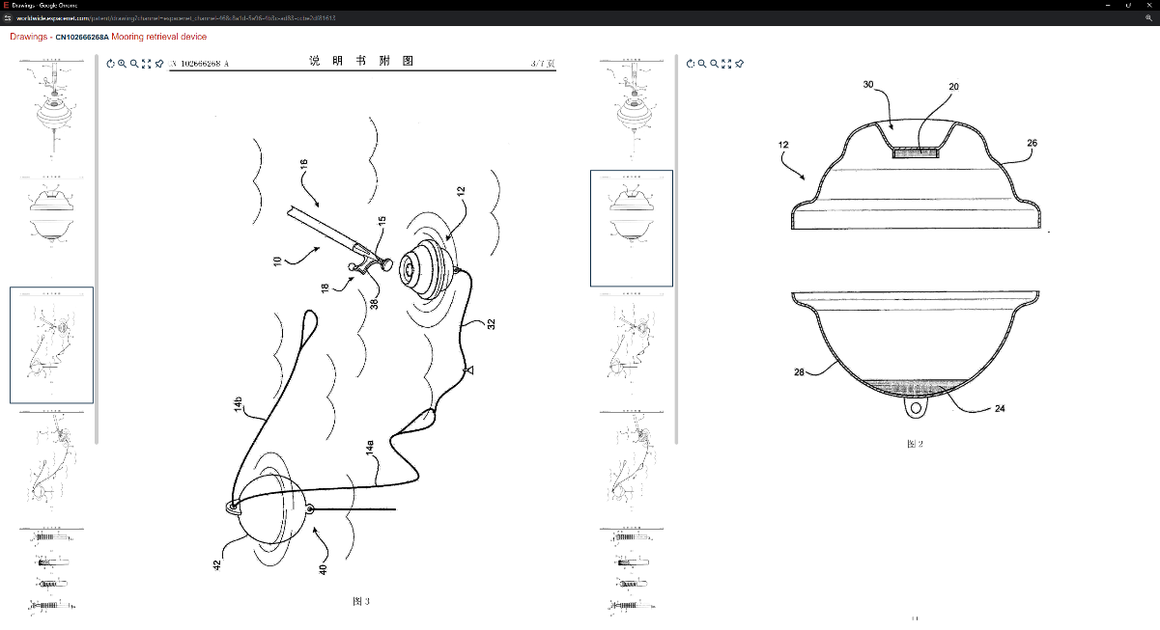

Dates and Legal

Priorities - AU2009904933A·2009-10-09; AU2010001336W·2010-10-11

Application - CN201080054008A·2010-10-11

Publication - CN102666268A·2012-09-12

Published as - AU2010305334A1; CN102666268A; EP2485939A1; US2013052893A1; US2014364021A1; WO2011041853A1



This legal event history shows that despite being published worldwide (WO2011041853A1), it was placed under examination soon after (CN C10) and was deemed invalid some years later (CN CO2). This means that the design holds no patent protection and cannot be infringed upon.

Independent Claim(s)  
It should be noted that the following claims have been translated by a machine. Also, it appears the formatting of the claims was done incorrectly, as most of the claims listed as independent require a previous claim. All listed independent claims will be analysed, with any requiring a previous claim being mentioned, but assumed dependent.

Claim 1:

This claim describes a mooring retraction device for reclaiming a mooring rope in water. The device is comprised of a floating member, and a retracting member engaged with the floating member.

Claim 8: This claim describes the mooring retraction device as claimed in any one of the preceding claims.

Claim 10: This claim describes the mooring retraction device as claimed in any one of the preceding claims.

Claim 13: This claim describes the mooring retraction device as claimed in any one of claims 2-12.

Claim 14: This claim describes the mooring retraction device as claimed in any one of claims 2-13.

Claim 16: This claim describes the mooring retraction device as claimed in any one of the preceding claims.

Claim 18:

This claim describes an end piece of a mooring retraction device, where the end piece is adapted to engage with a floating member tethered to a mooring line.

Claim 25: This claim describes an end piece according to any one of claims 19-24

Claim 26: This claim describes an end piece according to any one of claims 19-24

Claim 28: This claim describes a mooring retraction device that is substantially described or referenced by any one or more of the drawings.

Claim 29: This claim describes an end piece that is substantially described or referenced by any one or more of the drawings.

Claims 1 and 18 appear to be the independent claims, where a device comprised of a retraction member, a floating member, and an end piece is constructed, with the intention of retrieving a mooring line. These three components of the device, along with the function, are required for our project. The vagueness of these claims make them difficult to not infringe if used.

Summary

The concept of a separate floating device attached to the buoy, with the intention of making an easier platform to connect is a valid approach for this project. However, it should be noted that the current design involves a modified buoy as opposed to a separate body. If this approach changes to the design showed in this patent, infringement would not be an issue as the patent has been withdrawn.

# Guidance

## Search Strategy #1

To effectively search for relevant patents, keywords are used inside of ‘espacenet’ to filter out the relevant from the irrelevant patents. The summery of the component is “A guidance system for an automatic boat mooring system using infrared cameras and laser range finders”

Using key words from the description, search terms were taken as seen in the results list below. Each search got closer to a manageable number, but going too far caused the searches to be irrelevant.

Boat AND Mooring – 13 924 Results

Boat AND Mooring AND Sensor – 2101 Results

Boat AND Mooring AND Sensor AND Automatic – 909 Results

Boat AND Mooring AND Sensor AND Automatic AND Guidance – 155 Results

Boat AND Mooring AND Sensor AND Automatic AND Guidance AND Infrared – 50 Results

Boat AND Mooring AND Sensor AND Automatic AND Guidance AND Infrared AND Laser – 35 Results

The end search number of patents ended up being 35, this is a manageable number to work with, small enough to read them all, large enough that there will be some relevant patents included.

## Patent #1

[**ES2387144A1**](https://worldwide.espacenet.com/patent/search?q=pn%3DES2387144A1)System for guiding an unmanned vehicle towards a platform using visual analysis

Applicant(s) - UNIV MADRID COMPLUTENSE [ES]; UNIVERSIDAD COMPLUTENSE DE MADRI

Inventor(s) - DE LA CRUZ GARCIA JESUS MANUEL [ES]; SANCHEZ BENITEZ DAVID [ES]; PAJARES MARTINSANZ GONZALO

Abstract

*“The invention relates to a device and system for the take-off and landing of unmanned aerial vehicles or the berthing and unberthing of unmanned vessels, using visual analysis methods. The solution consists of a design for a platform containing a geometric figure having unusual characteristics. The image of the platform is obtained using a digital camera located on board the unmanned vehicle and connected to a device provided with image-processing means, allowing the orientation and relative position of the vehicle and platform to be obtained using the figure claimed.”*

Relevant Figure(s)



Dates and Legal

Priorities - [ES201001592A·2010-12-20](https://worldwide.espacenet.com/patent/search?q=ap%3DES201001592A)

Application - ES201001592A·2010-12-20

Publication - ES2387144A1·2012-09-14

The patent was granted in 2013 but only in Spain. No further legal data can be found on espacenet, due to this, the assumption is the patent is still in effect as its still within its 20 years cover.

Independent Claim(s)

The claims formatting seems to have gone wrong on this patent as all claims are added to one claim. In the appendix the whole claim is copied as one claim, but for analysis, where there are incrementing numbers or reference to another claim, these will be assumed to be separate claims.

Claim 1:

This claim describes a process of taking images on a landing area, and extracting the area where the pattern that it’s looking for is located. Then running some image processing on the image to determine where the centre of mass of the pattern is. This will give an x and y coordinate of where the unmanned vehicle should land.

This claim is close to our proposed guidance system in the sense that it will be looking for a specific pattern and finding the x and y coordinates, but our system will not be an unmanned vehicle and it will not be an aerial vehicle. These points mean we will not infringe on this claim.

Summary

There isn't a worry about infringing on this patent as looking at the claims this patent is made for an unmanned aerial vehicle not a manned boat. The patent is only in effect in Spain so even if there were infringements, as long as the project isn't sold in Spain, then there would be no problems.

## Patent #2

[**WO2020070529A1**](https://worldwide.espacenet.com/patent/search?q=pn%3DWO2020070529A1) A Method to enable autonomous guidance of vehicles

Applicants Ralph Thomas [CN]

Inventors Ralph Thomas [CN]

Abstract

*“This Invention is a method to enable autonomous guidance of a vehicle, employing radio frequency identification (RFID) as the medium of communication and enabled by an apparatus of º two- way RFID transmitter- receivers mounted on the vehicle, º RFID tags and beacons in the environment, º an onboard processor to translate environmental data input into vehicle control output and º a protocol for the formatting and transmission of system data.”*

Relevant Figure(s)

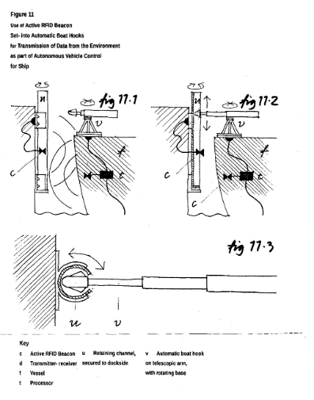

Dates and Legal

Priorities - IB2018000712W·2018-10-05

Application - IB2018000712W·2018-10-05

Publication - WO2020070529A1·2020-04-09

The patent was filed for World coverage, but at the end of 2021 the patent office couldn’t find who was filing the patent. And at the start of 2022 the patent was rejected in Europe due to the time running out to file it. So, if this patent does cause infringements, then it would be okay as long as the project stays within Europe.

Independent Claim(s)

Claim 1:

This claim states that the patent is a method to enable guidance of a vehicle using RFID for communication with other vehicles or with beacons in the environment controlling other systems.

Our project uses communication to activate buoys when at a close range, much like this patent. But unlike this patent we won't be using RFID.

Summary

The project won't infringe on this patent as not only will we be inside Europe where this patent won’t be in effect, the patent itself only talks about RFID communications, whereas the shown applications show a boat mooring system that contains an RFID transmitter receiver inside itself so it can be automated, the idea is a good one, but isn’t the point of the patent.

## Patent #3

[**US11711135B1**](https://worldwide.espacenet.com/patent/search?q=pn%3DUS11711135B1)Nautical ground station

Applicants - GAJJAR NEHAL [US]; FLEMING ALEXANDER JACQUES [US]

Inventors - GAJJAR NEHAL [US]; FLEMING ALEXANDER JACQUES [US]

Abstract

“An unmanned mobile communication station is adapted for location in a marine environment and includes a platform adapted for flotation or is semi-submersible, a communication node for sending and receiving wireless signals, a power system for energizing said communication node, a data center, at least one sensor for detecting the geolocation of the platform; and a processor for receiving signals from said sensors and controlling communication to and from communication nodes wherein embodiments include both autonomous and remote controlled navigation and propulsion systems.”

Relevant Figure(s)

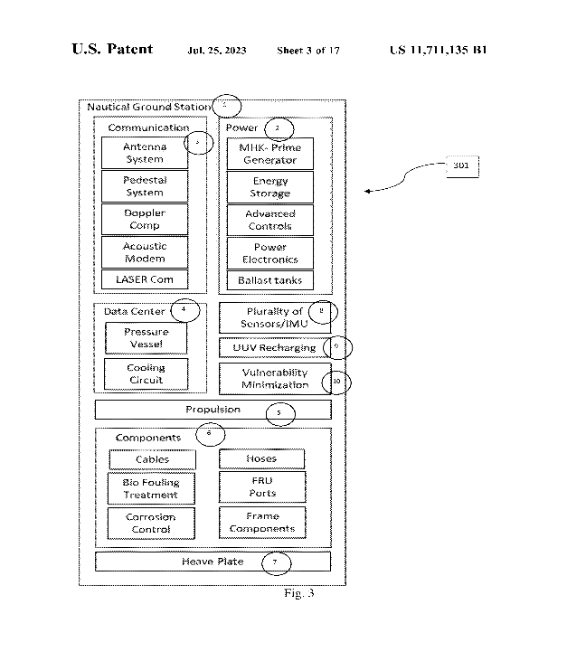

Dates and Legal

Priorities - US201962945892P·2019-12-10; US202017118513A·2020-12-10

Application - US202017118513A·2020-12-10

Publication - US11711135B1·2023-07-25

This patent was granted in the US, and the latest payment was 2023-01-19. With no further events, this patent is still in use and maintains all legal protections of a patent. However, it should be noted that the patent was Applied for in 2020-12-10, which means that more than 31 months have passed. This means that the patent cannot become a European patent as the time for application has expired.

Independent Claim(s)

Claim 1:

This claim describes a network comprising of multiple unmanned mobile communication stations, adapted for marine environments. Each station is comprised of A floatation/semi-submersible platform, a wireless communication node, a power system for said node, a data center, one or more sensors for geolocation of said platform, a signal processor, a propulsion system for moving/maintaining said station. The collection of stations form a mesh network, including antennae for satellite signals in Low Earth Orbit, Medium Earth Orbit and Geostationary Satellites.

The application and usage of this system is similar to the project’s application, however some details made within the claim ensure that infringement will not occur. For example, this project will use local communications rather than global signals, and no propulsion system is used.

Summary  
Due to some of the specifics of the independent claim, and the application timeline, infringement cannot occur proving this project does not reach the US. The networking and system specifications found in the figures may be useful to this project if scaled down with smaller systems.

Search Strategy #2  
From here on, the search strategy has been changed slightly, the search terms Laser and infrared were removed to broaden the search as remaining patents were irrelevant. Removing these search terms opened up the results to 115. The new search terms are “Boat AND Mooring AND Sensor AND Automatic AND Guidance”

## Patent #4

[**WO2022239580A1**](https://worldwide.espacenet.com/patent/search?q=pn%3DWO2022239580A1) Mooring System and Mooring Method

Applicant(s) - KAWASAKI HEAVY IND LTD [JP]; 川崎重工業株式会社; KAWASAKI JUKOGYO KABUSHIKI KAISHA

Inventor(s) - OE HIROSHI; KAZAMA EIKI; NODA TAKASHI; 大江　啓司; 風間　英輝; 野田　嵩; OE, Hiroshi; KAZAMA, Eiki; NODA, Takashi

Abstract

*“This mooring system is for mooring a floating structure to a mooring facility, one of the floating structure and the mooring facility serving as a first object and the other as a second object. The mooring system comprises: a mooring line; a winch provided to the second object and enabling the mooring line to be wound up and drawn out; a locking tool provided to the second object and detachably engaging with the tip section of the mooring line; at least one unmanned craft having a holding tool for holding the mooring line; and a control device for controlling the unmanned craft so as to move, while holding the mooring line, from the second object toward a mooring post disposed on the first object and to hook a section of the mooring line midway between the tip section and a base section drawn out of the winch.”*

Relevant Figure(s)

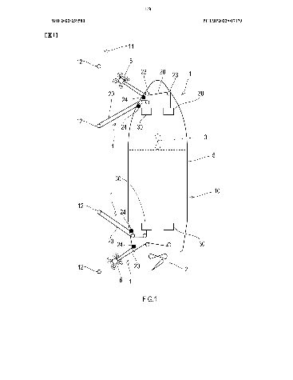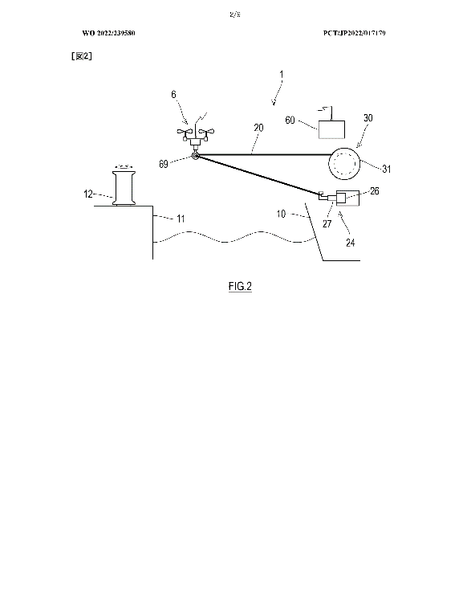

Dates and Legal

Priorities - JP2021082667A·2021-05-14

Application - JP2022017179W·2022-04-06

Publication - WO2022239580A1·2022-11-17

This patent is a worldwide patent but is still in the filling phase. It should be treated as granted until said otherwise. This patent could show some problems when it comes to the claims and would be enforceable due to it only just being filed in 2023.

Independent Claim(s)

The claims tree seems to be a bit messed up for this patent, so some dependent and independent claims might differ from the tree. As well as some of the claims not having finished text, these claims seem to mostly be dependent claims, so it isn’t too much of a problem.

Claim 1:

This claim talks about the mooring lines attached to the mooring facility and an aerial vehicle that will carry the mooring lines to the mooring facility. There is a winch system to wind and withdraw the mooring lines and a lock to engage the mooring lines.

This claim won't affect our project as it is based around an aerial unmanned vehicle, basically a drone. Our project doesn’t use drones to moor, therefore this claim doesn’t conflict with our project.

Claim 2:

The second claim talks about the device on the boat tensioning the line that the drone has already placed while it places the second mooring line.

Our project doesn’t use drones, so this point isn’t conflicting. Our project doesn't connect the mooring lines either so there is no need to tension the lines already connected either.

Summary

Looking at the Claims and legal the project will not infringe on this patent due to the project not utilising drones or a tensioning system for the lines. This patent is also still in the reviewing phase so it might not get accepted, but assuming it get accepted our project is still safe.

## Patent #5

[**KR102063735B1**](https://worldwide.espacenet.com/patent/search?q=pn%3DKR102063735B1) GUIDANCE SYSTEM AND METHOD FOR DOCKING OF SHIP

Applicant(s) - 한국전자통신연구원

Inventor(s) - 마진석; 김도형

Abstract

It should be noted this abstract was translated by a machine.

*“The present invention relates to an automatic berthing device for a ship, comprising a beacon transmitter (300, 301, 302) installed at the dock (20), information on the final location (303) where the ship (10) will be anchored, and an entry route (304). A radio signal station 400 that transmits information to the ship 10, corrects the current path, appearance, and location information of the ship 10 and retransmits it to the ship 10, and GPS receiving modules (100 to 106) that are installed and receive signals from the beacon transmitters (300, 301, 302) and the wireless signal station (400), and the final location and entry route corrected from the GPS receiving modules (100 to 106) It relates to an automatic berthing device and method for a ship, which consists of a berthing control device 210 that controls the direction and speed of the ship 10 according to information, and allows automatic, rapid and accurate berthing “*

Relevant Figure(s)

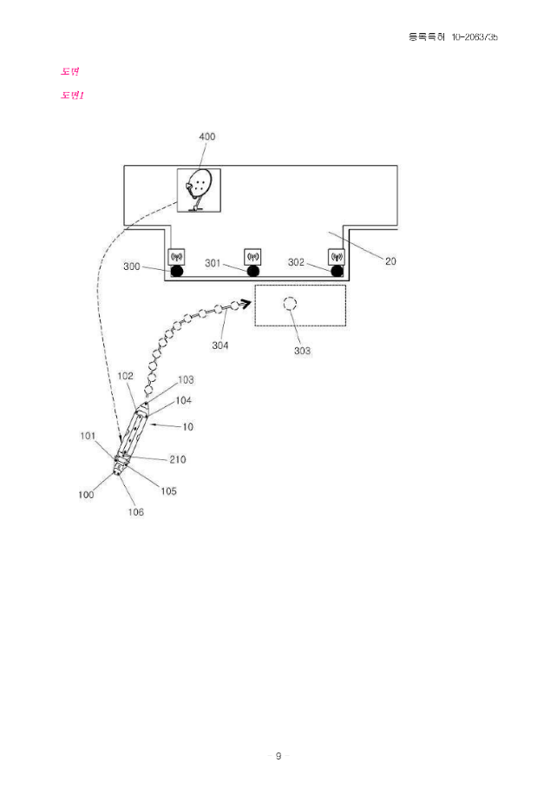

Dates and Legal

Priorities - KR20120146401A·2012-12-14

Application - KR20120146401A·2012-12-14

Publication - KR102063735B1·2020-01-09

Published as - KR102063735B1; KR20140077509A

This patent is currently in use and protected under patent law. However, the patent was applied for in 2012-12-14, meaning the timeframe for international application (31 months) has long expired. This means that as long as this project does not extend to Korea, no infringement will occur.

Independent Claim(s)

It should be noted that the following claims were translated by a machine.

Claim 1:

This claim describes a beacon signal transmitted from a unit at the edge of a boat and a unit installed at the pier. The final position for the boat is known by the pier unit. GPS receivers are used for receiving location information of the boat to match to a planned path. An eyepiece control device is configured to display the GPS modules’ data.

As this project is not using GPS, this claim will not be infringed. The use of a predicted path of entry is an interesting idea, which may be useful for a similar project of larger scope (e.g. cargo ships), where mooring and docking requires much more planning and calculations as opposed to a single-person boat.

Claim 5:

This claim describes a radio signal station that compares the position of the pier with the GPS geographical location of the boat. This station determines the necessary speed and direction of the ship to dock.

Similar to claim 1, a larger scoped project may require this form of path planning, however this project aims to do the majority of computing on-board the boat as opposed to the pier, meaning no land-based radio station would be made for calculations.

Claim 8:

This claim describes an automatic anchoring system that communicates with the GPS systems to ensure anchoring occurs at the correct location.

This project is focused on an automatic mooring system as opposed to an anchoring system, however the aim of the two systems are similar, so a method of deployment upon reaching a determined distance will be needed for this project. A method similar to this design could be used providing it does not use GPS communications.

Summary

While this patent is in use, the dates and legal section describes why infringement is not an issue. The main difference between this patent and our project is that we intend to do the calculations and predictions on-board as opposed to on-land. However, the principles and methods are similar, meaning this design and method may be partially used in our project.

## Patent #6

[**US7721666B1**](https://worldwide.espacenet.com/patent/search?q=pn%3DUS7721666B1) Hull-mounted line retrieval and release system

Applicant(s) – US Navy[US]

Inventor(s) – Sovel James E[US]

Abstract

*“A line retrieve-release system is provided for mounting on the hull of a boat. Jaws are coupled to the hull of the boat and face substantially aft relative to the boat's bow. The jaws are capable of movement between a partially open position defining the system's “line retrieve” position and a fully open position defining the system's “line release” position. A latch coupled to the jaws is biased to cooperate therewith in the partially open position to thereby define a first enclosed region bounded by the jaws and latch. The latch permits one-way entry into the first enclosed region when a force is applied to the latch from outside of the first enclosed region. Line catch means are coupled to the hull of the boat aft of the jaws. The line catch means combines with the jaws in their partially open position to define a second enclosed region adjacent to the first enclosed region. The line catch means permits one-way entry to the second enclosed region when a force is applied thereto from outside of the second enclosed region. Actuator element(s) are coupled to the jaws to move them to their fully open position to thereby open both the first and second enclosed regions. The actuator elements also allow the retrieve-release system to reset to its “line retrieve” position.”*

Relevant Figure(s)

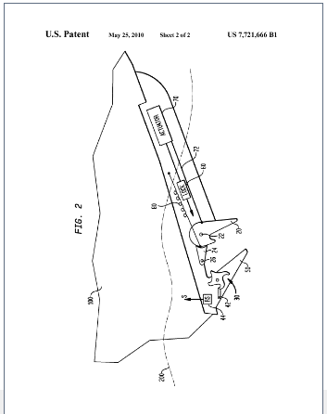

Dates and Legal

Priorities - US97398507A·2007-09-25

Application - US97398507A·2007-09-25

Publication - US7721666B1·2010-05-25

The patent expired in mid 2014 due to the failure to pay maintenance fees, this means that the patent will definitely not conflict with our project. The patent was local to the US so even if it were still in effect today, as long as the project isn’t sold in the US it would still be fine according to the legals.

Independent Claim(s)

Claim 1:  
This claim talks about the hooking mechanism on the side of the boat. It states that the mechanism has two states, the jaw open and ready to catch the lines, and closed when it has caught the line. The catching system is one way meaning without manually releasing the line, it will stay caught.

This is an interesting idea and could be used as an automatic boat mooring system but seems to require the boat to go over a rope to attach to it. If this system misses, then the line could just get caught in the props rather than the connection area, causing more problems than fixing. In the context found, it is more of a hooking system than a guidance system, so it won't conflict with our project.

Claim 6:

This claim talks about the opening of the mechanism in claim 1, so will have the same outcome as claim 1. This will not conflict with our project.

Claim 8:

Claim 8 talks about the rotational movement of the mechanism in claim 1. This again states the same function as claim 1, so will not conflict with out project idea.

Summary

In summary, this patent will not cause problems for our project as the claims talk about a hooking mechanism attached to the side of the hull rather than an automatic guidance and hooking system like our project. The patent has also expired due to no payments being made on it; this means that even if it conflicted it wouldn’t affect the project.

## Patent #7

[**JP2021011263A**](https://worldwide.espacenet.com/patent/search?q=pn%3DJP2021011263A) PROXIMITY SENSING SYSTEM AND METHOD FOR MARINE VESSEL

Applicant(s) - BRUNSWICK CORP

Inventor(s) - TRAVIS C MALOUF; AARON J WARD; MATTHEW E DERGINER

Abstract

*“To provide a proximity sensing system intelligently classifying vicinity measurement data, implemented with simplified vessel shape in order to place priority order, and used for controlling an autonomous or semi-autonomous vessel.SOLUTION: A proximity sensing system on a marine vessel includes one or more proximity sensors in positions of sensors each at a sensor location on the marine vessel and configured to measure proximity of objects and generate proximity measurements. A sensor processor is configured to: store a two-dimensional vessel outline of the marine vessel with respect to a point of navigation for the marine vessel; receive the proximity measurements measured by one or more proximity sensors on the marine vessel; and identify four linearly-closest proximity measurements to the two-dimensional vessel outline, including one closest proximity measurement in each of a positive X direction, a negative X direction, a positive Y direction, and a negative Y direction. The processor then generates a most important object (MIO) dataset identifying the four linearly-closest proximity measurements.SELECTED DRAWING: Figure 6”*

Relevant Figure(s)

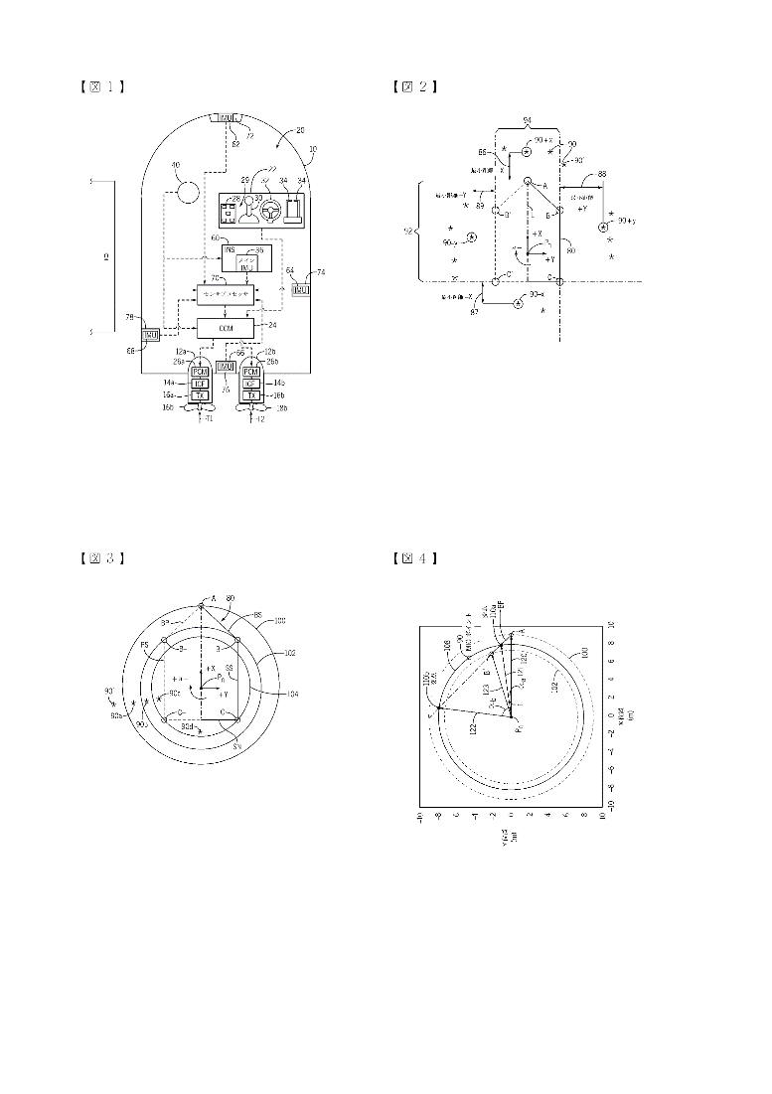

Dates and Legal

Priorities - US201862770513P·2018-11-21; US201916674908A·2019-11-05

Application - JP2020172164A·2020-10-12

Publication - JP2021011263A·2021-02-04

Published as - EP3657214A1; EP3657214B1; EP4119981A1; JP2020097406A; JP2021011263A; J P6779356B2; US11443637B2; US2020160726A1; US2022383754A1

The legal events for this patent is dense and difficult to understand. It would appear that this patent was filed in Japan, then attempted to go international, then was denied in Japan (JP2021011263A - JP A131 – NOTIFICATION OF REASONS FOR REFUSAL 2023-09-26)) but accepted in other districts (EP3657214A1 - GB FG4D – EUROPEAN PATENT GRANTED 2022-09-28). Unless it is explicitly stated elsewhere, it will be treated as a valid European patent, with all legal protections included.

Independent Claim(s)

Claim 1:

This claim describes one or more proximity sensors on a marine vessel, each placed at locations to generate a 2D image of the vessel along with distance measurements. The 2D image is stored on a memory processor, and the distance measurements are used to understand the surroundings.

As we have no intention of storing any significant data, we can avoid infringement by not requiring a 2D image of the boat, just a side of the boat and any necessary measurements.

Claim 8:

This claim describes a method of operating a proximity sensor system on a marine vessel. A 2D image of said marine vessel is processed using this system and a common reference system for navigational points is generated.

This claim describes a system similar to Claim 1. Providing that the project does not generate and store a 2D contour outline of the marine vessel, this claim will not be infringed and any other points

Claim 9:

This claim describes how the 2D contour outline of the vessel will contain a pentagonal cartesian point to be considered as the navigational point. This will be defined by a front point, a starboard corner point, a port corner point, a starboard rear point, and a port rear point.

While our system may use either use two starboard points OR two port points, it will not require all five points listed above. This means we may use the methods and principles listed for a single side (depending on mooring direction) of the boat without infringement.

Claim 16:

This Claim describes the processor defining the outer yaw circle as a circle with radius of the distance between navigation point and front point of the ship contour. A number of intersections between circles defined between the navigation point and the additional points fully define the proximity system.

While this claim appears to be a dependent claim, it will be analysed as it is listed as independent. This claim is more related to object awareness and avoidance rather than mooring and docking. The navigational point for this project will be the midpoint of a line (midpoint of each launcher) rather than a pentagon, thus avoiding infringement.

Summary

While this project is a valid European Patent, infringement can be avoided as we don’t require the full outline of the vessel for our project. Should we choose to use the system described by this patent, care will be needed to ensure the system does not develop into the patented system, as this would go from acceptable to infringement.

# Overall

## Search Strategy

To find patents relevant to the boat mooring system a key term can be derived to describe the design and operation. The term used:

“A boat/yacht mounted, automatic mooring system using an infrared camera to identify buoys, laser for range estimation and a spring launcher to retrieve a bridal line.”

From this term the key words were selected and used to search for patents on Espacenet.

Yacht OR Boat AND Automatic AND Mooring – 2549 Results

Yacht OR Boat AND Automatic AND Mooring AND Infrared – 225 Results

The number of patents is still very high, however attempting to refine the search further caused related patents to be overlooked and an increase in the number of patents that fell out of the scope of the project. Therefore, the patents from this search have been manually looked through and only patents relating to the project have been analysed.

## Patent #1

[**US2022198342A1**](https://worldwide.espacenet.com/patent/search?q=pn%3DUS2022198342A1)Method and device for detecting mooring and monitoring of a navigable area

Applicant(s) – LADOUX JEREMY (FR)

Inventor(s) – LADOUX JEREMY (FR)

Abstract

*“The device for detecting* ***mooring*** *in a navigable area comprises: means for detecting the presence of a* ***boat*** *close to a berthing member or attached to said berthing member, means (56) for transmitting information representative of the detection performed and means (59) for transmitting a request (58) to a communicating portable terminal (56) associated with the user of the* ***boat*** *of which a movement has been detected, in order to receive, in return, an envisaged duration of presence of the boat in the navigable area.”*

Relevant Figure(s)

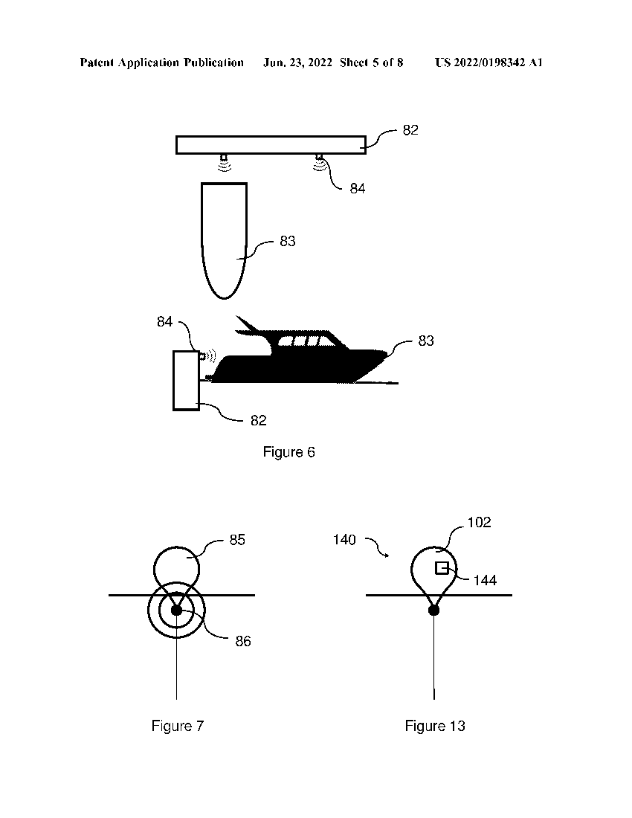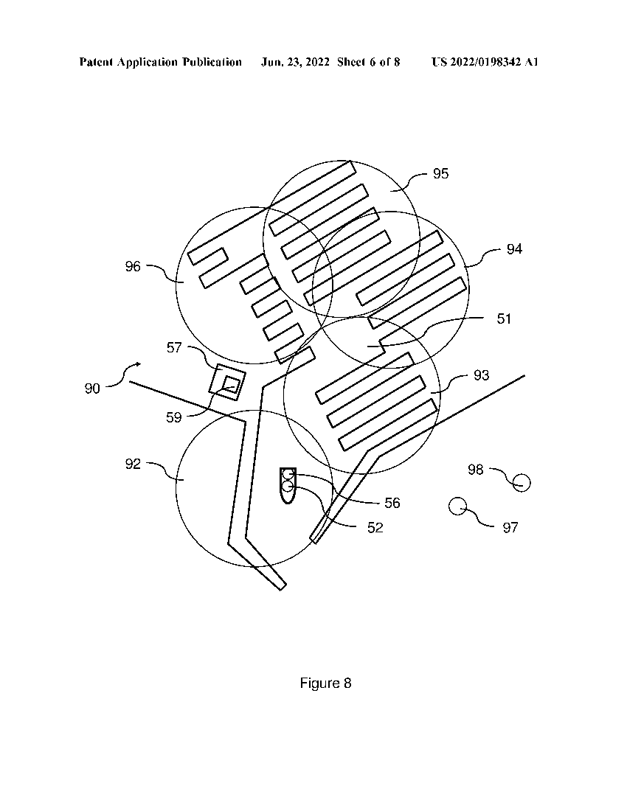

Dates and Legal

Priorities – FR1759958A·2017-10-23; FR1762548A·2017-12-19; FR2018052627W·2018-10-22

Application – US201816763996A·2018-10-22

Publication – US2022198342A1·2022-06-23

The patent was discontinued in 2022 due to a failure to respond to the Patent Office and therefore the designs can be used without infringement.

Independent Claim(s)

Claim 18:

The only independent claim for this patent describes a network of devices within a set area that detects if a boat is near or attached to a berthing member. This information is sent to a database which can be accessed, through a mobile device, by the operator of the boat and input how long they are intending to stay in the set area.

The idea of detecting the boats from an external position as opposed to detecting an external position from the boat is a useful concept for the project however the scope of this patent seems to be focused on logging boats within a space and so the rest of the patent is unrelated.

Summary

There is no risk of infringement on this patent due to the scope of the project and patent not aligning and so there would only be slight overlap in claims. This is on top of the fact that the patent is filed in the US and could be avoided and that the patent has been discontinued.

## Patent #2

[**CN105744229A**](https://worldwide.espacenet.com/patent/search?q=pn%3DCN105744229A) Unmanned ship automatic anchoring system and working method thereof based on integration of infrared and panoramic technologies

Applicant(s) – UNIV JIANGSU SCIENCE & TECH

Inventor(s) – LI YUANJIANG; HUANG YAPING

Abstract

*“The invention discloses an unmanned ship* ***automatic*** *anchoring system based on the integration of* ***infrared*** *and panoramic technologies. The system comprises an unmanned ship centralized control system and a shore base control system. Four* ***infrared*** *and visible light dual-channel monitoring cameras installed around the unmanned ship are used for acquiring the photographic field information around the unmanned ship, the visible light and* ***infrared*** *images are integrated by using a uniform search wind model, and finally the integration results in the four directions are jointed together, thus a spread* ***infrared*** *panoramic image is formed. At last, the unmanned ship centralized control system delivers the unmanned ship position, the motion trail information, the integrated panoramic image and the barrier information to the shore base control system. The operator judges the anchoring location of the unmanned ship, and corrects the motion trail of the unmanned ship. According to the system, the wide* ***infrared*** *and visible light viewing angle monitoring based on light intensity information can be achieved, the convenience is provided for monitoring the ambient of the unmanned ship, and meanwhile the system makes up the limitation of the unmanned ship in night anchoring.”*

Relevant Figure(s)

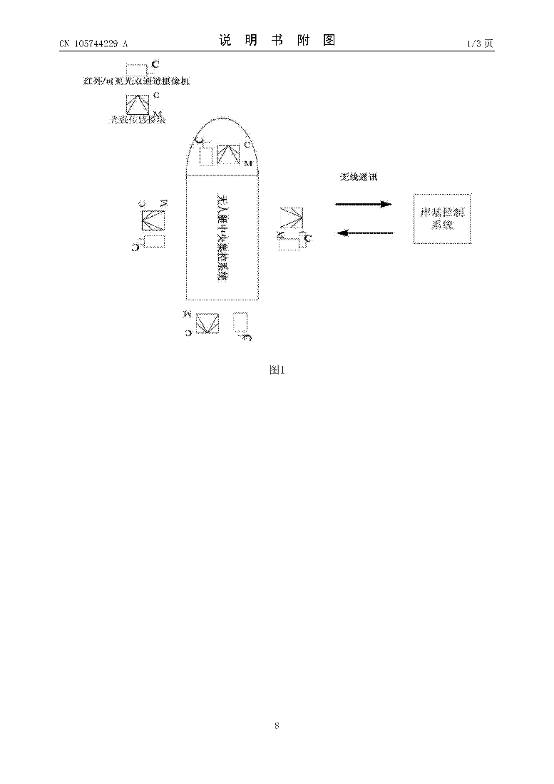

Dates and Legal

Priorities – CN201610104897A·2016-02-25

Application – CN201610104897A·2016-02-25

Publication – CN105744229A·2016-07-06

The rights of this patent were transferred in 2019 however it appears this patent is still valid. The patent has passed the 36-month window to be filed in other countries and so if there is any infringement then it will only be an issue in China.

Independant Claim(s)

Claim 1:

The independent claim of this patent describes a system for unmanned boats to moor using infrared panoramic view fusion. The main parts of the system are a vessel-based control system and a shore-based control system. The vessel system comprises of a variety of sensors, GPS, image processing, wireless communications, and most notably a dual-channel infrared and visible light surveillance camera. The shore system comprises of wireless communications, display module, and an alarm.

The components listed within this claim are close to those proposed to be used in the project. However, due to this patent using a “shore-based control system” and being designed for unmanned boats there is minimal risk of infringement on this claim.

Summary

This patent has a very similar scope to the project as both cover automatic mooring of boats. As well as the methods and components used with both designs using boat-based infrared cameras to gather information about the surrounding area. Beond this however, there are some important differences namely the patents use for exclusively unmanned boats, shore-based control system, the use of infrared cameras, and the large number of sensors used are all different to those to be used by the project. Therefore, despite the broad similarities between the patent and project, the specifics differ enough for there to be no risk of infringement.

## Patent #3

[**CN207799466U**](https://worldwide.espacenet.com/patent/search?q=pn%3DCN207799466U) Automation system of mooring a boat based on outboard engine

Applicant(s) – ZHEJIANG PAINIER TECH INC

Inventor(s) – YANG HUIMING; CHENG ZHIMING

Abstract

*“The utility model discloses an automation system of* ***mooring*** *a* ***boat*** *based on outboard engine relates to the* ***automatic*** *technical field that* ***moors*** *a* ***boat****, include: outboard engine assembly, hull,* ***infrared*** *draw gear and berth the point, the outboard engine assembly sets up on the hull, and* ***infrared*** *draw gear sets up under water, and* ***infrared*** *draw gear is used for guiding the hull accuracy stop point that traveles, be equipped with controller,* ***infrared*** *sensing devices and control connection portion on the hull, the outboard engine assembly includes controller wiring end and outboard engine operating means, the controller passes through the control outboard engine operating means of control connection portion, and the controller passes through control connection portion to be connected with controller wiring end electricity, and* ***infrared*** *sensing devices is used for responding to* ***infrared*** *draw gear's* ***infrared*** *signal, the utility model discloses an adopt* ***infrared*** *sensing and control techniqueto realize accurate reliable automation and* ***moor*** *a* ***boat****, have simple structure simultaneously concurrently, advantage that implementation cost is low, and the utility model discloses an automation system of* ***mooring*** *a* ***boat*** *based on outboard engine commonality is strong, can be applicable to multiple outboard engine.”*

Relevant Figure(s)

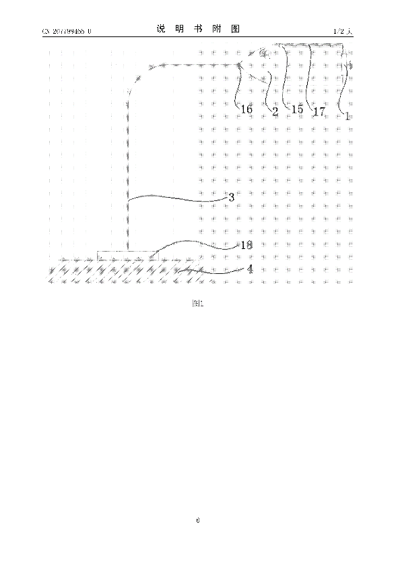

Dates and Legal

Priorities – CN201820152554U·2018-01-30

Application – CN201820152554U·2018-01-30

Publication – CN207799466U·2018-08-31

The patent was granted in 2018 and there have been no other legal events since. Therefore, the patent is still valid.

Independent Claim(s)

Claim 1:

The claim describes a system of controlling a boat equipped with an outboard motor using an infrared device and sensor positioned underwater. The infrared device and sensor are used to guide the boat to a stop. The boat is controlled by the “outboard operating device” with a terminal and controller for user input.

The design uses automatic control over the boat and positions the infrared sensor underwater which are not the case in our design meaning there is no risk of infringement on this claim

Summary

The patent is of Chinese origin and doesn’t seem to be translated accurately meaning the design is somewhat difficult to understand. Despite this the patent specifies the use of similar components and a similar scope to that of the project but implements them in different ways, for instance the way the infrared technology is used and where it is positioned on the boat. On top of this the patent seems to take direct control of the boat which is not within the scope of the project. Therefore, the patent and project are distinct enough to avoid any infringement.

## Patent #4

[**CN206557605U**](https://worldwide.espacenet.com/patent/search?q=pn%3DCN206557605U) Automatic system of berthing of unmanned ship

Applicant(s) – UNIV NANJING INFORMATION SCIENCE & TECH

Inventor(s) – LIU YUNPING; XU ZE; LIU JIA; LIU QINGSHAN; HU KAI; LI YU; JIANG XINGYU

Abstract

*“The utility model discloses an* ***automatic*** *system of berthing of unmanned ship is equipped with GPS send -receiver device, wireless communication device, electron compass, gyroscope, grey level camera, camera, controller, an ultrasonic sensor, power pack on the hull, be equipped with black discernment strip, grey colour discrimination strip on retrieving the location tablet of platform, retrieve the platform and still be equipped with and retrieve platform base, rear portion bracing piece, anterior bracing piece, motor, guide rail, cable, gasbag, second to the 3rd ultrasonic sensor, first to second* ***infrared*** *ray send -receiver device, pressure sensor. The utility model discloses an unmanned ship and the relative position who retrieves platform top location tablet are judged to the grey level camera to adjustment unmanned ship realizes smart accurate halt pool in the course, retrieve the collision protective film root tuber of platform and judge the dangerous condition such as whether unmanned ship can bump according to infrared ray and ultrasonic wave to whether open gasbag protection unmanned ship with this decision.”*

Relevant Figure(s)

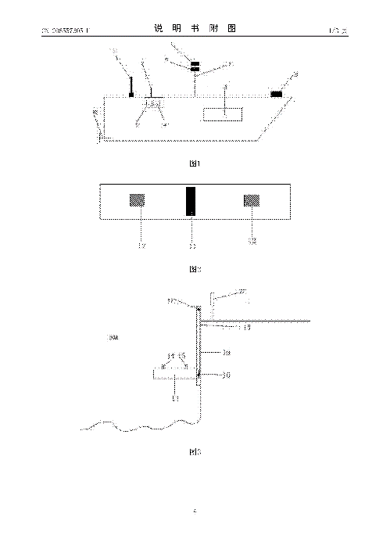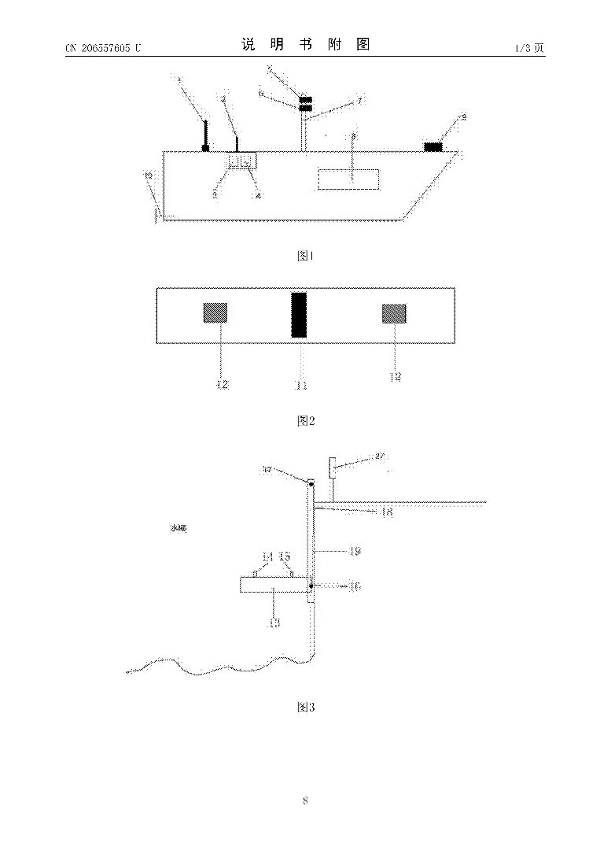

Dates and Legal

Priorities – CN201720255554U·2017-03-16

Application – CN201720255554U·2017-03-16

Publication – CN206557605U·2017-10-13

The rights of this patent were terminated in 2020 due to a failure to pay annual fees and therefore the designs can be used without infringement.

Independent Claim(s)

Claim 1:

The claim describes a system of parking unmanned boats using three main parts. An automatic positioning parking module, mounted on the boat, comprising of a controller, GPS, wireless communications, electronic compass, gyroscope, cameras, and a power unit. A positioning plate made up of one black and two grey identification strips. And the recovery platform, positioned at a waterfront junction, comprising of a base, four support rods, four pressure sensors, motor, guide rail, and cable. The controller communicates wirelessly with the recovery platform and receives data from the platform as well as controlling its lowering and raising along the guid rail which is driven by the motor winding the cable.

There are some similarities in components used between this claim and the project however the project does not use identification strips or a recovery mechanism. Therefore, there is no risk of infringement on this claim.

Summary

There were some common components across this patent and the project as well as a somewhat similar scope. Other than this there is minimal crossover with the patent having its focus on lifting the boat out of the water as opposed to mooring. It is also unclear as to how the infrared is used during the operation of the claims design. On top of this the patent in no longer enforced resulting in no risk of infringement.

## Patent #5

[**CN102085909A**](https://worldwide.espacenet.com/patent/search?q=pn%3DCN102085909A) Large-angle automatic docking device suitable for small-sized ship

Applicant(s) – UNIV JILIANG CHINA

Inventor(s) – BINRUI WANG; YINGLIAN JIN

Abstract

*“The invention relates to a large-angle* ***automatic*** *docking device suitable for a small-sized ship. The existing* ***automatic*** *docking device has the defects of complicated structure and high cost. In the invention, a distance-measuring ultrasonic sensor is installed on a bow lower than the deck of the ship; a circular chassis is installed on the deck of the bow; a motor for rotation is fixedly installed with the chassis; the output shaft of the motor for rotation is connected with a fixed plate; a motor for expansion, a screw rod, a pair of nuts and a barrier-measuring ultrasonic sensor are installed on the fixed plate; the motor for expansion drives the screw rod to rotate; the rotation of the screw rod can drive the nuts to make opposite or relative motion; the opposite or relative motion of the nuts causes the corresponding compression or elongation strain of a telescopic multi-link mechanism; the two top ends of the telescopic multi-link mechanism are fixed with a support plate in a rectangular clamp ring; and the barrier-measuring ultrasonic sensor is positioned right below the telescopic multi-link mechanism. The large-angle automatic docking device provided by the invention has the advantages of simple structure, low energy consumption, good stability and wider service range.”*

Relevant Figure(s)

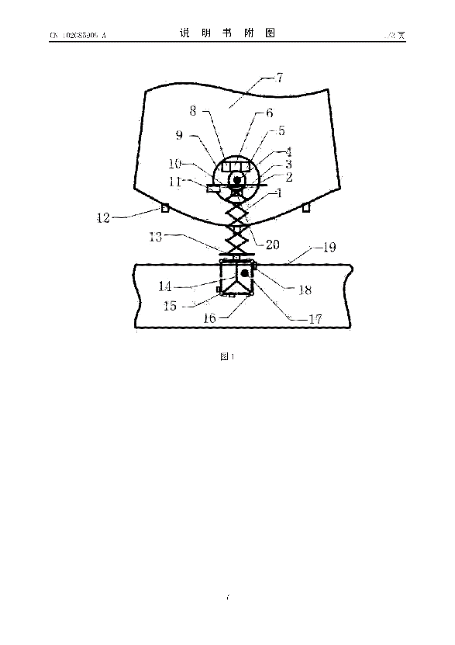

Dates and Legal

Priorities – CN201110008062A·2011-01-15

Application – CN201110008062A·2011-01-15

Publication – CN102085909A·2011-06-08

The last legal event of this patent was the “CESSATION OF PATENT RIGHT” meaning the patent is no longer enforceable and therefore the designs can be used without infringement.

Independent Claim(s)

Claim 1:

The claim describes a system that uses ultrasonic range sensors, an infrared sensor, and a retractable multi-linkage mechanism to dock small ships.

The ultrasonic range sensors are located at the bow of the ship below the level of the deck with a chassis housing a motor that rotates a plate on the deck itself. Attached to the rotating plate is the retractable multi-linkage mechanism and the motor that drives it. The retractable multi-linkage mechanism operates much like a scissor lift where the motor has a threaded output shaft which moves the struts and so extend or retract the mechanism. On the end of the retractable mechanism is a plate and attached to this is Y shaped support rib. Located on the edge of the plate and the top of the Y support are spring loaded hinges for gates that surround the support. Each set of gates is equipped with an infrared sensor and an electronic lock.

The ultrasonic range and obstacle avoidance, and infrared sensors are connected to the input of the control unit with the output connected to the motors.

This claim covers almost all aspects of the design. The scope and the outline of methods used in this claim are like that of the project namely the use of range sensors and that of deploying a device to attach to a mooring or docking area from the boat however there are differences in the specifics such as the project using a launcher and light-based range finders. Therefore, there is no risk of infringement on this claim.

Summary

The operation of this patent is very similar to that of the project with a user-controlled vessel equipped with sensors to guid in a deployment system to deliver a device that attaches to a mooring or docking point. The differences occur in the specifics of how this is achieved. Ultimately this patent is not enforceable and so there is no risk of infringement.

## Patent #6

[**KR20100072361A**](https://worldwide.espacenet.com/patent/search?q=pn%3DKR20100072361A) AUTOMATED DOCKING AND MOORING SYSTEM

Applicant(s) – CAVOTEC MSL HOLDINGS LTD (NZ)

Inventor(s) – MONTGOMERY PETER JAMES (NZ)

Abstract

*“A* ***mooring*** *system for receiving and exercising at least partial control over the approach of a vessel approaching a* ***mooring*** *facility. An array of* ***mooring*** *robots are mounted to the* ***mooring*** *facility. Each robot has at least one vessel contact member supported by a moving mechanism in a manner to thereby be movable relative to the* ***mooring*** *facility and presentable to engage the side of said vessel. A sensor can sense the position of the vessel relative the* ***mooring*** *facility. A processor can calculate movement instructions based on information received by the processor to calculate instructions for the movement of the contact member during the receipt of the vessel by the* ***mooring*** *system. A controller can preposition the contact member and then control the condition of each* ***mooring*** *robot such as to reduce the approach speed of the vessel at least in a direction towards the* ***mooring*** *facility.”*

Relevant Figure(s)

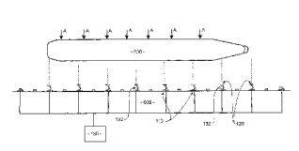

Dates and Legal

Priorities – NZ56278207A·2007-10-24

Application – KR20107011264A·2008-10-24

Publication – KR20100072361A·2010-06-30

The decision to refuse application was made on this patent in 2012 and therefore the designs can be used without infringement.

Independent Claim(s)

Claim 1:

The first claim describes a system of mooring using robots attached to a mooring facility via a moving mechanism which have a coupling mechanism that engages a ship. A sensing system used to establish the position of the ship and a sensing system to guide the mooring robots to the ship, and motion calculation to translate the guidance of the robots into the correct movements. The movements of the robots are so that there is no change in inertia of the ship upon engagement and no damage is caused to the robots or ship.

The project does not use robots from the moorings to engage boats nor a sensing system for the position of the boat. For these reasons there is no risk of infringement on this claim.

Claim 44:

Claim 44 appears to be the same as Claim 1 but with different wording. As there is no risk of infringement on Claim 1, there is no risk on this claim either for the same reasons.

Claim 52:

Claim 52 describes the same system as Claims 1 and 44 with different wording again. As there is no risk of infringement on Claims 1 and 44, there is no risk on this claim either for the same reasons.

Claim 53:

Claim 53 describes the same system as Claims 1, 44 and 52 with different wording with the possible addition of calculations for the purposes of guiding the movement of the ship. As previously shown, there is no risk of infringement on most of this claim. The guidance for the ship movement is like that of the feedback proposed in the project however the feedback doesn’t give any guidance on the boats movements only the status of readiness of the mooring system. For this reason, there is no risk of infringement on this claim.

Claim 54:

Claim 54 describes the same system as Claims 1, 44 and 52 with different wording with the addition of having some control over the speed of incoming ships. The project does not control of the vessel it is used on and the remainder of the claim has already been addressed. Therefore, there is no risk of infringement on this claim.

Claim 64:

Claim 64 describes the robots as previously mentioned being used to keep the ship they are attached to being used to maintain the ship close to the pier and the attachment to the ship is achieved by suction cups. The project is not intended to be used to maintain mooring and doesn’t actively pull on the vessel it is used on. The project doesn't use suction cups so there is no risk of infringement on this patent.

Claim 65:

Claim 65 describes the same system as Claims 64 with the addition of control over the position of the pier if the ship isn't completely parallel to it. The project doesn’t control the position of the moorings. Therefore, there is no risk of infringement on this patent.

Summary

The patent seems to attach to and then pull a ship close to a pier which is out of the scope of the project and there are no common parts or concepts between them. Therefore, there is no risk of infringement on this patent as well as the patent being refused and so is not enforceable.

## Patent #7

[**CN105842724A**](https://worldwide.espacenet.com/patent/search?q=pn%3DCN105842724A) Ship mooring assisting method and ship mooring assisting system

Applicants - JIANGSU NANDA WUWEI ELECTRONIC TECH CO LTD

Inventors - ZHU XI; LI YUANYUAN; YAN FENG; LI XIANG; CAO XUN; PAN WEISONG; DING JIANWEN; WANG JIBIN; WANG JUN; CHEN CHEN; LI DAPENG; LI WEI; WANG WENZHU

Abstract

*“The invention provides a ship mooring assisting method and a ship mooring assisting system. The method is characterized in that the position information of a ship relative to a berth is determined by use of a solar blind ultraviolet imaging method, and the attitude angle of the ship relative to the berth is determined by at least two GPS receivers through a GPS method, so the problem on how to moor a ship safely when the ship is close to the shore under the condition of low visibility is solved effectively. Further, according to the method and the device of the invention, a normalized autocorrelation algorithm and a data fusion algorithm can be preferably adopted to integrate coordinate data and angle data received by a solar blind ultraviolet imaging module and a GPS signal receiving module in order to improve the positioning accuracy. By using the ship mooring assisting method and the ship mooring assisting system of the invention, the problem that it is very difficult to moor a ship in fog in the prior art and the problem that the ship piloting and berthing device in the prior art is largely affected by the weather and environment are solved obviously.”*

Relevant Figure(s)

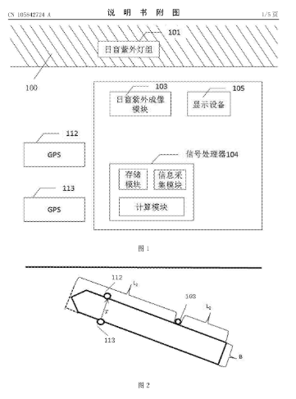

Dates and Legal

Priorities - CN201510020599A·2015-01-15

Application - CN201510020599A·2015-01-15

Publication - CN105842724A·2016-08-10

This patent has been granted as of 2018-07-17 but has only been granted in China and has passed the 36-month time limit to apply for further countries. This means that even if it causes infringements, they will only be in effect in China.

Independent Claim(s)

Claim 1:

This claim states the system will use at least two GPS modules. At least one GPS module will be for receiving the position of the ship from a satellite.

The project doesn’t use GPS at all, so it is safe from this claim.

Claim 2:

The claim states that the data processing module will include signal receiving components to watch to the sunblind ultraviolet imaging module and GPS module either wired or wirelessly. This will calculate the attitude angle of the berth shoreline.

The project doesn’t use GPS or Sunblind ultraviolet imaging modules and doesn’t do and calculations with their data, this means the project won't infringe on this claim.

Claim 12:

Claim 12 restates the same as claim 1 and claim 2 but in a few more words. Due to this, the project will not infringe on this claim for the same reasons as stated in claim 1 and 2, the project does not use GPS or sunblind ultraviolet imaging modules.

Summary

Looking at the dates and legal, the project will not infringe as it is not in China, and looking at the claims they are all omitted due to using modules such as GPS which the project does not. Overall, the project will not infringe.

## Patent #8

[**EP3639105A1**](https://worldwide.espacenet.com/patent/search?q=pn%3DEP3639105A1) Autonomous and Assisted Docking Systems and Methods

This patent is part of a family of patents all based around the same thing, but all in different countries around the world and for differing applications.

Applicant(s) - FLIR BELGIUM BVBA [BE]; FLIR SYSTEMS [US]

Inventor(s) - JOHNSON MARK [GB]; HAWKER OLIVER [GB]; JALES RICHARD [GB]; YEOMANS CHRISTOPHER [GB]; RULL MARCELO [GB]; RIVERS MARK [GB]

Abstract

“Techniques are disclosed for systems and methods to provide docking assist for mobile structures. A docking assist system includes a logic device, one or more sensors, one or more actuators/controllers, and modules to interface with users, sensors, actuators, and/or other modules of a mobile structure. The logic device is adapted to receive docking assist parameters from a user interface for the mobile structure and perimeter sensor data from a perimeter ranging system mounted to the mobile structure. The logic device determines docking assist control signals based, at least in part, on the docking assist parameters and perimeter sensor data, and it then provides the docking assist control signals to a navigation control system for the mobile structure. Control signals may be displayed to a user and/or used to adjust a steering actuator, a propulsion system thrust, and/or other operational systems of the mobile structure.”

Relevant Figure(s)

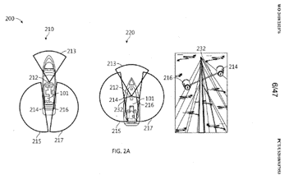

Dates and Legal

Priorities - US201762521346P·2017-06-16; US201762584718P·2017-11-10; US2018037953W·2018-06-15; US201862628905P·2018-02-09

Application - EP18742875A·2018-06-15

Publication - EP3639105A1·2020-04-22

The legal events page is full of “Lapse because of failure to submit a translation of description or to pay the fee within prescribed time-limit” all these messages are for other countries, accept the one for UK, the UK patent was translated/fees paid for. This means the project could be within infringement range, if the claims line up as the patent application was made in 2018, so well within its lifespan, and with it being paid up for the UK it could be a problem.

Independent Claim(s)

Claim 1:

This claim talks about a logic device that communicated with a user interface for the docking system. It will receive docking parameters from user interface and perimeter sensor data. This will then provide docking assist controls using this data.

The project will have a user interface feedback system, but will not have perimeter sensors for docking, it will have two sets of sensors to detect buoys. So, the project is close to infringement, but is unique enough to skirt around the claim.

Claim 13:

Claim 13 is very similar to claim 1, in which is explains the same setup, it is slightly more in depth, but does still only use the same setup. For the same reasons the project won’t infringe upon claim 1, the project won’t infringe upon claim 13.

Conclusion

From looking at the claims the project won’t infringe upon the patent, they both do use a user interface, but they won’t be the same so there won’t be any infringement there. Looking at the Legal if there were any infringements, they would be enforceable due to it being a European patent, along with the other patents in the family being form around the world. But due to the project not infringing, then there will be no problems from them.

# IP Landscape Conclusion

The overall conclusion of the research done is that our project idea doesn’t seem to infringe upon any found patents in any section of the project. There have been no changes made to the project idea due to any findings in the landscape. Many of the patents found were able to be dismissed due to the patent being only done in specific countries, such as only be filed in Japan or Spain. Patents were dismissed because they excluded Europe but covered the rest of the world, so as long as the project is done in Europe then there will be no infringing upon those. There were many patents that were dismissed due to the inventors not paying for the maintenance fees or the 20 years lifespan of the patent running out. While there were some valid patents for similar projects, infringement is avoidable due to the wording of the independent claims.

The most relevant (and closest to infringing) patents for each sub-section in our project design are listed below.

Overall:

**CN105744229A** Unmanned ship automatic anchoring system and working method thereof based on integration of infrared and panoramic technologies

The patent that was most like the project was Patent #2 CN105744229A. The main similarity between this patent and the project was the use of infrared cameras. In the patent these cameras are used to create an infrared panoramic image of the unmanned boat’s surroundings, using this as a guide to navigate to an anchoring position with some corrections from a user. The project will use infrared cameras to find the position of the buoys for mooring and use that as a guide for the launcher to deploy a hook while a user is constantly in control of the vessel. However, beyond the use of boat-based infrared cameras there was no other overlap and no risk of infringement. This was the case for all patents analysed in this section with many sharing similar scopes or containing common components to the project but none that matched enough to risk infringement. If the project were to evolve to include creating an infrared panoramic image to better locate the buoys, then there may be reason to reevaluate this patent however this would not necessarily be an issue as the patent is only enforced in China.

Delivery:

[**US2022234871A1**](https://worldwide.espacenet.com/patent/search?q=pn%3DUS2022234871A1)Retractable Docking Line

Of the patents examined for the delivery system, patent #6 had the most similarities to our proposed system. However, we concluded that our proposed system does not infringe any of the claims made by this patent, due to several fundamental differences between the two systems outlined in the independent claim discussion and summary sections for this patent. Furthermore, according to espacenet, this patent is still under examination in the US, with no data on applications for other countries. Considering this, the mechanisms described may have potential for our delivery system if we do not plan on US operations. If the project evolves however, and expansions to the US are planned, a re-examination of this patent may be required if it passes the examination process. An example of how our system may infringe this patent in the case of a future of the evolution of the design could be if our system was designed to include a dock mooring, with a loop terminated line, making it much more similar to that described in the patent, in terms of the environment it operates in and the mechanical details of the system.

Connection:

[**US2550770A**](https://worldwide.espacenet.com/patent/search?q=pn%3DUS2550770A) Boat hook

As the project will be using some system of projectile launching, as opposed to an arm/pole method of delivery, a hook was deemed more appropriate than a clip, due to the simpler mechanism involved. Of the connection patents, the one most likely to be used was the Boat Hook. This is because it has become mainstream due to the simplicity and effectiveness of the design. Despite the age of the application, it is still finding common use in marine environments, further proving the effectiveness of the design. Fortunately, the patent has long-since expired, and we may even find some adaptations or design types better suited for this specific project while looking for a connector to purchase

Guidance:

[**ES2387144A1**](https://worldwide.espacenet.com/patent/search?q=pn%3DES2387144A1) System for guiding an unmanned vehicle towards a platform using visual analysis

The closes patent to our project idea for guidance was Patent #1. This patent was “[ES2387144A1](https://worldwide.espacenet.com/patent/search?q=pn%3DES2387144A1) System for guiding an unmanned vehicle towards a platform using visual analysis”. This patent is a system that uses cameras to land an aerial vehicle automatically using patterns on the ground and some form of image processing to find the pattern and land on its centre of mass. This is quite close to our project idea in the sense that we will also be doing a form of camera image processing on an area looking for a pattern of IR LEDs. This will be done automatically. Our project idea seems to run parallel with this patent in terms of guidance but doesn’t cause infringements due to the patent being about an aerial vehicle and our project being a marine vehicle. No changes had to be made to avoid infringement, but some inspiration can be drawn from it to better our system, such as arranging the IR LEDs in a pattern, as opposed to a straight line. This can help our system distinguish the LEDs from other surfaces (such as the water line).

# Appendix

## A.1

[A](#Del1).1.1

(Bracketed numbers are referring to figure elements)

Claim 1:

*“A mechanical arm-type deployment and recovery system for underwater robots, which is characterized by: including a mother ship (1), a mechanical arm (2), a winch and anti-sway mechanism (3), a rope throwing mechanism (5) and a damping hydraulic cylinder ( 7), in which one end of the mechanical arm (2) is detachably installed on the mother ship (1), and the upper end of the hoisting and anti-sway mechanism (3) is hinged to the other end of the mechanical arm (2) through the connecting plate A (6). One end; one end of the damping hydraulic cylinder (7) is installed on the other end of the mechanical arm (2), and the other end of the damping hydraulic cylinder (7) is connected to the connecting plate A (6), and the winch stops swinging. The mechanism (3) uses the damping hydraulic cylinder (7) to prevent yaw and pitch, and after stopping the sway, it uses the damping hydraulic cylinder (7) to limit and lock; the underwater robot (4) The bow is equipped with a rope-throwing mechanism (5) that enables the underwater robot (4) to throw a rope on the sea level. The rope-throwing mechanism (5) has a bow-throwing buoyancy block (501) that can be released and thrown. After being released and thrown, the buoyancy block (501) drives the throwing rope (503) connected to the underwater robot (4) to unfold. The lower end of the hoisting and anti-sway mechanism (3) is connected to Throwing throw line cable connection.”*

Claim 19:

*“A method for deployment and recovery of a robotic arm-type deployment and recovery system for an underwater robot according to any one of claims 1 to 18, characterized in that: after the underwater robot (4) finishes working, the rope throwing mechanism ( The bow-throwing buoyancy block (501) in 5) is released and thrown, driving the rope-throwing cable (503) to unfold and float on the sea after being thrown; then, the rope-throwing cable (503) is picked up , connected to the cable (30201) in the hoisting and anti-sway mechanism (3), using the hoist and anti-sway mechanism (3) to recover the cable (30201), and then recover the underwater robot (4); and then through The mechanical arm (2) recovers the hoisting and anti-sway mechanism (3) and the underwater robot (4) to the mother ship (1). During the recovery process, the horizontal movement is achieved through the action of the damping hydraulic cylinder (7). The combination of roll and pitch stops swing.”*

A.1.2

Claim 1:

*“A computer-implemented method of transferring a line from a tug-boat to a vessel, comprising: configuring a lower manipulator coupled to the tug-boat to orient an upper manipulator in accordance with an inertial frame; tracking, by one or more processors, a target position on the vessel relative to an end-effector of the upper manipulator based on output of one or more photosensors trained on the vessel; and configuring the upper manipulator to position the end-effector relative to the target position, the end-effector coupled to the line to allow transfer of the line from the tug-boat to the vessel.”*

Claim 3:

*“A system for transferring a line from a tug-boat to a vessel, comprising: a lower manipulator mounted on to the tug-boat; an upper manipulator defining an end-effector coupled to the line, the upper manipulator being coupled to the lower manipulator for orientation of the upper manipulator by the lower manipulator; one or more photosensors trained on the vessel to detect a target position on the vessel; one or more processors connected to the one or more photosensors to receive output from the one or more photosensors indicative of the target position,*

*the lower manipulator and the upper manipulator being actuatably connected to the one or more processors; computer-readable memory coupled to the one or more processors and storing processor-executable instructions that, when executed, configure the one or more processors to cause: configuring of the lower manipulator to orient the upper manipulator in accordance with an inertial frame, determining, by the one or more processors, a separation vector between the target position and the end-effector based on the output of the one or more photosensors, and configuring of the upper manipulator based on the separation vector to position the end-effector in proximity of the vessel to allow transfer of the line from the tug-boat to the vessel.”*

A.1.3

Claim 1:

*“The method of employing a service ship having anchor-deploying equipment for assisting in the mooring to the seabottom of a structure floating in a body of water, said structure having mooring means including a mooring line attached to an anchor, said ship being on the surface of said body of water and having a service line, a hook attached to the service line, said method being characterized by utilizing the following steps: moving the service ship near said structure, coupling the hook to said mooring means; progressively releasing the mooring means from the structure into the body of water; supporting the mooring means with the service line; moving the ship away from said structure to a desired location; progressively lowering the service line through the body of water; burying the anchor in the seabottom; detaching the hook from the mooring means; taking in the service line onto the ship; and mooring said structure to said mooring means.”*

Claim 5:

*“The method of employing a service ship and anchor-deploying and retrieving equipment for mooring and unmooring to and from the sea bottom a structure floating in a body of water, said structure having mooring means including a mooring line attached to an anchor, said ship being on the surface of said body of water and having a service line, a remote-operated hook attached to the service line, and a control unit on the ship for controlling the operation of the hook; said method being characterized by utilizing the following steps: with the service ship near said structure, coupling the hook to said mooring means; progressively releasing the mooring means from the structure into the body of water; supporting the mooring means with the service line; moving the ship away from said structure to a desired location; progressively lowering the service line through the body of water; when the anchor reaches the vicinity of said desired location, actuating said control unit to remotely open the hook; detaching the hook from the mooring means; burying the anchor in the sea bottom thereby mooring the structure to the mooring means; taking in the service line onto the ship; moving the ship near the structure; submerging the hook and a portion of the service line into the body of water; towing the submerged hook in a direction intersecting the mooring line until the mooring line is caught inside the hook; gradually swerving the service line in the direction of the mooring line toward the buried anchor; progressively releasing the service line as the ship moves toward said desired location and the hook slides down on the mooring line toward the anchor; uplifting the hook to unseat the anchor from the sea bottom; progressively taking in the service line into the ship, while supporting the mooring means with the service line; releasing the hook from the mooring line; and bolstering the anchor on the structure.”*

A.1.4

Claim 1:

*“A device of the type designed to releasably hold a mooring line so that said line can be readily grasped by a boatsman as a boat approaches its docking location, comprising, an elongate flexible rod member having a proximal end and a distal end, a hemispherical base member having a vertical axis of symmetry, said base member having a convex upper surface, said base member having a flat, circular bottom surface, a plurality of bore means formed in said base member, each of said bore means adpated to slidingly receive the proximal end of said rod member, a first bore means formed in said base member substantially orthogonal to said vertical axis of symmetry and disposed in proximity to said flat bottom surface, a second bore means formed in said base member, said second bore means being angularly disposed to said vertical axis of symmetry at an angle less than ninety degrees and being circumferentially spaced from said first bore means and being spaced more remote from said flat bottom surface relative to said first bore means, a plurality of successive bore means formed in said base member, each successive bore means being angularly disposed relative to said vertical axis of symmetry at an angle less than the preceding bore means and being increasingly remote from said bottom surface of said base member so that a helical pattern of bore means is observed when the base member is seen in plan view, a mooring line having a free, looped end, a cleat member fixedly secured to the distal free end of said rod member, and said cleat member adapted to releasably grasp the free, looped end of said mooring line.”*

A.1.5

Claim 1:

*“An apparatus for connecting an aquatic vessel to a fixed structure over water, the apparatus comprising:*

*a. a docking line connected to said fixed structure*

*b. a retrieval line communicating with said docking line*

*c. in combination first means for urging retraction, storage proximal to said fixed structure, and permit extension of said retrieval line, said first means being attached to said fixed structure*

*d. in combination second means for attaching said retrieval line to said docking line, and restraining said docking line thereby preventing jams and kinks from forming in said docking line during retraction of said first means, said second means being attached to said docking line and slidably communicating with said retrieval line at a plurality of locations on said docking line*

*whereby enabling orderly retraction and extension of said docking line, and whereby when retracted said docking line remains proximal to said fixed structure and out of said water and ready for extension for subsequent docking of said vessel; and whereby docking and undocking said vessel each require only one manual operation and whereby only two manual operations are required to accomplish a complete undocking and docking cycle regardless of the sequence in which performed.”*

Claim 12:

*“An apparatus for connecting an aquatic vessel to a fixed structure over water, the apparatus comprising:*

*a. a docking line connected to said fixed structure*

*b. an elastic cord connected to said docking line at a plurality of locations along said docking line including at or near the ends of said docking line to urge retraction store, and permit extension of said docking line, and said elastic cord is connected directly to said docking line at said locations so that said elastic cord and said docking line are of equal length and are parallel and close to each other throughout their lengths when said elastic cord is fully extended, whereby when retracted said docking line remains proximal to said fixed structure and out of said water and ready for the subsequent docking operation, and whereby the docking and undocking of said vessel each require only one manual operation and whereby only two manual operations are required to accomplish a complete undocking and docking cycle regardless of the sequence in which performed.”*

Claim 20:

*“A method for connecting an aquatic vessel to a fixed structure over water, comprising:*

*a. providing a docking line communicating with said fixed structure*

*b. providing a retrieval line attached to said docking line and slidably communicating with said docking line at a plurality of locations, and in combination means for urging retraction of said retrieval line, and storage of said docking line proximal to said fixed structure and out of said water, and in position to permit subsequent extension of said docking line without requiring any intervening manual operations*

*c. providing in combination means for restraining movements of said docking line with said retrieval line attached comprising a plurality of fittings each comprising an opening slidably connected to said retrieval line, and an additional disc or other object larger than said fittings affixed to said docking line to generate drag forces when said docking line moves through the water urged by said retrieval line, resulting in orderly retraction and extension of said docking line and avoiding snags and kinks and jams*

*d. grasping the end of said docking line when attached to said vessel, detaching and abandoning said docking line during undocking, thereby initiating refraction and storage of said docking line proximal to said fixed structure and out of said water using only one manual operation, whereby said docking line with said retrieval line attached is in position and ready for a docking operation*

*e. Grasping or grappling the end of said docking line when stored proximal to said fixed structure during docking, extending said docking line with said retrieval line communicating with said docking line, and attaching said docking line to said vessel using only one manual operation*

*whereby the method resulting in orderly and stable retraction and storage of said docking line proximal to the said fixed structure when undocking, keeping said docking line out of the water and in position ready for the next docking operation; and facilitating the grasping, extension, and attachment of said docking line to said vessel when docking, all resulting in easy, safe, and anxiety-free undocking and docking of aquatic vessels and requiring only seconds to accomplish either docking or undocking; and whereby docking and undocking said vessel each require only one manual operation, and whereby only two manual operations are required to accomplish a complete undocking and docking cycle regardless of the sequence in which performed; and providing continuous urgings while docked to keep vessel substantially centered in a slip or held against a dock.”*

A.1.6

Claim 1:

*“A retractable mooring line assembly for storing and dispensing line used to moor a boat or the like, comprising:*

*a mooring line having a loop on a distal end thereof*

*a user interface comprising a canister including a top lid and a bottom lid, wherein said top lid is slidably engaged with an upper portion of said canister, and wherein said bottom lid defines a hole through which a mooring line may pass; and*

*an auto-retracting reel assembly for windably storing said mooring line, said reel assembly having a spool rotatably attached to a base, and further including a spool spring operatively engaged between said spool and said base to provide a constant force for automatically winding said mooring line onto said spool.”*

A.1.7

Claim 1:

*“A self contained integrated mooring system, comprising:*

*a system container having an internal cavity configured to retain payload;*

*a mooring line handling and storage module in communication with the system container and including at least one spool with mooring line wound thereon;*

*at least one anchor in communication with the mooring line handling and storage module.”*

Claim 9:

*“A self contained integrated mooring system, comprising:*

*a system container having an internal cavity configured to retain payload and a lid providing access to the internal cavity configured to retain payload;*

*a mooring line handling and storage module in communication with the payload container and including a plurality of spools with mooring line wound thereon, wherein the mooring line handling and storage module is attached to the system container at a head of the system container;*

*wherein the plurality of spools are positioned on a shaft, wherein adjacent walls of spools include crossover slots enabling the mooring line to crossover spools, and including a multiple spool locking mechanism adapted to separately lock mooring line on each spool to prevent each spool from being pulled from each spool, thereby enabling the self contained integrated mooring system to be deployed at different depths by setting the locking mechanism before deployment; and*

*a system container having at least a payload container receiving chamber, a mooring line handling and storage module receiving chamber, and an anchor receiving chamber, wherein an inner surface of each of the chambers is configured to match a shape of the payload container, the mooring line handling and storage module, and the at least one anchor to limit movement relative to the system container.”*

## A.2

A.2.1

Claim 1:

*“A shackle for selectively connecting a mooring line to a mooring loop comprising a main body member adapted to be connected to said mooring line, said main body member having a loop engaging section open at one side, a shackle pin carried by said body member for movement between an advanced position closing said open side and a retracted position permitting access to said open side, said shackle pin being spring biased to said advanced position, said shackle pin having a portion projecting externally of said main body member and terminating in its outer end in an enlarged connector portion, and a blocking member adapted to be detachably mounted on said projecting portion of said shackle pin externally of said body member between said body member and said enlarged connector portion for preventing movement of said shackle pin to said advanced position whereby said shackle may be secured to said mooring loop by removing said blocking member after said loop is positioned in said loop engaging section”*

A.2.2

Claim 1:

*“A deployable boat hook assembly for securing a boat to a dock, comprising: a mechanical clamping assembly, attachable to a pole, wherein the clamping assembly includes a clamp adapted to temporarily secure a boat hook which is configured to connect to a receiving member on a dock, the boat hook further configured to receive a boat line extending from the boat, wherein the temporary securement of the boat hook is overcome by an operator moving the pole in a manner to release the clamping assembly from the pole, such that the boat is connected to the dock by the boat hook and the boat line;*

*wherein the clamping assembly includes a lower arm member, an upper arm member and an intermediate plate, and further includes a spring forcing the intermediate plate in the direction of the lower arm member to hold the boat hook in place therebetween”*

Claim 9:

*“A deployable boat hook assembly for securing a boat to a dock, comprising: a magnetic clamping assembly attachable to a pole, wherein the clamping assembly includes a clamp adapted to temporarily secure a boat hook which is configured to connect to a receiving member on a dock, the boat hook further configured to receive a boat line extending from the boat, when the temporary securement of the boat hook is overcome by an operator moving the pole in a manner to release the boat hook from the clamping assembly, such that the boat is connected to the dock by the boat hook and the boat line, wherein the magnetic clamping assembly is mounted on a beam plate, wherein the magnetic clamping assembly includes a magnetized element which is positioned for direct contact with the boat hook, wherein when the boat hook is positioned on the magnetic clamping assembly, the magnetic attraction between the magnetic clamping assembly and the boat hook is sufficient to hold the boat hook to the magnetic clamping assembly as the boat hook is connected to the receiving member on the dock”*

Claim 16:

*“A deployable boat hook assembly for securing a boat to a dock, comprising: a clamping assembly which includes a securing portion permitting the clamping assembly to be removably attachable to a pole; a boat hook configured to receive a boat line extending from the boat, wherein the clamping assembly further includes a first attachment portion to which the boat hook is non-releasably attached, and a second attachment portion connected to the securing portion and the first attachment portion.”*

A.2.3

Claim 1:

*“A securing device for fastening an object to a securing point, the securing device comprising an elongate elastic flexible member provided with a clamp for releasable attachment to the securing point.”*

Claim 9:

*“A securing device as defined in any one of the preceding claims, wherein the clamp comprises at least two spaced clamping members that are biased to retain a piece of rope inserted between the members.”*

Claim 13:

*“A securing device as defined in any one of the preceding claims, wherein the elongate elastic flexible member is provided with a clamp at each end.”*

Claim 14:

*“A securing device as defined in any one of the preceding claims, wherein the elongate elastic flexible member is one of a pair of elongate elastic flexible members provided with a common clamp.”*

Claim 15:

*“A securing device as defined in any one of the preceding claims, wherein the object is a marine vessel and the securing device is used for fastening the marine vessel to a securing point.”*

A.2.4

Claim 1:

*“The invention relates to a submarine pulley mooring system, which comprises a submarine, a pulley, an anchor base and a rope. One end of a rope is attached to a submarine with a specific gravity less than water and the other end is passed around the pulley Need to moor body, the pulley frame connected to the anchor; tied rope in the ropes, ropes knot for the rope on the convex point, the ropes can be a solid on the line, it can be a rope tied their own knot; along the other along The rope is further provided with a stopper between the knot and the submarine, and the stopper is a solid which does not occupy the space of the movement path of the rope but occupies the movement path space of the knot. The stop is a pulley or part of the carriage or the stop can also be a separate solid fixed on the carriage or the wrong base or another solid as a stop can also be fixedly connected with the connecting element, And then fixedly connected with the pulley frame or the anchor base. When the connecting element is under tension, the connecting element may also be movably connected. Alternatively, the stopper may also be a rotating body, and the rotating shaft bracket may be a pulley frame. Alternatively, The slewing body can also be fixedly connected with the connecting element first, and then the connecting element is fixedly connected with the pulley frame or the anchor base. When the connecting element is subjected to tension, the connecting element can also be movably connected; Alternatively, it is also possible to use a barricade or a folding link with one end connected to a point on the rope between the pulley and the submarine or to the submarine, and the other end connected to the anchor or the pulley, In addition, the stopping mechanism may also be: without the stopper but with the intermediary firmware occupy the knot forward path space, and the stopper occupies the intermediary firmware with rope knot linkage motion path space; or block by the cable instead of blocking the end of the cable Is anchored in the anchor or pulley frame, the other end of the intermediary firmware; The above constitutes a submarine pulley anchoring unit; the mooring body is pulled outwards by the ropes of the submarine pulley anchoring units around the plurality of groups. A counterweight pulley mooring system is characterized in that it comprises a counterweight, a pulley, a pin base, a rope and a pulley frame which are connected with the mooring body to be moored, one of the ropes being anchored to the anchor base of the seafloor and the other end being bypassed After the pulley a weight greater than the weight of the water; tied rope in the ropes, ropes knot for the rope on the convex point of the rope can be on the line of the solid, it can be a rope tied their own knot; the other along the rope in the There is also a barrier between the knot and the counterweight, which is a solid that does not occupy the path of movement of the rope but occupies the path of movement of the knot; Or the barrier may also be another solid, fixed on the pulley frame or on the mooring body to be required; or another solid as a barrier may also be fixedly connected with the connecting element first, The connecting element is fixedly connected with the pulley carrier or the mooring element to be moored. When the connecting element is subjected to tensile force, the movable element can also be movably connected. Alternatively, the stop element can also be a rotary element with the rotary shaft carrier being the pulley carrier. Is a rotating body as a stopper. The bracket may be fixedly connected with the connecting element first, and then the connecting element is fixedly connected with the pulley frame or the mooring body to be moored. When the connecting element is subjected to tension, a movable connection ; Alternatively, it is also possible to use a blocking cable or a folding link without a stopper, one end of which is connected to a counterweight at a point on the rope between the pulley and the counterweight and the other end of which is connected to a mooring body or a pulley carrier on; In addition, the stopping mechanism may also be: without the stopper but with the intermediary firmware occupy the knot forward path space, and the stopper occupies the intermediary firmware with rope knot linkage motion path space; or block by the cable instead of blocking the end of the cable Dependent on mooring body or pulley on the other end of the line in the intermediary firmware; The above constitutes a counterweight pulley anchoring unit; the mooring body is pulled outward by the rope of the anchoring unit around the plurality of groups. The submarine pulley mooring system according to claim 1, characterized in that the submarine is a cylindrical shell structure with steel end caps on both end faces and is connected by a steel column, the side wall of the cylindrical column is made of superfine fiber or Steel wire winding to strengthen or glass fiber reinforced plastic, steel end cap installed on the valve or on-off valve, the side wall and the end cap can be consolidated as a whole, can also be separated, at the junction of the installation of seals or sealant; The standard may also be an open-ended hollow shell structure with a spring-loaded swing door at the bottom opening and a spring swing-open door which may also be replaced by a piston that slides within a tube that is open at the bottom end. The piston rod is attached to the housing The guide rail can slide up and down, one end of the resetting spring is connected with the other end of the piston and is fixed on the submarine shell, a valve or an on-off valve is installed on the submarine shell, followed by an air pipe of an air compressor and a charged switch of an air compressor. The counterweight pulley mooring system according to claim 2, characterized in that: the counterweight slides up and down in a sliding cylinder which is fixed on the mooring body to be moored; or the counterweight is provided with a hole on which the guide rail extends from the hole Through the guide rails fixed to the mooring body or the weight is fixed on the mooring body required a plurality of rails sandwiched. The submarine pulley mooring system according to claim 1 or the counterweight pulley mooring system according to claim 2, characterized in that the connection between the pulley frame and the anchor / required mooring body can be fixedly connected or If the connection is fixed, the direction of the rope winding of the pulley needs to be matched with the direction of the rope into the actual operation, or the guide rope roller is arranged at the rope inlet, the guide rope roller bracket is fixed on the anchor base / required mooring body; if Is an active connection, it can be through the hanging ring / rope / chain / ball hinge / universal joint / rotating rings connected. The submarine pulley mooring system according to claim 1 or the counterweight pulley mooring system according to claim 2, wherein the bearing of the pulley is an oil-free self-lubricating bearing or a plastic bearing / a ceramic bearing / a magnetic bearing ; It can also be a bearing embedded in the bearing housing seal cover, shaft seal is provided on the outside of the bearing, the pulley shaft in turn through the shaft seals, bearings; can also be: the center of the pulley hole, hole embedded bearings, bearing sleeve On the mandrel, the mandrel is fixed on the pulley frame, with seal rings on both sides of the bearing. The submarine pulley mooring system according to claim 1 or the balancing pulley mooring system according to claim 2, characterized in that a spring is provided between the stopper and the knot, and the stopper occupies a space for advancement of the spring It is also possible to add a perforated ball between the spring and the stopper, which can slide on the rope in its hole, the stopper occupying the space of the advance path of the perforated ball, the knot, the spring, the perforated ball can be separate elements from each other, Connected together, perforated ball can be any shape. The submarine sheave mooring system according to claim 1 or the balancing sheave mooring system according to claim 2, wherein the knot is a perforated ball and the rope is a cable chain, Through freely, the rope knot also has horizontal through holes intersecting with the through holes, when the position of the knot is to be fixed, the pins pass through the horizontal through holes and the links; , Pin through the hanging ring and link through. The submarine-sheave mooring system according to claim 1 or the counterweight-pulley mooring system according to claim 2, wherein the mooring body needs to be a wind turbine tower, and there are two kinds of mooring systems The bottom of the fan tower tube is connected to the anchor foundation of the seafloor through a universal joint or a ball joint, the transverse arm is extended from the middle of the tower barrel, and the outer ends of the transverse arm are anchored by the submarine / counterweight pulley mooring unit; the second is that the fan tower The tube is fixed on the tension leg platform TLP, the outer end of the TLP is anchored by the submarine / counterweight pulley unit, and the TLP drooping tension bar can be replaced by the submarine / counterweight pulley anchoring unit. Alternative schemes Is: the rope drooping on the TLP platform moves horizontally after bypassing the first pulley just below, then the second pulley is connected and then the sub standard is connected upwardly; both pulleys of the pulleys are connected to the seabed anchors by ropes , The position of the knot can be on the rope above the first pulley or between the second pulley and the first pulley. 0、 The submarine pulley mooring system according to claim 1 or the counterweight pulley mooring system according to claim 2, wherein the lower end of the mooring buoy is fixed with a bottom post, and the upper end of the floating body needs to be moored, The ends are anchored by a plurality of surrounding submarine / counterweight pulley anchoring units, and the bottom of the bottom column may also be anchored to the submarine anchor without using the submarine / counterweight pulley anchoring unit. , The bottom column can not use any anchor, but the connection weight”*

A.2.5

Claim 1:

*“A mooring pendant apparatus for use in docking a boat, wherein the apparatus releasably couples or decouples to an eyelet on the bow of the boat or to a buoy, the apparatus comprises: a clip including: a hook section integral with a ring section and having a mouth defined there between, and having an attachment hook; a movable arm having an upper bridge section which contains an internal spring that causes the movable arm to be biased into a closed position on the clip; a functional retractor lever comprising: a right arm section and a left arm section, each arm being bowed and having an angular deviation defined therein; an activating system that is in functional engagement with the movable arm; and, a looped section; a rod having means for connecting a first end to the clip; a cable having one end fastened to the looped section of the retractor arm; means for guiding and controlling the cable, wherein a boater may pull on the cable with a sufficient force to overcome, any biasing created by the internal spring, therein causing the clip to open, or subsequently closing by releasing the pull on the cable.”*

A.2.6

Claim 1:

*“A boat hook comprising, a handle, a head mounted thereon, a longitudinal channel extending throughout a substantial portion of the handle, an armored wire located in the channel-, means for actuating the wire at its lower end, A spring latch attached to the upper end of said wire, a swingable spring biased perforated lever mounted on the head and restricted by said latch, hook portion formed integral with said head, recess in said hook, a detachable element mounted in said hook recess for coaction with said swingable lever, a latch carried by said detachable element, a groove in the head and hook interconnected with the hook recess, a leader attached to the detachable element at its inner end and located in said groove, a spring on the lower end of the leader, a clip mounted on the handle near its lower end to receive the said spring, and a snap hook on the lower end of the lead wire adapted to receive a cable.”*

Claim 2:

*“A. boat hook comprising a handle, a head mounted - thereon,. a hook- formed integral with 4 said head, a detachable element mounted on said hook, swingable means mounted on the head, means for bringing said swingable means toward and into operative engagement with said detachable element, a latch on the handle normally restraining said swingable means, a remote release for said latch mounted in the handle, and means for securing said swingable means to said detachable element, the parts being, so constmct6d and arranged that the operation of the latch release enables the swingable means to be biased into operative engagement with the detachable element.“*

Claim 3:

*“A boat hook comprising a handle, a head mounted thereon, a hook formed integral with said head, a detachable element mounted on said hook, swingable means mounted on the head, means for bringing said swingable means toward and into operative engagement with said detachable element comprising a spring based on the head and biasing the swingable means toward said detachable 'element, a latch on the handle normally restraining said swingable means, a remote release for said latch mounted in the handle, and means for securing said swingable means to said detachable element, the parts being so constructed and arranged that the operation of the latch release enables the swingable means to be biased into operative engagement with the detachable element.”*

Claim 4:

*“A boat hook comprising a handle, a head mounted thereon, and a hook. formed integral with said head, a recess in said hook, a detachable element mounted in said recess, swingable means mounted on the head, means for bringing said swingable means toward and into operative engagement with said detachable element, means for securing said swingable means to said detachable element and carried thereby, and means for holding the detachable element in said hook recess including a tail portion of said element provided with a centering pin riding in said hook recess, flexible means attached to said detach able element, and mechanical means on the handle so constructed and arranged that the flexible means is yieldingly held to the handle.”*

Claim 5:

*“A boat hook comprising a handle, a head mounted thereon, a hook formed integral with said head, a recess in said hook, a detachable element mounted in said recess, swingable means mounted on the head, means for bringing said swingable means toward and into operative engagement with said detachable element ' means for securing said swingable means to said detachable element and carried thereby, and means for holding the detachable element- in said hook recess including a tail portion of said element provided with 9 centering pin riding in said hook recess, flexible means attached to said detachable element and mechanical means on the handle so constructed and arranged that the flexible means is yieldingly held to the handle, said last named means comprising a clip on the handle and a spring on the flexible means engageable by said clip.”*

Claim 6:

*“A boat hook comprising a handle, a head mounted thereon, a hook formed integral with said head, a detachable element mounted on said hook, means mounted on the head, means for bringing said swingable means toward and into operative engagement with said detachable element, the hole in said swingable means being aligned with said detachable element, means for limiting the outward swing of said 7r) swingable means - comprising a cutout in the 2,550)7O base of said means engageable with the outer surface of the head, a latch on the handle normally restraining said swingable means, a remote release for said latch mounted in the handle, and means for securing said swingable means to said detachable element, the parts being so constructed and arranged that the operation of the latch release enables the swingable means to be biased into operative engagement with the detachable element.”*

Claim 7:

*“A boat hook comprising a handle, a head mounted thereon, a hook formed integral with said head, a detachable element mounted on said hook, swingable means mounted on the head, means for bringing said swingable means toward and into operative engagement with said detachable element, a latch on the handle normally restraining said swingable means, a remote release for said latch mounted in the handle, and means for securing said swingable means to said detachable element, the parts being so constructed and arranged that the operation of the latch release enables the swingable means to be biased into operative engagement with the detachable element, said securing means comprising a spring '25 biased latch mounted in the detachable element.”*

Claim 8:

*“A boat hook comprising a handle, a head mounted thereon, said head comprising a knob, and a hook formed integral with said head and 6 projecting therefrom, a detachable element mounted on said hook at its outer end, swingable means mounted on the head, means for bringing said swingable means toward and into operative engagement with said detachable element, and means for holding the detachable element to the hook, said last named means comprising a longitudinal groove extending across the head, knob and hook. portions and a flexible leader affixed to the detachable element and located in said groove below the upper edges thereof, the parts being so constructed and arranged that the knob is available for fending off without damage to said flexible leader.”*

A.2.7

Claim 1:

*“What is claimed is: 1. An adjustable tether system that comprises:(A) a first strap and second strap movably connected together by a length adjustment device that adjusts the overall length of the adjustable tether system; (B) first strap has one first strap end that supports a first attachment device and other first strap end that connects to the length adjustment device; (C) second strap has one second strap end that passes into and is movably held by the length adjustment device and other second strap end supports a second attachment device; wherein the first attachment device is configured to removably attach to a boat, the second attachment device is removably attached an object to be connected to the boat.”*

Claim 5:

*“A process of operating an adjustable tether system to connect a boat to a boat fender comprising the following steps:(A) providing an adjustable tether system, the adjustable tether system comprises a first and second strap movable connected together by a length adjustment device that adjusts the overall length of the adjustable tether system, first strap has one first strap end that supports a first attachment device and a second first strap end fixedly attached to the length adjustment device, the second strap has one second strap end that passes into and is movably held by the length adjustment device and other second strap end that supports a second attachment device, wherein the first attachment device is configured to removably connect to the boat while second attachment device is configured to removably connect to the boat fender. (B) providing a boat; (C) providing a boat fender; (D) removably connecting second attachment device to the boat fender; (E) removably connecting the first attachment device to the boat; and (F) setting the desired length of the adjustable tether system by using the length adjustment device.”*

Claim 11:

*“A process of operating an adjustable tether system tether to removably connect a boat to a mooring device comprising the following steps:(A) providing an adjustable tether system, the adjustable tether system comprises a first and second strap movable connected together by a length adjustment device that adjusts the overall length of the adjustable tether system, first strap has one first strap end that supports a first attachment device and a second first strap end fixedly attached to the length adjustment device, the second strap has one second strap end movably inserted into the length adjustment device and other second strap end that supports a second attachment device, the one first strap end is configured to removable connect to a vehicle such as a boat while other second strap end connects to mooring device; (B) providing a boat; (C) providing a mooring device; (D) removably attaching first attachment device to the boat; (E) removably connecting the second attachment device to the mooring device; and (F) setting the length of the adjustable tether system using the length adjustment device.”*

A.2.8

Claim 1:

*“A mooring retraction device for reclaiming a mooring rope in water, the device comprising: A floating member adapted to be tethered to the end of a mooring line; and A retracting member having a device adapted to engage with the floating member, whereby in use, the end of a mooring line tethered to the floating member can be retracted more easily.”*

Claim 8:

*“The mooring retraction device as claimed in any one of the preceding claims, wherein the floating member is equipped with a counterweight device adapted to keep the floating member in an upright state during use.”*

Claim 10:

*“The mooring retraction device as claimed in any one of the preceding claims, wherein the floating member has a generally spherical shape and is formed by connecting an upper hemisphere and a lower hemisphere together.”*

Claim 13:

*“The mooring retraction device according to any one of claims 2 to 12, wherein the magnetic device provided in association with the end of the retraction member also includes a permanent magnet.”*

Claim 14:

*“The mooring retraction device according to any one of claims 2 to 13, wherein the lower hemisphere is formed so that the weighting device is at the lowermost of the hemisphere when the floating member is in an upright state In the area.”*

Claim 16:

*“The mooring retraction device as claimed in any one of the preceding claims, wherein the floating member has an elongate flexible member provided therewith, whereby, in use, the floating member can be tethered by the elongate flexible member Tie to the end of a mooring rope.”*

Claim 18:

*“An end piece of a mooring retraction device for reclaiming a mooring line in water, the end piece being adapted to engage with a floating member tethered to the end of the mooring line, whereby in use The end of the mooring line tethered to the floating member is easily retracted.”*

Claim 25:

*“An end piece according to any one of claims 19 to 24, wherein the magnetic means provided in connection with the end piece comprises a permanent magnet.”*

Claim 26:

*“An end piece according to any one of claims 18 to 25, wherein the end piece is adapted to be received on the end of an elongated member such as a rod or rod to form an elongated retracting member.”*

Claim 28:

*“A mooring retraction device is substantially as described herein with reference to any one or more of these drawings and as shown in any one or more of these drawings.”*

Claim 29:

*“An end piece for a mooring retraction device is substantially as described herein with reference to any one or more of these drawings and as shown in any one or more of these drawings.”*

## A.3

A.3.1

Claim 1:

*“Approach procedure to a platform of an unmanned vehicle by visual analysis comprising at least the following steps: taking pictures of the approach area sequentially by a camera located in the unmanned vehicle; image analysis by a processing unit; extracting the region in which the pattern is contained; obtaining a complementary image to the original; start binary image to have an image with only two tones or values in it; calculating the coordinates of the centers of mass (10, 11 and 12) of each image for each geometric figure, the main circle (1) and secondary ellipsoidal (4) and a circular (6); calculating distances between the centers of mass: one horizontal, "Drx" and another vertical "Dry"; calculating the angle of rotation or yaw; Euler number calculation for each geometric figure, the main circulating (1) and secondary ellipsoidal (4) and Circular (6). 20 2. Apparatus for approach to a platform of an unmanned vehicle by visual analysis to carry out the process according to claim 1 characterized by comprising: a platform with a pattern figure, a device signal processing, algorithm processing the captured image and a control system. 25 3. An apparatus for a platform approach to an unmanned vehicle by visual analysis according to claim 2 wherein the pattern consists of a main figure geometric shape that contains within it two secondary elements; and in that the main element (1) is a circle of given radius, with four ellipsoidal hollow (2) and a central circular recess (3); 5 And because one of the secondary figures is an ellipse (4) with two circular holes (5) located inside an ellipsoidal hole (2) and the other secondary figure is a circle (6) with a circular hole (7) and it is located within the central circular hollow (3). 4. Apparatus for approximating a platform an unmanned vehicle 10 by visual analysis according to claim 2 and 3 characterized in that the centers of the hollow ellipsoid (2) is symmetrically located about two to two circle center (1) and that two holes have their major axis in the horizontal direction and the other two have their major axis in the vertical direction. 5. Apparatus for the approach to a platform of an unmanned vehicle 15 by visual analysis according to claim 2 and 3 characterized in that the secondary figure ellipsoidal (4) is concentric with the hollow ellipsoid (2) that contains it and that is the same color that the main geometric figure (1). 6. Apparatus for approaching a platform of an unmanned vehicle by visual analysis according to claim 2 and 3 wherein Figure 20 secondary Circular (6) is concentric with the hollow (3) that contains it and because it is the same color as the main geometric figure (1). 7. Apparatus for approximating a platform an unmanned vehicle by visual analysis according to claims 2, 3 and 6 characterized in that the three circles (3, 6 and 7) are concentric with each other and with the main circle (1). 25 8. Apparatus for approach to a platform of an unmanned vehicle by visual analysis according to claims 2, 3, 5, and 6 characterized in that the color contrast between the figures (1, 4 and 6) and the recesses (2, 3, 5 and 7) is maximum. 9. Apparatus for approaching a platform unmanned vehicle by visual analysis according to claim 2, 3, 5, 6 and 8 characterized in that the colors used are black and white for figures for the gaps. 10. Apparatus for approaching a platform of an unmanned vehicle by visual analysis according to claim 2 and 3 characterized in that the secondary circular figure (6) is replaced by a reproduction of the main figure 5 smaller scale and concentric with the circular hole (3) that contains it.”*

A.3.2

Claim 1:

*“Claim 1 Shortform description of This Invention:*

*This Invention is a method to enable autonomous guidance of a vehicle, employing radio frequency identification (RFID) as the medium of communication and enabled by an apparatus of*

*two- way RFID Transmitter- Receivers mounted on the vehicle,*

*• a plurality of RFID Tags or Beacons in the environment,*

*an onboard Processor to translate environmental data input into vehicle control output and*

*■ a Protocol for the formatting and transmission of system data.”*

A.3.3

Claim 1:

*“A network comprising a plurality of unmanned mobile communication stations adapted for location in a marine environment each said station comprising:a platform adapted for flotation or semi-submersible; a communication node for sending and receiving wireless signals; a power system for energizing said communication node; a data center; at least one sensor for detecting the geo location of said platform; and a processor for receiving signals from said sensors and controlling communication to and from said communication node; a propulsion system, for moving said station and maintaining the position of said station, wherein said plurality of stations form a mesh network comprising a plurality of nodes, said nodes comprising antennae adapted to receive satellite originated wireless transmissions from Geocentric, low earth orbit (“LEO”) Medium Earth Orbit (“MEO”) and geostationary (GEO) satellites, and in response to location data, said processor is configured to provide an output signal to a navigational system to change the position of said station and said navigation and propulsion systems further comprise an autonomous system, said navigation system comprising geolocation sensors and radar, and said navigation and propulsion systems allow for autonomous positioning of said station according to predetermined instructions, and said position of said stations comprises a grid array and wherein said instructions comprise signals to said navigation and propulsion system to maintain said stations in an array at predetermined distances apart from one another.”*

A.3.4

Claim 1:

*“A mooring system in which one of a floating structure and a mooring facility is defined as a first object and the other is defined as a second object, and the floating structure is moored to the mooring facility, comprising: mooring ropes; , a winch capable of winding and withdrawing the mooring cable; a locking device arranged on the second object and locked so that the tip of the mooring cable can be engaged and disengaged; at least one unmanned aerial vehicle having a retainer for holding the mooring rope; and, with the unmanned aerial vehicle holding the mooring rope, heading from the second object to the mooring post arranged on the first object, A mooring system comprising: a control device that controls the unmanned aerial vehicle so that a midway portion of the mooring cable between the tip portion and the base portion pulled out from the winch is hung on the mooring post.”*

Claim 2:

*“The control device controls the second mooring rope while the drone holds the midway portion of the mooring cable between the tip portion engaged with the locking device and the base portion pulled out from the winch. 2. The mooring system of claim 1, wherein the drone is controlled to steer from an object to the mooring post.”*

A.3.5

Claim 1:

*“The beacon signal transmitted from the beacon transmission unit installed at the edge of the bow and the stern portion of the ship and installed at the pier, the final position information and the final position at which the vessel is to be anchored from the radio signal station installed at the pier. A plurality of GPS receiver modules for receiving entry path information for entering the vehicle and information corrected to converge the current path, appearance, and position information of the ship to a final position and the entry path at which the ship is to be anchored; And receiving the corrected final position information, the corrected entry path information, and the corrected appearance and position information from the plurality of GPS receiving modules, and thereby correcting the final position information, the corrected entry path information, and the corrected appearance. And an eyepiece control device configured to control a propulsion direction and a speed for driving the ship's propulsion device according to the position information, wherein the eyepiece control device is configured to display the appearance and the like through signals inputted from the plurality of GPS receiving modules. Computing the position information, The corrected information is calculated in the control center of the pier, The corrected information is sent to the plurality of GPS receiving module via the wireless signal station The vessel anchoring apparatus.”*

Claim 5:

*“The said radio signal station compares the signal of the beacon transmitter which shows the position of the said pier with the signal of the GPS receiver module installed in the said ship, and determines the eyepiece direction and eyepiece speed of the said ship. Automatic berth of the ship.”*

Claim 8:

*“In the ship's automatic anchoring method using the vessel's automatic anchoring device, in a plurality of GPS receiving modules, the guidance signal from the control center of the dock to the information about the final position and the approach path leading to the final position from the dock control center Receiving a position information receiving step from the vessel being anchored to the vessel; Ship route transmission step of transmitting the appearance and position information to the control center by analyzing the path, appearance and position of the current vessel in the vessel; transmitted from the vessel A correction information receiving step of receiving from the control center the corrected information so as to converge the current path of the vessel, the final position at which the vessel is anchored with the appearance and the position information, and the approach path; An anchoring entry step of proceeding to anchor by controlling the propulsion device of the vessel; And a fine adjustment step of receiving the distance information between the bow and the stern of the ship from the control center, respectively, to adjust the ship to reach an appropriate distance, through signals input from the plurality of GPS receiving modules. The appearance and position information is calculated, the corrected information is calculated in the control center, the corrected information is sent to the plurality of GPS receiving modules via a wireless signal station installed in the pier Automatic anchoring method.”*

A.3.6

Claim 1:

*“1. What is claimed as new and desired to be secured by Letters Patent of the United States is: 1. A line retrieve-release system mounted on a hull of a boat, comprising: jaw means configured for attachment to the hull of the boat and facing substantially aft relative to the bow of the boat, said jaw means being capable of movement between a partially open position and a fully open position; a latch coupled to said jaw means and biased to cooperate therewith in said partially open position thereof to thereby define a first enclosed region bounded by said jaw means and said latch, said latch permitting one-way entry to said first enclosed region when a force is applied to said latch from outside of said first enclosed region; line catch means configured for attachment to the hull of the boat aft of said jaw means, said line catch means combining with said jaw means in said partially open position to define a second enclosed region adjacent to said first enclosed region and separated therefrom by said latch, said line catch means permitting one-way entry to said second enclosed region when a force is applied thereto from outside of said second enclosed region; and actuator means coupled to said jaw means for moving said jaw means to said fully open position to thereby open said first enclosed region and said second enclosed region.”*

Claims 6:

*“6. A line retrieve-release system mounted on a hull of a boat, comprising: jaw means to the hull of the boat and facing substantially aft relative to the bow of the boat, said jaw means being capable of movement between a partially open position and a fully open position; a latch coupled to said jaw means and biased to cooperate therewith in said partially open position thereof to thereby define a first enclosed region bounded by said jaw means and said latch, said latch permitting one-way entry to said first enclosed region when a force is applied to said latch from outside of said first enclosed region; line catch means to the hull of the boat aft of said jaw means, said line catch means combining with said jaw means in said partially open position to define a second enclosed region adjacent to said first enclosed region and separated therefrom by said latch, said line catch means permitting one-way entry to said second enclosed region when a force is applied thereto from outside of said second enclosed region; and line release means coupled to said jaw means for (i) moving said jaw means to said fully open position to thereby open said first enclosed region and said second enclosed region, and (ii) returning said jaw means to said partially open position from said fully open position.”*

Claim 8:

*“6. A line retrieve-release system mounted on a hull of a boat, comprising: jaw means to the hull of the boat and facing substantially aft relative to the bow of the boat, said jaw means being capable of movement between a partially open position and a fully open position; a latch coupled to said jaw means and biased to cooperate therewith in said partially open position thereof to thereby define a first enclosed region bounded by said jaw means and said latch, said latch permitting one-way entry to said first enclosed region when a force is applied to said latch from outside of said first enclosed region; line catch means to the hull of the boat aft of said jaw means, said line catch means combining with said jaw means in said partially open position to define a second enclosed region adjacent to said first enclosed region and separated therefrom by said latch, said line catch means permitting one-way entry to said second enclosed region when a force is applied thereto from outside of said second enclosed region; and line release means coupled to said jaw means for (i) moving said jaw means to said fully open position to thereby open said first enclosed region and said second enclosed region, and (ii) returning said jaw means to said partially open position from said fully open position.“*

A.3.7

Claim 1:

*“One or more proximity sensors on a marine vessel, each located at the location of the sensor on the marine vessel and configured to measure the proximity of an object and generate proximity measurements. A proximity measurement value measured by one or more of the proximity sensors on the marine vessel, comprising a memory and a processor for storing the two-dimensional vessel contour of the marine vessel with respect to the navigation point of the marine vessel. Is received, and based on the two-dimensional ship contour, four linear lines including one closest proximity measurement value for each of the positive X direction, the negative X direction, the positive Y direction, and the negative Y direction. A system configured to identify the closest proximity measurement to and generate the most important object (MIO) dataset that identifies the four linearly closest proximity measurements.”*

Claim 8:

*“A method of operating a proximity sensor system on a marine vessel that defines a two-dimensional vessel contour of the marine vessel with respect to a navigation point of the marine vessel and allows the processor to access the two-dimensional vessel contour of the marine vessel. The processor receives the proximity measurement value measured by one or more proximity sensors on the marine vessel, and the processor stores the proximity measurement value on the marine vessel. Converting to a common reference system for navigation points and including one closest proximity measurement in each of the positive X, negative X, positive Y, and negative Y directions on the processor. The most important object (MIO) data set that identifies the four linearly closest proximity measurements to the two-dimensional ship contour and that the processor identifies the four linearly closest proximity measurements. How to generate and include.”*

Claim 9:

*“The two-dimensional vessel contour includes a pentagonal Cartesian point defined for the navigation point, including a front point, a starboard corner point, a port corner point, a starboard rear point, and a port rear point. The method described in.”*

Claim 16:

*“The processor defines the outer yaw circle as a circle having a radius between the navigation point and the front point of the two-dimensional ship contour, and the processor defines the navigation point and the corner point of the two-dimensional ship contour. Defining the inner yaw circle as a circle with a radius between, and in the processor, the starboard bow line intersecting the front point and the starboard corner point, and the port bow line intersecting the front point and the starboard corner point. And for each proximity measurement between the outer and inner yaw circles, the processor defines a proximity measurement circle with a radius between the navigation point and the proximity measurement. At least one of the starboard intersection where the proximity measurement circle intersects the starboard bow line and the port intersection where the proximity measurement circle intersects the port bow line is defined by the processor. The method of claim 15, further comprising determining in the processor a positive yaw angle based on the starboard intersection and a negative yaw angle based on the port intersection.”*

## A.4

A.4.1

Claim 18:

*“A device for detecting mooring in a navigable area, that comprises: at least one detector of a presence of a boat close to a berthing member in the navigable area or attached to said berthing member, an information transmitter of information representative of said detected presence, a database for associating a boat to a change of detected presence and for associating a communicating mobile terminal of a user with the boat for which a detected presence has changed, and a request transmitter to the communicating mobile terminal associated with the user of a boat for which a detected presence has changed, requesting to receive, in return, an envisaged duration of the boat's presence in the navigable area.”*

A.4.2

Claim 1:

*“An unmanned boat automatic mooring system based on infrared panoramic view fusion, comprising: an unmanned boat central centralized control system and a shore-based control system; the unmanned boat central centralized control system comprises a light intensity sensing module and a surface Flow rate sensor, wireless signal transceiver, infrared and visible light dual-channel surveillance camera, image fusion and splicing processing module, obstacle avoidance module, mooring module, storage module, power supply and GPS module; the shore-based control system includes wireless signal transceiver , display module, alarm module.”*

A.4.3

Claim 1:

*“An outboard-based automatic boating system, characterized in that the outboard-based automatic boating system comprises: an outboard assembly (1), a hull (2), an infrared traction device (3), and a stop (4), the outboard assembly (1) is disposed on the hull (2), the infrared traction device (3) is disposed under water, and the infrared traction device (3) is used for guiding The hull (2) travels accurately to the stop (4); the hull (2) is provided with a controller (15), an infrared sensing device (16) and a control connection (17), the outboard machine The controller (1) includes a controller terminal (10) and an outboard operating device; the controller (15) controls the outboard operating device through the control connection (17), the controller (15) And electrically connected to the controller terminal (10) through the control connection (17), the infrared sensing device (16) is for sensing an infrared signal of the infrared traction device (3).”*

A.4.4

Claim 1:

*“An unmanned automatic parking system includes an automatic positioning parking module disposed on an unmanned boat, a recovery platform disposed at a waterfront junction, and a positioning plate disposed on a bank; wherein the automatic positioning parking module comprises: A controller, a GPS transceiver, a wireless communication device, an electronic compass, a gyroscope, a grayscale camera, a camera, a first ultrasonic sensor, a power unit, the GPS transceiver, an electronic compass, a gyroscope, a grayscale camera, An ultrasonic sensor and a power unit are respectively connected with the controller, the first ultrasonic sensor is arranged at the position of the unmanned vessel bow, and the controller communicates with the recovery platform through the wireless communication device; the positioning plate comprises a black identification strip and two gray identification strips, The two gray identification strips are symmetrical with the black identification strip as the center; the recycling platform comprises a base of the recycling platform, four support rods, four pressure sensors, a motor, a guide rail, a cable, a pressure sensor and a motor respectively connected with the controller; An average of the support rods are distributed on the surface of the base of the recovery platform, at the top of each support rod A pressure sensor is set up, one side of the base of the recovery platform is connected with the guide rail, the motor drives the base of the recovery platform to move up and down along the guide rail through a cable; the length of the side of the recovery platform base connected with the guide rail is equal to the length of the positioning tag, The card is set behind the recovery platform.”*

A.4.5

Claim 1:

*“Large angle automatic boat parking device suitable for small ships, including chassis, screw, nut, retractable multi-linkage mechanism, rectangular snap ring, rotating motor and its driver, telescopic motor and its driver, ranging ultrasonic sensor, The obstacle detection ultrasonic sensor, infrared sensor, control unit and power supply are characterized by:*

*The distance measurement ultrasonic sensors are installed directly in front of the bow below the ship deck and on both sides. The round chassis is installed on the bow deck. The motor for rotation is fixed to the chassis. The output shaft of the motor for rotation is fixed with a fixed plate. The board can rotate with the output shaft; the fixed board is equipped with a telescopic motor, screw, nut and obstacle detection ultrasonic sensor. The output shaft of the telescopic motor is connected with the screw to drive the screw to rotate. Two nuts are installed on the screw. The nuts are symmetrically distributed about the center point of the screw rod. The nut and the screw rod are threaded. The rotation of the screw rod can drive the pair of nuts to move in opposite or opposite directions. One nut is hinged with one end of the retractable multi-link mechanism Connection, another nut is hingedly connected to the other end of the telescopic multi-linkage mechanism, the opposite or opposite movement of the nut causes the corresponding compression or elongation deformation of the telescopic multi-linkage mechanism; The support plate in the rectangular snap ring is fixed; the ultrasonic sensor for fault detection is located directly under the retractable multi-link mechanism;*

*One side of the rectangular snap ring is a support plate, and the other three sides are openable and closable doors. The rectangular snap ring is equipped with a Y-shaped support rib. The bottom end of the Y-shaped support rib is fixed to the support plate. The two top ends of the Y-shaped support rib Two-way spring hinges are installed respectively. Two-way spring hinges are installed along the two edges of the rectangular snap ring at each top. Two-way spring hinges are also installed at both ends of the support plate. The two-way spring hinge corresponding to the top of the Y-shaped support rib constitutes an openable and closable door, and the two-way spring hinge at the other end of the support plate and the two-way spring hinge at the corresponding top of the Y-shaped support rib form another openable and closable door , The two-way spring hinge between the two top ends of the Y-shaped support ribs constitutes another openable door; each door is equipped with an infrared sensor that senses the opening and closing of the door, and each two-way spring hinge is equipped with an electronic lock;*

*The signal output ends of the ranging ultrasonic sensor, obstacle detection ultrasonic sensor and infrared sensor are all connected to the input end of the control unit, and the output end of the control unit is respectively connected to the signal input end of the motor driver for rotation and the signal of the motor driver for telescoping The input end is connected to the signal input end of the electronic lock, the output end of the rotary motor driver is connected to the rotary motor, and the output end of the telescopic motor driver is connected to the telescopic motor; the power supply is the control unit, the rotary motor driver and the telescopic motor The driver provides power; the rotary motor and the telescopic motor are equipped with absolute angular position code wheel sensors.”*

A.4.6

Claim 1:

*“A mooring system for mooring a ship approaching by a mooring robot mounted on at least one mooring facility having a coupling mechanism operable to engage with the ship and a moving mechanism for moving the coupling mechanism relative to the mooring facility A position sensing system for sensing the position of the vessel and generating a position signal corresponding to the sensed position of the vessel, and a position sensing system for determining the coupling mechanism of the at least one mooring robot with respect to the vessel without causing a serious initial change in the inertia of the vessel. And a motion calculation instruction for issuing an instruction to the processor to use the generated position signal to calculate an index value representing a required movement of the at least one mooring robot to engage the mooring robot.”*

Claim 44:

*“A method of mooring a ship using a mooring robot mounted on at least one mooring facility having a mating mechanism for mating with a side of a ship approaching a mooring facility and a moving mechanism for moving the mating mechanism, Calculating an index value indicative of the movement required of the mooring robot to couple the coupling mechanism to the vessel without causing a serious initial change in the inertia of the vessel; And controlling movement of the mooring robot according to the calculated movement.”*

Claim 52:

*“A method for providing a mooring system for accommodating a ship approaching the mooring facility equipped with a plurality of mooring robots having a coupling mechanism for coupling with a side surface of the ship and a moving mechanism for moving the coupling mechanism with respect to the mooring facility Wherein the mooring robot forming part of the mooring system comprises: a position sensing system for sensing a position of a vessel and / or a part of a vessel with respect to the mooring facility and / or each mooring robot and / or each coupling mechanism; A processor for calculating the movement required by the coupling mechanism of the mooring robot; And a controller for controlling the movement of the mooring robot in response to information received from the processor, the method comprising: providing the mooring robot and / or the vessel with the coupling mechanism Providing a movement calculation instruction to instruct the processor to use the generated position signal to calculate the required movement for each mooring robot to engage with the vessel; And for instructing the processor to use the generated position signal to calculate the movement required by the mooring robot to cause the mating mechanism to contact the vessel in a manner that avoids causing damage to the mooring robot and / Wherein the step of configuring the mooring system comprises: constructing a command.”*

Claim 53:

*“A method of mooring a ship using a mooring robot mounted on at least one mooring facility having a mating mechanism for mating with a side of a ship approaching a mooring facility and a moving mechanism for moving the mating mechanism, Measuring the position of the vessel with respect to the terminal by means of the terminal; And a control unit for controlling the mooring robot to combine the coupling mechanism with the ship in a state that enables control of movement of the mooring robot for reducing at least the kinetic energy of the ship in the direction in which the mooring robot acts on the mooring equipment, And calculating an index value indicating a required movement of the vessel.”*

Claim 54:

*“A mooring system for receiving at least partial control over the speed of approach of a ship receiving a ship approaching the mooring facility and approaching the mooring facility, wherein each mooring robot is fixed to the mooring facility and (i) An array of a plurality of mooring robots movable with respect to the mooring facility and having at least one ship contact member supported by a moving mechanism so as to be able to engage with the side of the ship, At least one sensor for sensing the position of the vessel with respect to the facility, receiving information about the position of the vessel from the sensor, calculating a movement command based on the received information, A processor for calculating a command for movement of the vessel contact member of each mooring robot; And (i) to position the vessel contact member of each mooring robot in an appropriate position prior to contact with the vessel in such a manner that the mooring robot can at least reduce the approach velocity of the vessel in the direction towards the mooring facility (Ii) placing the vessel contact members of the respective mooring robots in their proper positions at the time of contact with the vessel in order to reduce the approach velocity of the vessel in the direction at least toward the mooring facility And a controller for controlling the state of each of the mooring robots.”*

Claim 64:

*“A subdivision having a plurality of mooring robots positioned in a linear array and mounted on a pier, each mooring robot being coupled to the side of the vessel close to the pier to maintain the vessel close to the pier, Wherein said suction cups of each mooring robot comprise a suction cup which is movably mounted with respect to said linear array so that said suction cups of said respective mooring robots, Characterized in that it is controllable as far as possible.”*

Claim 65:

*“A subdivision having a plurality of mooring robots positioned in a linear array and mounted on a pier, each mooring robot being coupled to the side of the vessel close to the pier to maintain the vessel close to the pier, Wherein said suction cups of each mooring robot comprise a suction cup which is movably mounted relative to the approaching vessel, including when the side of the vessel is not completely parallel to said linear array, Wherein the control unit is operable to control the position of the pier.”*

A.4.7

Claim 1:

*“Providing at least two GPS signal receiving modules, wherein at least one GPS signal receiving module is disposed on the ship for receiving a position signal of the ship from a satellite concerned”*

Claim 2:

*“The data processing module includes a signal receiving component that can be matched to the sunblind ultraviolet imaging module and the GPS signal receiving module in a wired and/or wireless manner, and from the sunblind ultraviolet imaging module and the GPS signal receiving module Receiving data related to the position of the ship, calculating a coordinate value of the ship reference point, and determining, according to the position data of the sun blind ultraviolet imaging module and the GPS signal receiving module installed on the ship, The attitude angle of the berth shoreline.”*

Claim 12:

*“A ship-assisted berthing system comprising a solar blind ultraviolet imaging module disposed on a ship and measuring the position of the ship and the relevant berth according to the received optical signal of the array of solar blind ultraviolet light sources arranged in advance on the shore Relational information; a data processing module electrically connected to the solar blind ultraviolet imaging module, processing the received data of the solar blind ultraviolet imaging module to obtain coordinates of the ship, wherein the system further comprises: At least two GPS signal receiving modules, wherein at least one GPS signal receiving module is mounted on the vessel, each GPS signal receiving module comprising a satellite signal receiving portion for receiving a positioning signal from a satellite concerned, and receiving the received Transmitting a satellite signal to a signal transmitting portion of the data processing module; the data processing module is electrically connected to the GPS signal receiving module, and processes positioning data received by the GPS signal receiving module from the satellite concerned, and determines the location The attitude angle of the ship.”*

A.4.8

Claim 1:

*“1. A system comprising: a logic device configured to communicate with a user interface and a perimeter ranging system mounted to a mobile structure and to provide docking assist for the mobile structure, wherein the logic device is configured to: receive docking assist parameters from the user interface and perimeter sensor data from the perimeter ranging system; determine one or more docking assist control signals based, at least in part, on the received docking assist parameters and the received perimeter sensor data; and provide the one or more docking assist control signals to a navigation control system for the mobile structure.”*

Claim 13:

*“13 . A method comprising: receiving docking assist parameters from a user interface for a mobile structure and perimeter sensor data from a perimeter ranging system mounted to the mobile structure; determining one or more docking assist control signals based, at least in part, on the received docking assist parameters and the received perimeter sensor data; and providing the one or more docking assist control signals to a navigation control system for the mobile structure.”*